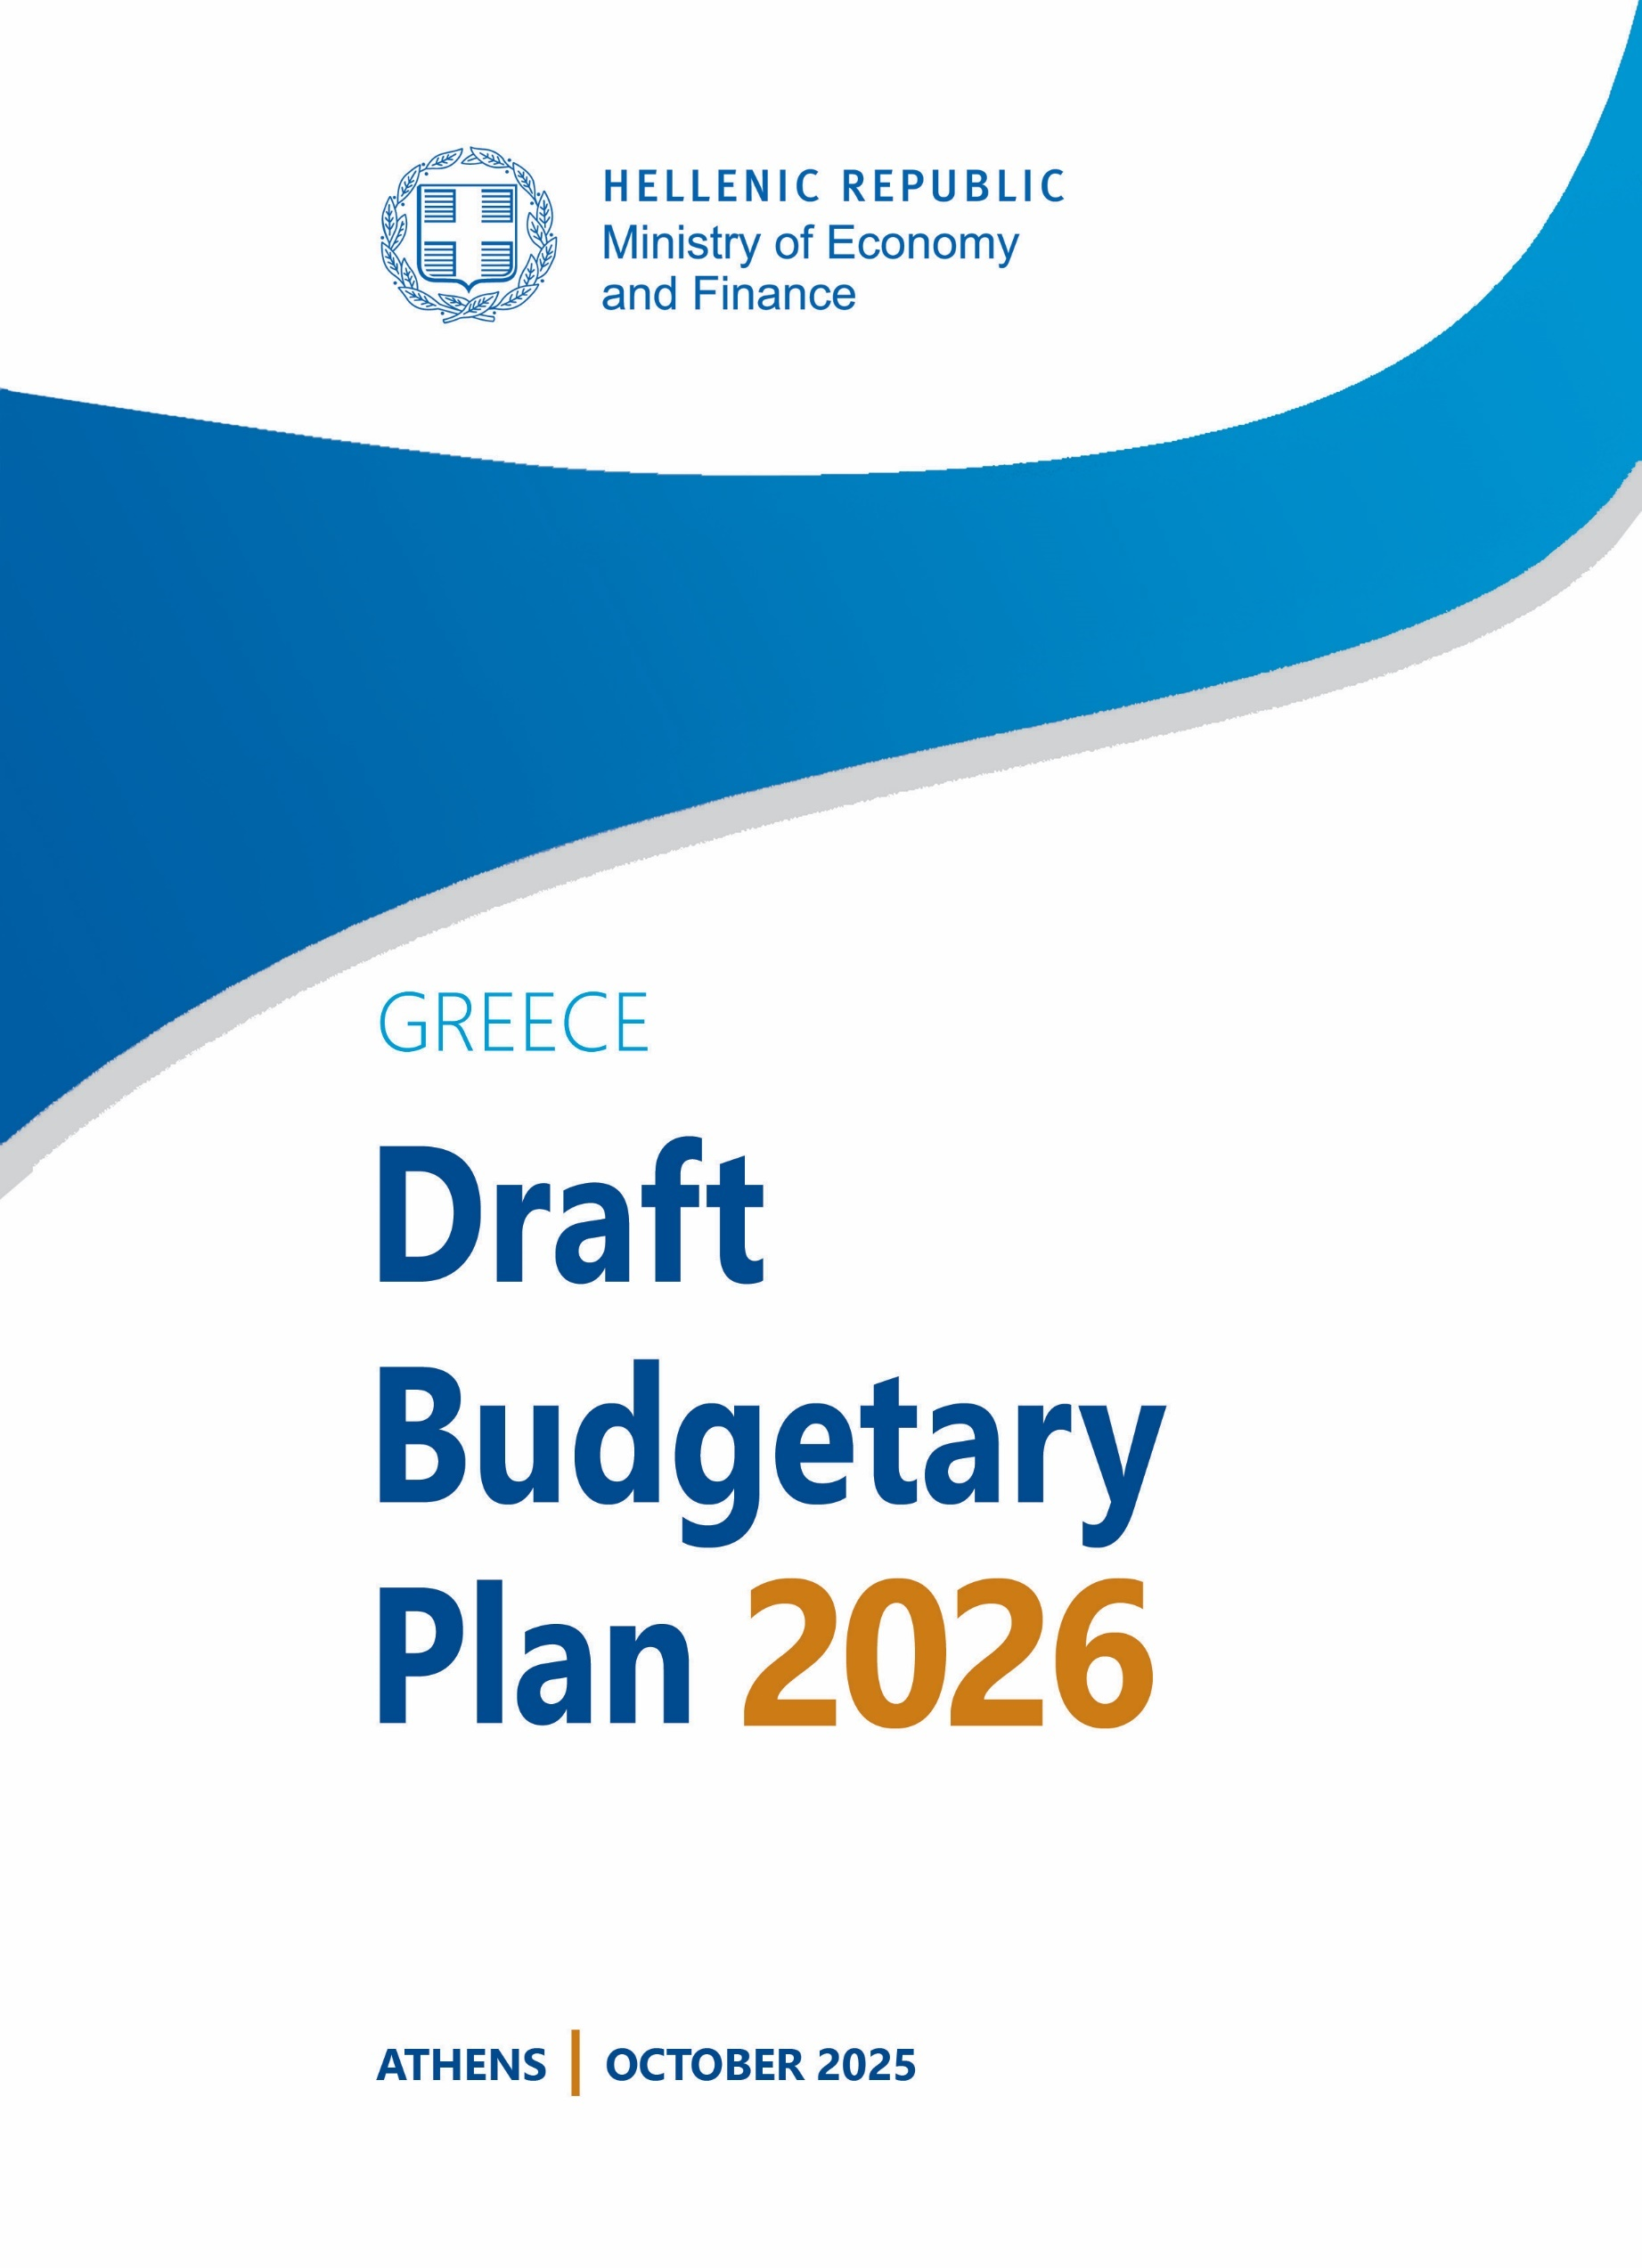
Greece
Draft Budgetary Plan 2026
[cover]

Contents
1. Introduction 6
2. Macroeconomic forecast 7
2.1. Macroeconomic developments in 2025 7
2.2. Macroeconomic prospects in 2026 16
3. Budgetary targets 23
3.1. Fiscal outlook 2025 23
3.2. Fiscal outlook 2026 24
3.3. Net expenditure growth 24
3.4. Debt developments 25
4. Expenditure and revenue projections 27
4.1. GG Revenue & expenditure 27
4.2. Discretionary measures 29
4.3. National Recovery & Resilience Plan (NRRP) 36
5. Distributional impact of the main revenue and expenditure measures 38
5.1. Methodology 38
5.2. Results 39
6. Country Specific Recommendations 2025 42
Annex I: DBP tables 67
Annex II: Measure tables 70
Annex III: Hellenic Fiscal Council opinion 72

Tables
Table 1 Key indicators for the European and the world economy 16
Table 2 Key indicators of the Greek economy 22
Table 3 Main variables 24
Table 4 Fiscal commitments 25
Table 5 Budgetary projections 27
Table 6 Main permanent discretionary measures 2025-2026 30
Table 7 RRF grants 37
Table 8 RRF loans 37
Table 9 Scenarios simulated for distributional analysis 38
Table 10 Mean annual equivalised disposable income, relative and absolute changes 39
Table 11 Average tax burden, relative changes 40
Table 12 Inequality indices 40
Table 13 FGT(0) poverty headcount index 41
Table 14 FGT(1) poverty gap 41
Table 15 FGT(0) poverty headcount index 41
Table 16 Macroeconomic scenario 67
Table 17 External assumptions 68
Table 18 Budgetary projections under unchanged policies 69
Table 19 Discretionary revenue measures 70
Table 20 One-off expenditures 71

Figures
Figure 1 European countries growth rates 2nd quarter 2025 7
Figure 2 Deviation of quarterly real GDP and GDP components 2019Q4-2025Q2 8
Figure 3 Real domestic demand in the Euro Area 2024-2023 9
Figure 4 Evolution of the contribution of GDP components 2021-Q2 2025 10
Figure 5 Evolution of Gross Value Added by main industrial sectors 2022Q1-2025Q2 11
Figure 6 Evolution of international energy prices 14
Figure 7 Greece’s Current Account Balance 15
Figure 8 Greece’s investment gap vis-à-vis the euro area 19
Figure 9 Rate of change in GDP per capita 20
Figure 10 General Government primary balance 23
Figure 11 General Government debt 26

Introduction
R
egulation (EU) 473/2013 of the European Parliament and of the Council (part of the so-called ‘Two-pack’) introduces a common budgetary timeline for Euro Area Member States. Specifically, Draft Budgetary Plans for the forthcoming year must be submitted to the European Commission and to the Eurogroup by October 15th of each year.
The document herein is being submitted to the European Commission and the Eurogroup in accordance with the Regulation.
The format and content of the document are in line with the requirements of the Two-pack Code of Conduct, which inter alia, requires macroeconomic and budgetary forecasts for the current and forthcoming year (in this case 2025 and 2026). The tables used are revised, in line with the reporting requirements under the reformed budgetary framework.
The macroeconomic forecasts used for the current and the next year have been endorsed by the Hellenic Fiscal Council (HFC), as required under article 6(3F) of the Regulation. The Opinion of the HFC is provided in Annex III.
All data presented, are on ESA 2010 statistical basis.

Macroeconomic forecast

Macroeconomic developments in 2025
In 2025, the global economy continues to operate in an environment of increased challenges and uncertainties. The persistence, and in some cases, escalation of geopolitical tensions in Ukraine and the Middle East, as well as disruptions in critical maritime trade routes such as the Red Sea, have affected the smooth operation of supply chains and increasing uncertainty over global growth prospects. At the same time, competition among groups of countries, the strengthening of protectionism and the imposition of tariffs on key product categories, have slowed down international trade, acting as a drag on investment and productivity.
On the other hand, the decline in global inflation has enabled central banks to gradually ease monetary policy, while energy prices have remained contained despite prevailing uncertainty.
Despite this high uncertainty in the global economic environment and the escalation of geopolitical instability in several cases, the Greek economy continues to demonstrate resilience, recording GDP growth rates consistently above the Eurozone and European Union (EU) averages. Specifically, during Q2 2025, according to the European Statistical Office (Eurostat) data, Greek GDP expanded by 1.7%, compared with 1.5% in the Eurozone and 1.6% in the EU, as shown in Figure 1.
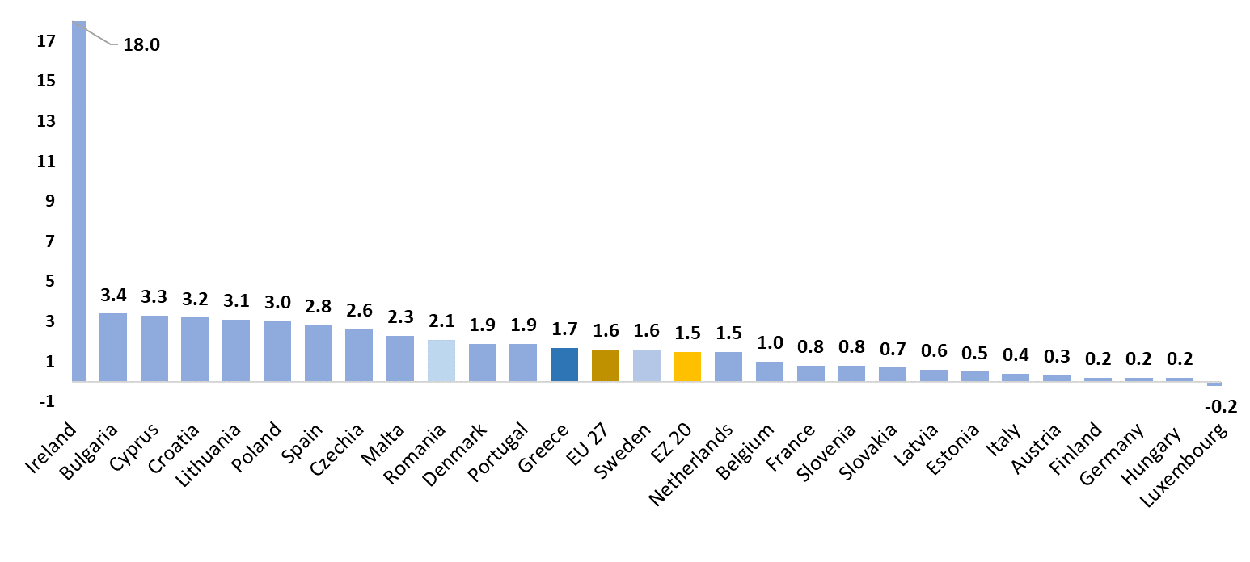
Figure 1 | European countries growth rates 2nd quarter 2025 (constant prices, %)
Source: Quarterly national accounts (ELSTAT, Eurostat), calculations by Ministry of Economy and Finance.
During the same period, several Eurozone countries and mostly major economies —such as Germany, France, Italy, Belgium, and Austria— recorded subdued growth rates, less than one pp, while Luxembourg slipped into recession. The sluggish economic growth of the Eurozone’s stronger economies is attributed, among other factors, to the impact of the U.S. tariff policy as well as to fiscal constraints.
Figure 2 | Deviation of quarterly real GDP and GDP components 2019Q4-2025Q2
(constant prices, seasonally adjusted data, as % of 4th quarter 2019 GDP)
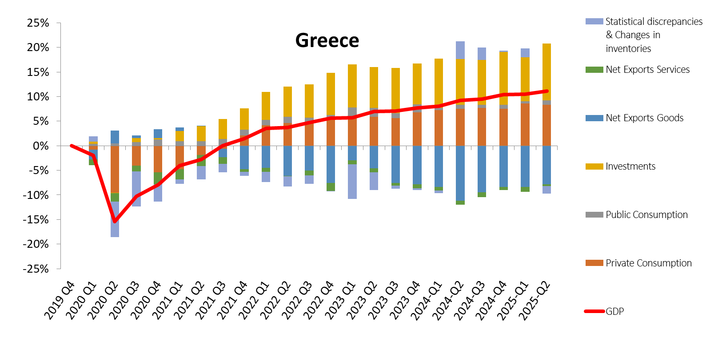
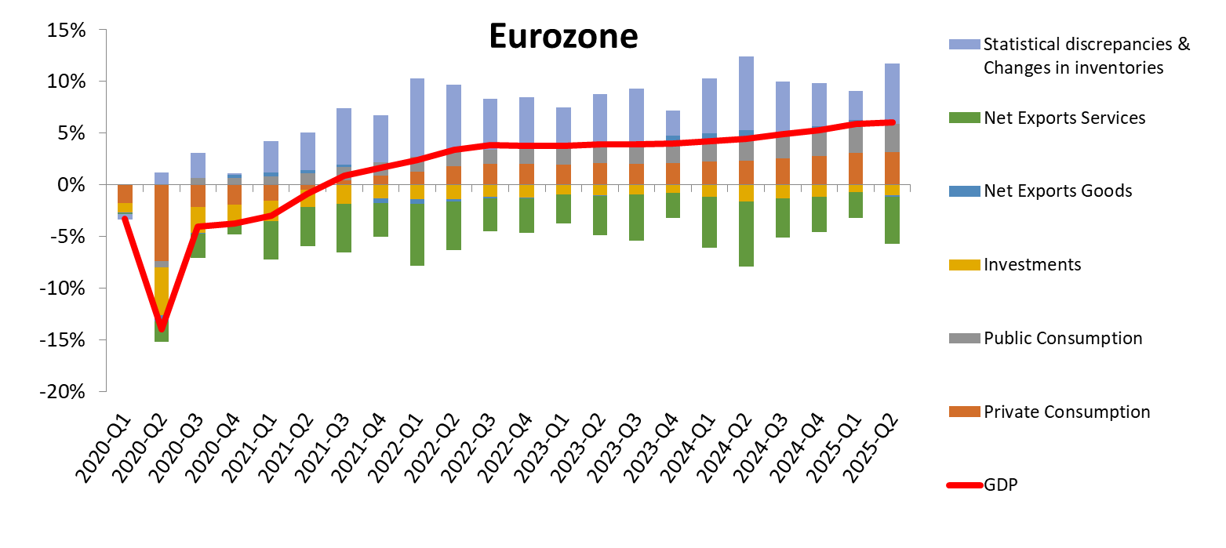
Source: Quarterly national accounts (ELSTAT, Eurostat), calculations by Ministry of Economy and Finance.
The Gross Domestic Product (GDP) of the Greek economy (in volume terms) continued to expand on an annual basis in Q2 2025, marking the seventeenth consecutive quarter of growth since Q1 2021 (Figure 2). This expansion was driven by stronger investments, steady private consumption, and the robust recovery of the tourism sector. Net exports of goods and services also contributed positively, despite the imposition of U.S. tariffs on EU imports since April 2025.
Overall, the impact of U.S. tariff measures on Greece in 2025 is expected to remain limited, given the low exposure of Greek exports, though potential indirect effects should not be underestimated.
Figure 2 shows the contribution of the components of GDP to the economic growth of Greece and the Eurozone from 2019 onwards.
According to the European Commission data, domestic demand in the Eurozone recovered in 2024, though at a moderate pace, recording an increase of 0.8% compared to a marginal increase of 0.2% in 2023. This recovery was gradual, as consumers remained cautious due to inflationary pressures. In Greece, domestic demand increased by 1.3% in 2023, and this momentum accelerated significantly in 2024, with domestic demand rising by 2.1% on an annual basis. This performance ranked Greece among the top ten Eurozone member states in terms of strong and sustained growth in domestic demand in 2024, as illustrated in Figure 3.
Figure 3 | Real domestic demand in the Euro Area 2024-2023
(annual rates of changes %, including changes in inventories)
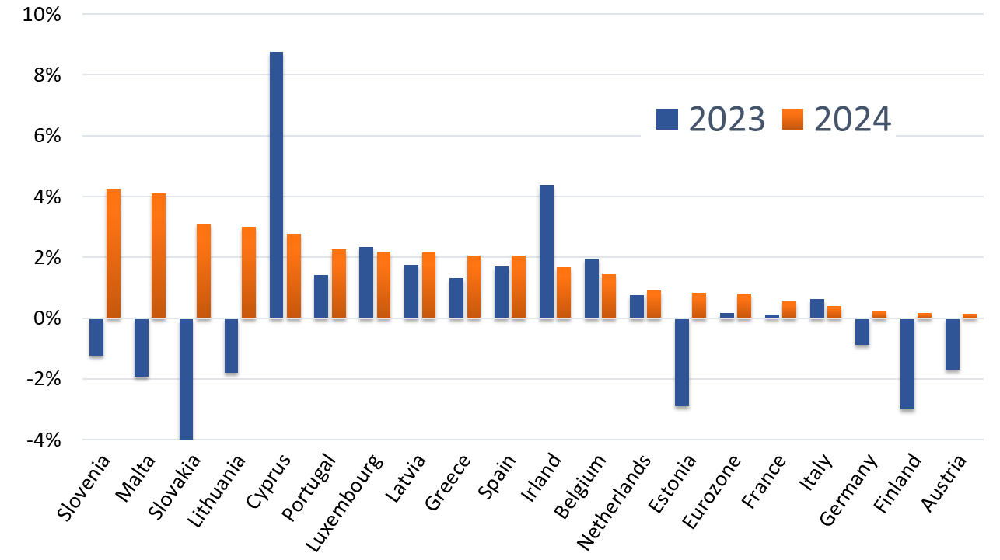
Source: European Commission AMECΟ macroeconomic database.
During the first half of 2025, the growth of the Greek economy stood at 2.0%, matching the pace of the first half of the previous year and exceeding the EU (1.6%) and Eurozone (1.5%) rates. The main growth drivers during the first half of the current year were private consumption, contributing one (1) pp to GDP (with an annual change of 1.5%), and investments, contributing 0.3 pp to GDP (with an annual change of 2.1%).
Total exports (of goods and services) in the first half of 2025 increased by 2.2%, while imports (of goods and services) fell by 0.5%. Despite ongoing uncertainty over global tariff policies, the Greek economy continued to expand on an annual basis in Q2 2025 by 1.7% (in real terms), compared to a 2.2% increase recorded in Q1 2025.
In terms of GDP components (constant prices), the continued increase in private consumption by 1.1% in Q2 2025 is directly linked to positive developments in the labour market, as employment continued to strengthen, enhancing households’ income. At the same time, the rise in average wages in both the private and public sectors played a major role in supporting consumption, helping to mitigate the impact of inflationary pressures for households.
Investments rebounded significantly in Q2 2025, compared to Q1 2025, increasing by 6.5% on an annual basis. This was largely supported by inflows from the Public Investment Programme (PIP), which also includes funds from the European Recovery and Resilience Facility (RRF). The strongest gains were recorded in “Transport equipment” (by 30.4%), “Residential buildings” (by 15.2%), “Agricultural products” (by 8.3%), and “Other constructions,” which mainly include productive investments (by 7.7%).
Public consumption also contributed positively to growth in Q2 2025, rising by 0.7% compared with Q2 2024.
During the same period, Greek exports of goods and services maintained an upward trend, increasing by 1.9% compared to Q2 2024. This trend was mainly driven by service exports, which rose by 3.9%, primarily reflecting the continued strong performance of tourism and corresponding high receipts.
Imports of goods and services in Q2 2025 declined by 3.2% compared with Q2 2024, mainly due to a 4.8% decrease in goods imports. This development contributed overall to the improvement in the trade deficit, while service imports increased by 1.5%.
Figure 4 | Evolution of the contribution of GDP components 2021-Q2 2025 (Q/Q-4, %)
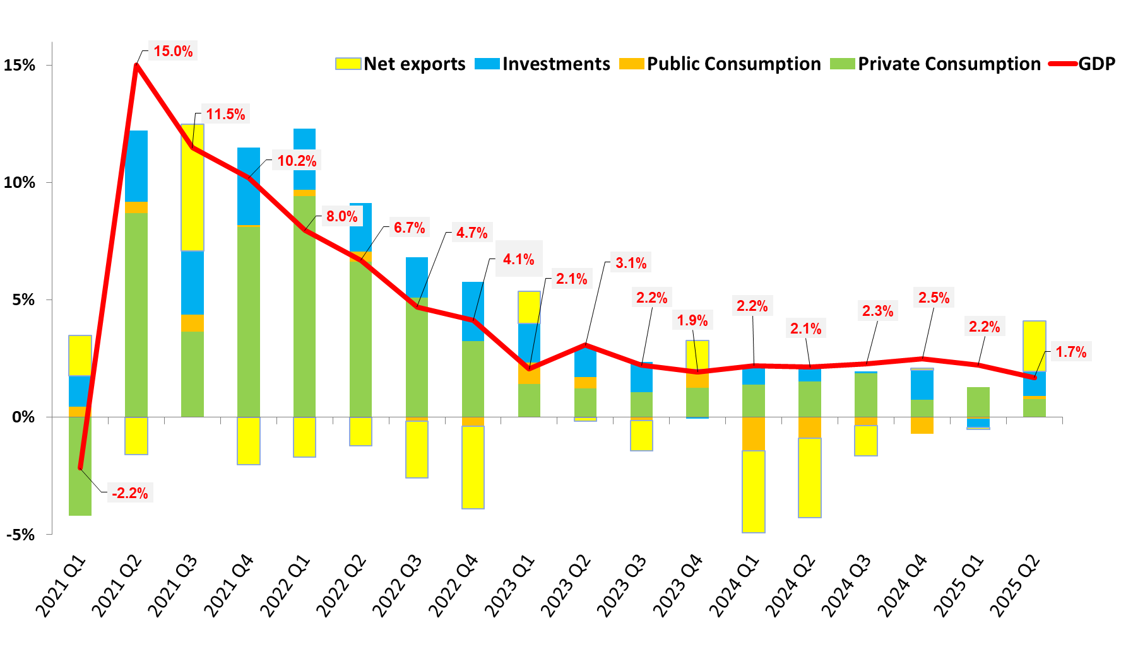
Source: Quarterly national accounts (ELSTAT, Eurostat), calculations by Ministry of Economy and Finance.
Figure 4 shows the evolution of the contribution of GDP components over time, from Q1 2021 up to Q2 2025. Specifically, in Q2 2025, the 1.7% growth of the Greek economy was mainly driven by the positive performance of private and public consumption, contributing by 0.8 and 0.1 pp respectively, as well as by investments (gross fixed capital formation, excluding inventories), which contributed by one (1) pp.
Exports of goods and services also had a positive impact on GDP in Q2 2025, contributing 0.7 pp due to the increase in service exports, which fully offset the marginal decline of 0.2 pp in goods exports. Imports of goods and services, following a decrease of 3.2% (-4.8% for goods and +1.5% for services), contributed positively to the impact of net exports on GDP by 2.2 pp.
For the full year 2025, the growth rate of the Greek economy is projected to reach 2.2%. Investments’ high growth rate combined with sustained consumption and a positive contribution from net exports, is expected to keep the Greek economy on a growth path throughout the year. In particular, investments are expected to increase by 5.7%, exports of goods and services by 2.2% and private and public consumption by 1.9% and 1.4% respectively.
The upward trend of the Greek economy during the first half of 2025, despite the persistent uncertainty in the international economic environment, is also evident in terms of real production. Gross Value Added (GVA) recorded an increase of 1.3% compared with the corresponding period of 2024, maintaining its positive dynamic.
Figure 5 | Evolution of Gross Value Added by main industrial sectors 2022Q1-2025Q2
(Quarterly data, current prices, seasonally adjusted, EUR million)
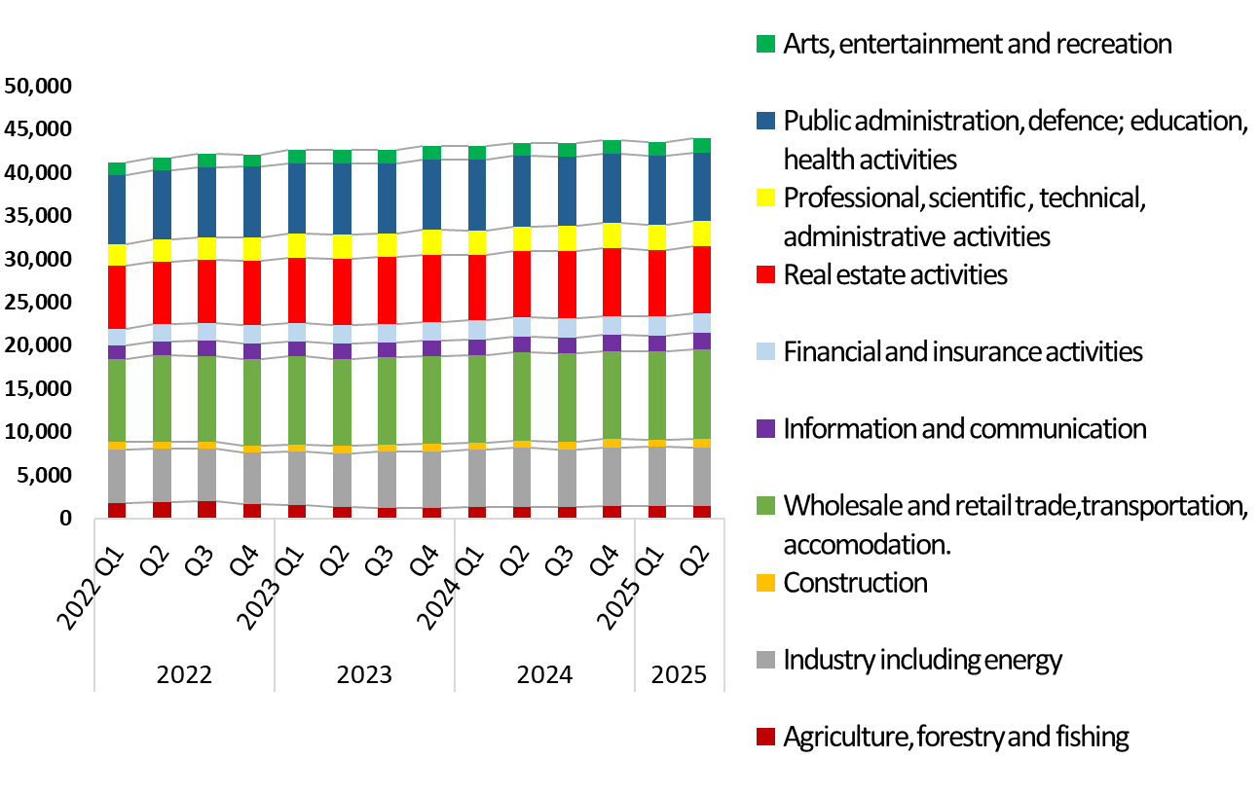
Source: Quarterly national accounts (ELSTAT, Eurostat), calculations of Ministry of Economy and Finance.
The evolution of the main economic sectors of the Greek economy over the last three years is presented in Figure 5. In the 2nd quarter of 2025, Gross Value Added (GVA) in real terms increased by 1.3%, compared to the corresponding quarter of 2024. The stronger growth was observed in the primary sector, “Agriculture, Forestry and Fisheries”, which expanded by 5.5%, confirming the reversal of the contraction of the agricultural sector as a result of the catastrophic floods in Thessaly in 2023.
The secondary sector recorded an overall increase of 1.2%, driven mainly by the construction industry, which grew by 11.0%. The tertiary sector also contributed positively, expanding by 0.9%, driven by the sectors of “Entertainment-Recreation-Arts” (8.9%), “Financial and insurance activities” (5.2%), “Professional, scientific, and technical activities” (5.6%), and “Trade, hotels and restaurants, transport and communications” (1.8%).
The labour market showed sustained growth during the first seven months of 2025, with total employment rising by 1.6% compared to the corresponding period in 2024, according to ELSTAT’s data. Based on ERGANI’s wage earners entry-exit balance, 319,843 new jobs were created in the first seven months of 2025, compared to 304,229 jobs created in the corresponding period of 2024. This figure represents the highest number of new jobs created in the first seven months of any year since 2001. During this period, 56.5% of the total hires were full-time contracts, 34.4% part-time contracts and 9.1% temporary employment contracts. The sectors showing the most significant net increases in employment (hires less of firings) between January-July 2025 predominantly include catering and accommodation services, which are directly linked to tourism and its substantial growth, as well as retail and wholesale trade.
Furthermore, according to ELSTAT’s Labour Force Survey, the number of employees in Q2 2025 amounted to 4,386,832, recording an increase of 4.0% compared to Q1 2025 and an increase of 1.4% compared to Q2 2024. The number of unemployed persons reached 411,722, down from 488,085 in Q1 2025, representing a 15.7% decrease on a quarter-on-quarter basis and a 12.0% decrease on a year-on-year basis. The unemployment rate in Q2 2025 fell to 8.6%, compared to 10.4% in Q1 2025 and 9.8% in Q2 2024. According to Eurostat’s data, this single-digit unemployment rate of 8.6% is the lowest recorded since Q1 2009. Based on the latest available data from ELSTAT (October 2025), the seasonally adjusted unemployment rate stood at 8.1% in August 2025, down from 9.7% in August 2024 and 8.3% in July 2025.
The aforementioned positive developments were facilitated by the policy measures and reforms that were implemented, such as the reduction of social security contributions in recent years, which directly contributed to the alleviation of non-wage labour costs, the reduction of tax-burdens, the introduction of the digital labour card, which supported the recording of actual working hours and the increase in employees’ earnings, policies aimed at promoting women’s participation in the labour market, as well as the strong growth rates of the Greek economy, driven by rising investment, which led to increased labour demand from employers.
It is noted that since 2019, wage levels have increased significantly, as the minimum wage has recorded a cumulative rise of 35.4%, with the goal of reaching €950 by April 2027. The increase in the minimum wage (which also partially pulls up the average wage) also helps address labor supply shortages in certain sectors such as retail trade, agriculture, construction, and tourism, while at the same time strengthening participation in the labor market.
In this context, the average wage also increased to €1,342, according to data from the annual report of the ERGANI system for the year 2024 (an increase of 28.3% since 2019), with the goal of reaching €1,500 by April 2027.
Compensation per employee is projected to increase further by 3.7% in 2025, a rate that aligns closely with the 3.8% growth forecasted in the European Commission’s Spring 2025 Economic Forecast (May 2025). Meanwhile, total compensation of employees, considering the increase in employment, is expected to rise by 6.3% in 2025, a rate significantly higher than the 3.4% forecast in the introductory report of the 2025 state budget.
The Harmonised Index of Consumer Prices (HICP) is estimated to increase by 3.0% in 2025. The annual rate of change of the National Consumer Price Index (CPI) is estimated at 2.6%. In particular, according to ELSTAT, during the period January-August 2025, the average rate of change of the CPI stood at 2.6%, compared with an increase of 2.8% over the same period of the previous year. The largest increase was recorded in the category “Hotels, cafés, and restaurants” at 6.2%, followed by “Clothing and footwear” and “Housing”, at 5.8% and 5.3%, respectively. In contrast, transport prices declined by 0.3% during January-August 2025, compared to the corresponding period of 2024.
According to Eurostat, the Harmonised Index of Consumer Prices (HICP) in Greece reached 3.2% during the period January-August 2025, compared to 3.0% in the corresponding period of 2024. The HICP Euro area average stood at 2.2% in the period January-August 2025, down from 2.5% in the previous year.
Regarding developments in the energy sector (Figure 6), the average monthly international price of Brent crude oil in 2025 decreased to lower levels compared with the previous year, following a downward trend. Between January and August 2025, prices ranged from 64 to 79 US dollars per barrel, with the lowest level recorded in May (64.21 US dollars per barrel) and the highest in January (79.21 US dollars per barrel). Downward pressures on the demand side, stemming from trade protectionism, combined with increased supply outside OPEC+, contributed to the gradual decline in prices, while geopolitical uncertainty continued to fuel short-term volatility.
During the second quarter of 2025, and particularly from June onwards, a stabilization trend emerged, with prices moving closer to 65-70 US dollars per barrel, while the decline since the beginning of the year exceeded 10%. Nevertheless, conditions in the oil market remain volatile, as developments in the Middle East and decisions by OPEC+ continue to represent significant sources of uncertainty.

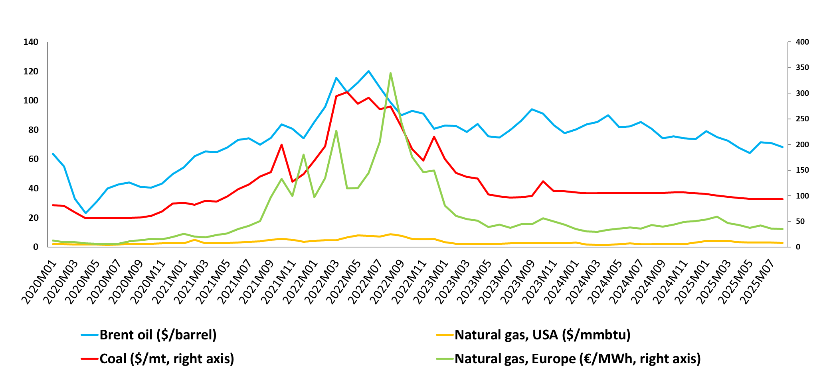
Figure 6 | Evolution of international energy prices (price level)
Source: Intercontinental Exchange (ICE), World Bank, Commodity Markets, monthly prices, September 2025
The price of natural gas in Europe declined further in 2025, following a downward trajectory after a temporary increase at the beginning of the year. This earlier rise was driven by lower energy reserves in Europe compared to 2024, harsher winter weather conditions, the suspension of Russian natural gas transit through Ukraine, and reduced output from renewable energy sources. The TTF (Title Transfer Facility) price fell from €42.8 per megawatt hour in August 2024 to €35.4 per megawatt hour in August 2025, marking a 17.3% decrease, while the decline since August 2022 —the peak of the energy crisis— amounted to 90%. This downward adjustment in 2025 is attributed to milder temperatures, the availability of sufficient liquefied natural gas (LNG) reserves, and the increased contribution of renewable energy sources. Despite this significant easing, international prices remain volatile and highly sensitive to supply and demand conditions, as well as to geopolitical developments that continue to affect Europe’s energy supply.
In the first half of 2025, the current account deficit stood at 6.5% of GDP, lower than in the corresponding period of 2024 (7.5% of GDP). During the period January-July 2025, the current account balance improved, with the deficit narrowing by €1.4 billion or 17.5% compared with the same period of 2024 (€8.1 billion). This development reflects improvements across all sub-balances, particularly in the primary income, services, and goods balances. The services balance surplus increased by almost €0.5 billion or 4.2%, from €11.4 billion to €11.8 billion, mainly as a result of strong travel receipts. Travel receipts during January-July 2025 reached €12.18 billion, exceeding the €10.83 billion recorded in 2024 by 12.5%.

Figure 7 | Greece’s Current Account Balance
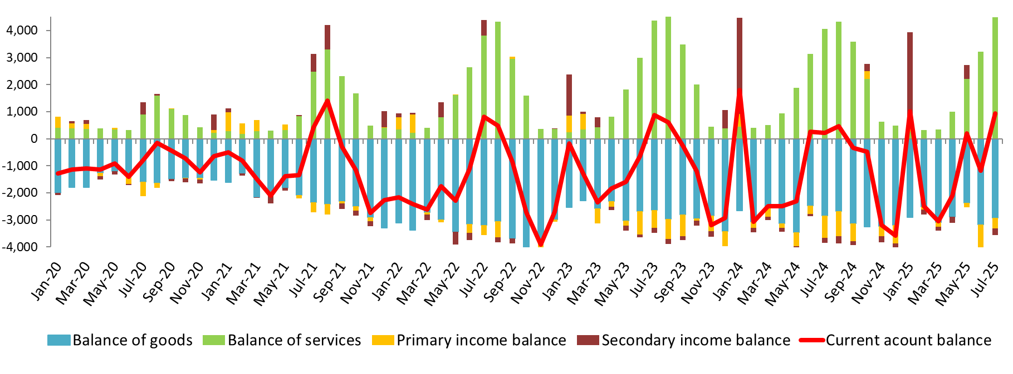
(million euros, current prices, non-seasonally adjusted data)
Source: Bank of Greece, monthly Balance of Payments data
The positive momentum of the Greek economy, despite the uncertain external economic environment, was reflected in the sustained performance of the Economic Sentiment Indicator (ESI), which, according to the European Commission data, stood at 107.8 points during the period January-August 2025, compared with 107.5 points in the corresponding period of 2024. In the Euro area, the Economic Sentiment Indicator remained at lower levels, standing at 95.1 points in January-August 2025, down from 95.9 points in the same period of 2024.
Greece’s stronger performance in the indicator is mainly attributed to business expectations in industry, where the corresponding index recorded a sharp upward trend during the first eight months of 2025, rising to 6.3 points from 0.6 points in the same period of 2024. Significant improvement was also observed in business expectations in construction, with the index increasing to 16.4 points from 8.3 points, reflecting optimistic forecasts associated with strong investment activity in both public and private infrastructure projects. In retail trade, expectations declined to -0.3 points from 13.9 points, while in services the index fell to 29.9 points from 41.3 points.
With regard to the manufacturing sector, data from the S&P Global Purchasing Managers’ Index (PMI) indicated a very strong performance in August 2025, as the increase in new orders recorded the sharpest improvement of the past five months and led to a significant rise in production. Specifically, the seasonally adjusted index rose to 54.5 points, up from 51.7 in the previous month (July 2025) and 52.9 in August 2024, signaling a clear strengthening of activity in the manufacturing sector. Despite continued weakness in external markets, the improvement in domestic demand proved strong enough to drive both production and new orders, with the overall increase in new sales being the fastest recorded since March 2024.
Despite the volatility of the international environment, the performance of the Greek economy continues to be acknowledged internationally, with the maintenance of investment-grade status and successive upgrades reaffirming its credibility and resilience. In this context, economic policy remains focused on fiscal stability, debt reduction, tax relief, and the strengthening of disposable income, while at the same time promoting investments that emphasize the green and digital transitions. By leveraging the resources of the Public Investment and Development Programme and further enhancing employment and productivity, this strategy reinforces investor confidence, improves financing conditions, and establishes the foundations for the sustained continuation of the economy’s growth momentum to the benefit of all citizens.

Macroeconomic prospects in 2026
The global economy continues to be marked by a high degree of uncertainty, driven by factors such as geopolitical tensions, climate change, and the lack of stability and predictability in international trade policy, affecting private consumption and fixed capital investment.
Τhe global GDP growth rate, according to the International Monetary Fund (IMF) forecasts in July 2025, is expected to slow down from 3.3% in 2024 to 3.0% in 2025, before slightly recovering to 3.1% in 2026. These forecasts have been revised upward by 0.2 pp for 2025 and 0.1 pp for 2026, compared to April projections. For the Euro area, GDP growth is expected to reach 1.0% in 2025 and 1.2% in 2026 from 0.9% in 2024.
According to the Spring Economic Forecast of the European Commission, the growth rate for the EU is estimated to increase from 1.0% in 2024 to 1.1% in 2025 and 1.5% in 2026, supported by continued consumption growth and a rebound of investment. For the Euro area, GDP growth is expected to increase from 0.9% in both 2024 and 2025 to 1.4% in 2026 (Table 1).
Table 1 | Key indicators for the European and the world economy
(% annual changes, constant prices)
 | 2024 | 2025* | 2026*
World GDP | 3.3 | 3.0 | 3.1
GDP of the European Union** | 1.0 | 1.1 | 1.5
GDP of the Euro Area** | 0.9 | 0.9 | 1.4
GDP of the USA | 2.8 | 1.9 | 2.0
World trade (goods and services) | 3.5 | 2.6 | 1.9
Inflation | 5.6 | 4.2 | 3.6
a. Advanced economies | 2.6 | 2.5 | 2.1
b. Emerging markets and developing economies | 7.7 | 5.4 | 4.5
c. Euro Area** | 2.4 | 2.1 | 1.7
Oil prices (Brent, USD/barrel)** | 80.5 | 67.7 | 64.0
* Estimates/projections. ** EC Spring European Economic Forecast, May 2025.
Source: IMF, World Economic Outlook, July 2025.
According to the Spring Economic Forecast of the European Commission, inflation in the EU is projected to decline from 2.6% in 2024 to 2.3% in 2025 and further to 1.9% in 2026. In the Euro area, inflation is forecasted to fall from 2.4% in 2024 to 2.1% in 2025 and to 1.7% in 2026. Downward pressures stem from significantly lower energy prices, US-China trade relations which increase competition in non-energy industrial goods within the EU and the appreciation of the euro and other EU currencies. These deflationary forces are partly offset by higher inflation in food and services.
According to forecasts of the European Central Bank (ECB) in September 2025, the growth rate for the Euro area is estimated at 1.2% in 2025 and 1.0% in 2026, compared to 0.8% in 2024. Inflation is projected to decline from 2.4% in 2024 to 2.1% in 2025 and further to 1.7% in 2026.
In advanced economies, according to the IMF forecasts in July 2025, GDP growth is estimated to slow from 1.8% in 2024 to 1.5% in 2025, before modestly increasing to 1.6% in 2026. Specifically, for the United States, GDP growth is expected to decelerate from 2.8% in 2024 to 1.9% in 2025 and then slightly recover to 2.0% in 2026, mainly driven by tax incentives for corporate investment. For Japan, the growth rate is forecast to rise from 0.2% in 2024 to 0.7% in 2025 before declining to 0.5% in 2026. For Canada, the growth rate is expected to increase from 1.6% in both 2024 and 2025 to 1.9% in 2026. For the United Kingdom, the growth rate is projected to rise from 1.1% in 2024 to 1.2% in 2025 and to 1.4% in 2026.
In emerging markets and developing economies, according to the IMF forecasts in July 2025, the GDP growth rate is expected to slow from 4.3% in 2024 to 4.1% in 2025 and further to 4.0% in 2026. Specifically, for China, the growth rate is projected to decline from 5.0% in 2024 to 4.8% in 2025 and further to 4.2% in 2026. Forecasts have been revised upwards compared to April, reflecting stronger-than-expected activity in the first half of 2025 and a significant reduction in US-China tariffs. For India, the growth rate is expected to decrease slightly from 6.5% in 2024 to 6.4% in both 2025 and 2026, however, the country is estimated to remain the fastest-growing major economy worldwide. Forecasts have been slightly revised upwards compared to April, reflecting a more favorable external environment.
According to the IMF forecasts in July 2025, the growth rate of global trade in goods and services, in volume terms, is projected to decelerate from 3.5% in 2024 to 2.6% in 2025 and further to 1.9% in 2026. The volume of global trade increased in early 2025 driven by frontloading in anticipation of tariffs, however this effect is expected to fade. For advanced economies, the trade growth rate is projected to decline from 2.0% in 2024 to 1.8% in 2025 and further to 1.2% in 2026 and for emerging markets and developing economies, a slowdown is also expected from 5.8% in 2024 to 3.8% in 2025 and to 3.2% in 2026.
According to the ECB forecasts in September 2025, the growth rate of global trade (excluding the Euro area) is expected to decline from 4.2% in 2024 to 2.8% in 2025 and further to 1.5% in 2026. The growth rate of foreign demand in the Euro area is projected to decrease from 3.6% in 2024 to 2.8% in 2025 and to 1.4% in 2026.
Global inflation, according to the IMF forecasts in July, is expected to ease to 4.2% in 2025 and decline further to 3.6% in 2026, down from 5.6% in 2024, though with notable divergences among countries. In advanced economies, inflation is expected to decrease from 2.6% in 2024 to 2.5% in 2025 and to 2.1% in 2026, while in emerging markets and developing economies, it is expected to remain relatively higher compared to advanced economies and is projected to slow from 7.7% in 2024 to 5.4% in 2025 and further decrease to 4.5% in 2026.
According to the Spring Economic Forecast of the European Commission, the average price of crude oil is on a downward trajectory and is expected to decline from $80.5 per barrel in 2024 to $67.7 per barrel in 2025 and to $64.0 per barrel in 2026. The oil price forecasts have been revised downward compared to those of autumn, reflecting expectations of weakening global demand.
The global economy following the disruptions caused by the pandemic and the energy crisis, is now confronted with a range of new challenges that increase the level of uncertainty regarding international economic prospects. The lack of stability and predictability characterizing the global tariff framework since early 2025 is expected to weigh on international trade and business investments, with direct repercussions for the global economy. Moreover, the escalation of geopolitical tensions could trigger new shocks to the global economy by adversely affecting maritime routes, supply chains, and consequently, the prices of key commodities and overall growth. Additionally, the increasing frequency and intensity of extreme climate events represent an additional, entrenched risk with unpredictable and severe implications for economic activity. On the other hand, the easing of trade tensions through a predictable framework of trade agreements, as well as a possible de-escalation of geopolitical tensions, would constitute favorable factors for the global economy, reducing uncertainty and fostering investment and growth.
The Greek economy is projected to maintain robust output growth momentum in 2026, despite ongoing external sources of instability and challenges, continuing to demonstrate the resilience it has shown in previous external crises. Real GDP is forecast to expand by 2.4% in 2026 on an annual basis, marking the sixth consecutive year of growth above 2% and indicating an acceleration compared to 2025 (2.2%).
The acceleration of real GDP growth in 2026 is anchored on the following key pillars of resilience:
- The new government initiatives aimed at reducing the tax burden and supporting incomes and investment,
- the continued expansion of the labour market,
- the effective utilisation of EU funds under the Recovery and Resilience Facility (RRF) / Next Generation EU (NGEU) and
- the gradual upgrading of the productive base through structural reforms.
Owing to robust private investment and increased RRF funding, as the “Greece 2.0” Recovery and Resilience Plan approaches its implementation horizon, the growth rate of gross fixed capital formation is projected to reach 10.2% in 2026, compared to 5.7% in 2025. The double-digit increase in total investment reflects positive developments across all investment categories. Notably, around 50% of the increase is expected to stem from construction investment (annual growth of 13.8%), while the remaining 50% is attributed to equipment investment (annual growth of 10.1%) and investment in agricultural and other products (annual growth of 2.7%).
Consequently, investment is projected to be the main driver of real growth in 2026, contributing 1.7 pp to annual real GDP growth. Greece’s negative investment gap vis-à-vis the euro area, which has been steadily narrowing since 2019, is expected to shrink to its lowest level since the onset of the economic adjustment programme by the end of 2026. These developments reflect a rise in real investment to 18.0% of GDP in 2026, while in nominal terms investment is projected to reach 16.8% of GDP in 2026, up from 15.7% in 2025 —the highest share since 2010.
Figure 8 | Greece’s investment gap vis-à-vis the euro area
(constant prices, non-seasonally adjusted data)
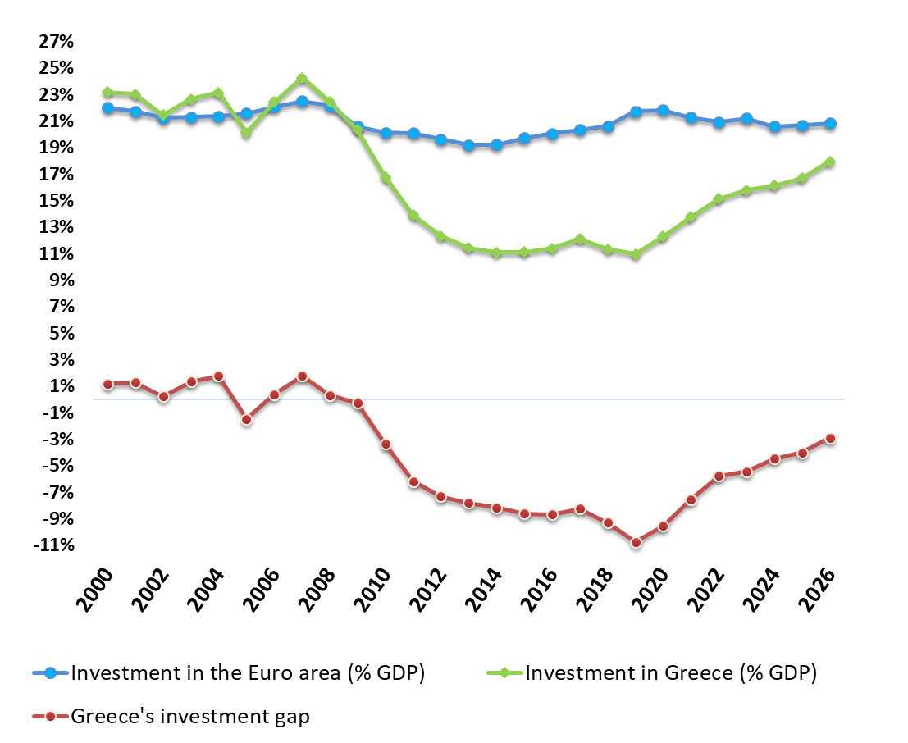
Source: Annual National Accounts (ELSTAT/Eurostat), European Commission 2025 Spring Economic Forecast, Hellenic Ministry of Economy and Finance projections.
The new government measures announced at the 2025 Thessaloniki International Fair (TIF) constitute permanent support measures to be implemented from 2026, with an estimated fiscal impact of €1.76 billion in the first year. They are primarily aimed at boosting incomes and reducing the tax burden for the majority of the population. At their core lies the significant reform of the personal income tax scale for employees, pensioners, farmers and the self-employed. Specific provisions for additional tax relief are envisaged for families with children and for young people up to 30 years of age. This structural reform of the personal income tax scale is projected to ease household budgets by €1.2 billion in 2026, followed by a further €400 million in 2027, aiming to provide substantial support to middle-income households, families with children and young people.
Further income support is expected in 2026 from additional new measures, such as the gradual elimination of the pensioners’ personal difference offset, the reduction of rental income tax for property owners, the 30% average reduction in imputed living expenses, the adjustments to special wage grids for the armed and security forces, the 30% cut in VAT for remote islands with populations up to 20,000, the three-year suspension of the minimum income threshold for new mothers and the relief measures for communities with population up to 1,500 persons, such as the gradual abolition of the Unified Property Tax (ENFIA) on primary residences and the 50% reduction in the minimum income threshold for the self-employed.
The implementation of these permanent income-support measures, carried out within fiscal targets, covers the vast majority of the population and aims to enhance household purchasing power and support domestic demand, leaving a lasting impact on disposable income.
Moreover, the reduction in tax rates implies that future wage increases will translate into larger gains in workers’ net income. For 2026, the positive effect of the full set of new government measures on real GDP growth is projected at 0.6 pp of GDP. As a result, the Greek economy is expected to record for the sixth consecutive year a higher real GDP growth rate, according to projections of the Hellenic Ministry of Economy and Finance (2.4% in total and 2.6% per capita), compared with the euro area and EU averages as reflected in the European Commission Spring Economic Forecast (1.4% for the euro area and 1.5% for the EU in total, and 1.1% and 1.3% per capita, respectively). This way, the medium-term convergence prospects with the euro area are strengthened, gradually improving Greece’s position within the European context.
Figure 9 | Rate of change in GDP per capita
(constant prices, year on year change %)
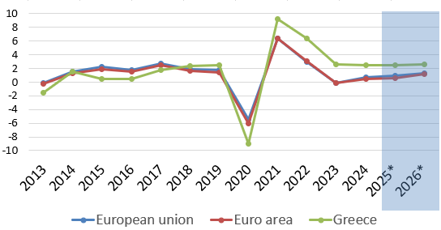
* Forecast years
Source: Annual National Accounts (ELSTAT/Eurostat), Hellenic Ministry of Economy and Finance projections, European Commission 2025 Spring Economic Forecast.
Against the backdrop of strengthened incomes, real consumption expenditure is projected to increase by 1.5% in 2026 on an annual basis, with private consumption expected to rise by 1.7% and public consumption by 0.7%. This expansion is underpinned by the income-support measures for the private and public sectors, the positive developments in the labour market, the slowdown in inflation and the improvement in consumer confidence.
Employment is expected to continue its upward trajectory in 2026, rising by 0.4% on a national accounts basis, reflecting a comparatively larger increase in the number of employees by 0.6%. In national accounts terms, the number of employees in 2026 is projected at around 3.9 million, which is 659,000 higher than the 2008 level, prior to the Greek sovereign debt crisis. Similarly, the total number of employed persons is expected to reach 5.2 million, exceeding the 2008 level by 297,000, entirely attributable to the progressive improvement observed since 2022.
The unemployment rate, having already fallen into single digits in 2025, is projected to decline further in 2026 by half a pp of the labour force, reaching 8.6% according to the Labour Force Survey — the lowest unemployment rate in Greece since 2008.
Given the new adjustment of the minimum wage as of 1 April 2026 and amid higher employment, the nominal average wage is expected to rise by 3.7% in 2026, the same rate as in 2025. This development brings per capita employee compensation for 2026 to 21.6% above the 2019 level. It should be noted that per capita employee compensation is expressed in gross terms. Accounting for the successive reductions in income taxes and social security contributions, net per capita employee compensation is estimated to have increased by more than 30% in 2026 compared with 2019.
The real average wage is expected to rise for the third consecutive year in 2026, with its growth rate accelerating to 1.5% from 0.5% in 2025. Labour productivity is also projected to enter a phase of acceleration, with its annual growth rate reaching 1.9% in 2026, up from 1.5% in 2025, supporting the preservation of the Greek economy’s international competitiveness.
The gains in the real average wage are underpinned by the expected easing of inflationary pressures in 2026. The Harmonised Index of Consumer Prices (HICP) is projected to increase by 2.2% in 2026, approaching the ECB’s medium-term target. This development signals the normalisation of underlying pressures in both the food sector and the core inflation, and the energy component’s negative impact of around 0.2 pp on the annual growth rate of the HICP.
In the external sector, international trade conditions are expected to ease in 2026 following the tariff agreement reached between the United States and the EU in July 2025. As a result, uncertainty in the international environment is projected to be high but moderated compared with the first half of 2025. This, combined with Greece’s relatively limited trade links with the United States, is expected to keep the impact of higher tariffs on the Greek economy contained in 2026.
In this context, the external services balance is expected to follow a positive trajectory in 2026, contributing 0.6 pp to real GDP growth due to faster growth in real exports of services (5.0%) compared with real imports of services (2.7%). The dynamic increase in nominal tourism revenues, projected at 6.5% on an annual basis, is expected to support this trend. Exports of goods at constant prices are projected to rise by 3.9%, while total exports of goods and services are expected to increase by 4.5%. Imports of goods and services are also anticipated to grow at similar levels (4.6%), supported by an increase in goods imports, projected at 5.3%, driven by robust domestic demand for investment and consumption.

Table 2 | Key indicators of the Greek economy
(% annual changes, constant prices)
 | 2024 | 2025** | 2026**
GDP | 2.3 | 2.2 | 2.4
Private consumption | 2.1 | 1.9 | 1.7
Public consumption | -4.1 | 1.4 | 0.7
Gross fixed capital formation | 4.5 | 5.7 | 10.2
Exports of goods and services | 1.0 | 2.2 | 4.5
Imports of goods and services | 5.5 | 0.9 | 4.6
GDP deflator | 3.2 | 2.8 | 2.1
HICP | 3.0 | 3.0 | 2.2
National CPI | 2.7 | 2.6 | 2.2
Employment* | 1.2 | 0.7 | 0.4
Unemployment rate* | 8.6 | 7.8 | 7.4
Unemployment rate (Labour Force Survey) | 10.1 | 9.1 | 8.6
* On a national accounts basis
** Estimates/ projections
Source: Annual National Accounts (Hellenic Statistical Authority), estimates/projections of the Hellenic Ministry of Economy and Finance
The main short-term risks to the economic outlook for 2025 and 2026 relate to an escalation of geopolitical tensions, a possible deviation from the US-EU tariff agreement (or other destabilisation of international trade conditions), a larger-than-expected impact of tariffs on the global and European economies, more pronounced manifestations of climate change, and delays in the implementation of planned investments. At the same time, the appreciation of the euro poses risks for the external balance and competitiveness in the euro area, while the implementation of contractionary fiscal policies in major EU economies could weigh on external demand.
On the upside, the output growth of the Greek economy could be further supported by an even stronger momentum in external tourism and shipping, a faster-than-expected easing of inflation, partly reflecting international developments in the energy sector, as well as a higher-than-anticipated investment and output growth impetus that could stem from synergies generated by the ongoing structural reforms.

Budgetary targets

Fiscal outlook 2025
For 2025, a primary surplus of +3.6% of GDP is expected to be achieved, while the headline budget balance is estimated to record a surplus of +0.6% of GDP, remaining significantly above the -3% of GDP Treaty reference value.
The decrease of the estimated budget surplus compared to the previous year (by -0.7 pp of GDP) mainly reflects the impact of the several measures taken, both on the side of revenues and expenditure in a number of key policy areas, targeted to support disposable income, promote investment and employment and aid vulnerable social groups. A detailed description of these measures can be found in Chapter 4. The fiscal effect of these measures, along with the regular increase of general government expenditure, is partly counterbalanced by the strong performance of tax and social security contributions revenues, due to the favourable economic growth, the measures taken to enforce tax compliance and the positive developments in the labour market and wages.
Compared to April estimations (Annual Progress Report 2025), the primary balance of 2025 is revised upward by 0.4 pp of GDP, driven mainly by the overperformance of tax and social security contributions’ revenues.
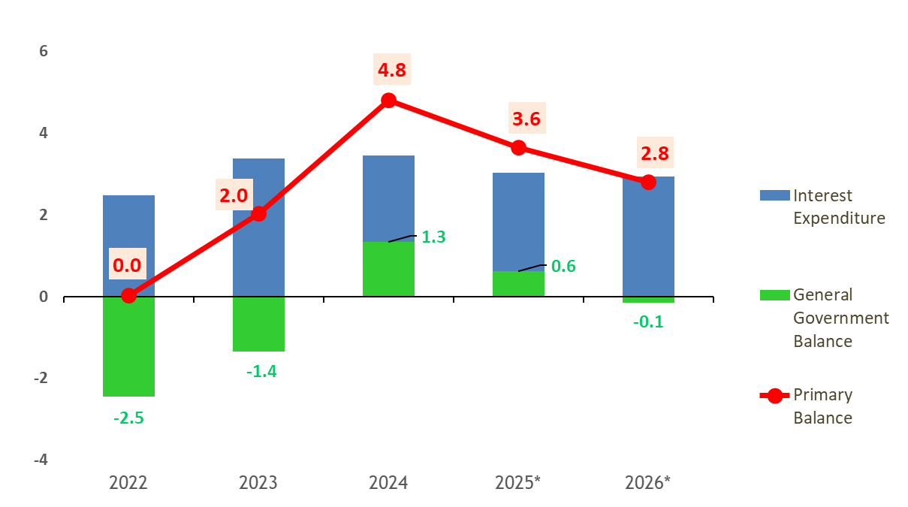
Figure 10 | General Government primary balance (% of GDP)
* Projections

Fiscal outlook 2026
For 2026, a sustainable primary surplus of +2.8% of GDP is expected to be achieved, based on the solid growth path of the economy. The headline budget is estimated to be almost balanced, at -0.1% of GDP, remaining significantly above the -3% of GDP Treaty reference value.
The decrease of the estimated general government balance compared to the previous year is mainly attributed to the inclusion of new, growth enhancive and supporting policy measures, that amount to 0.7% of GDP and were announced by the Prime Minister during the Thessaloniki International Fair. Their adoption was enabled by the prudent fiscal policy followed and the effective tax evasion policies. They stand within the fiscal boundaries and targets of the new fiscal framework and are presented in detail in the following section.
The tax and social security contribution revenues continue to have a positive carry over effect and grow further in 2026, due to the robust growth of the economy. The additional revenues are expected to cover the typical annual increases of operational expenditure following the inflation, the yearly increase of pensions and public sector wages and other emerging needs. In addition, Greece is implementing a comprehensive military investment programme addressing current geopolitical needs, increasing the military deliveries by 0.2 pp of GDP, compared to the previous year.
Table 3 | Main variables (% GDP)
 | 2024 | 2025 | 2026
1. Net lending/borrowing | 1.3 | 0.6 | -0.1
2. Primary balance | 4.8 | 3.6 | 2.8
3. Structural balance | 0.6 | 0.0 | -0.9
4. Structural primary balance | 4.0 | 3.0 | 2.0
5. Gross debt | 153.6 | 145.4 | 137.6
6. Change in gross debt | -10.3 | -8.2 | -7.8

Net expenditure growth
The reformed European economic governance framework entered into force in April 2024. In July 2025, Greece completed the transposition of the relevant Directive into its national law. In the new framework, the net expenditure indicator plays a central role, as it has become the single operational reference for fiscal surveillance, anchored in debt sustainability.
It should be noted that, after the relevant Council recommendation, Greece activated the national escape clause that allows the deviation from the maximum growth rates of net expenditure set, to the extent of the increase of defence expenditure compared to the relevant expenditure of 2024, as percentage of GDP.
For 2024, the net expenditure change is estimated at -0.4%, while the maximum growth rate recommended by the Council was +2.6%. The 2024 net expenditure level was affected by both the lower than anticipated general government spending and the inclusion of discretionary revenue measures that significantly increased tax compliance, such as the interconnection of POS with cash register machines and tax authorities, the full application of the “myDATA” platform and electronic invoices, the digital labour card and others.
Table 4 | Fiscal commitments
 | 2024 | 2025 | 2026
Council recommendation
1a. Net nationally financed primary expenditure  (annual growth rate) | 2.6 | 3.7 | 3.6
Outturn / projection
1b. Net nationally financed primary expenditure  (annual growth rate) | -0.4 | 4.4 | 5.8
Control account
Cumulated balance of the control account (GDP %) | -1.2 | -0.9 | 0.0
Cumulated balance after flexibility from increases in defence expenditure (GDP %) |  | -1.0 | -0.3
The net expenditure for 2025 and 2026 is estimated to grow by 4.4% and 5.8% on an annual basis, respectively. The cumulative growth in the years 2024-2026 taken together, does not exceed the relevant Council recommendation. Moreover the cumulative balance taking into account the flexibility provided by the escape clause for higher defense expenditure, continues to be negative, standing 0.3% of GDP below the maximum threshold. The estimated increase in total defence expenditure as a ratio to GDP from 2024 to 2026 is estimated to reach 0.3 pp.

Debt developments
The general government debt is estimated at 145.4% of GDP at the end of 2025, vs 153.6% of GDP in 2024. For the end of 2026, the general government debt is forecasted at 137.6% of GDP, i.e. reduced by 7.8 pp compared to 2025.
The Hellenic Republic continued its issuance activity smoothly, covering its low financing needs for the current year, mainly with syndicated issuances of 10-year, 15-year and 30-year bonds, which had high coverage ratios in their offer book and were allocated on a priority basis to end-investors. Significant contribution to the annual refinancing is made by the bond re-openings via auctions which are carried out on regular dates according to the already announced program. The total cash reserves of the Hellenic Republic remain at the high levels of recent years, continuing to enhance the flexibility of debt management. At the same time, part of the cash buffer reserves is already used, since 2024, for the early repayment of the GLF loans.
More specifically, by the end of this year, the early repayment of part of the GLF's European loans is expected to be continued with the pro-rata early repayment of loans maturing within the years 2033-2041, for an amount of €5,290 million. Early repayments of the above-mentioned loans have already been carried out in December 2024 for an amount of €7,935 million, in December 2023 for €5,290 million and in December 2022 for €2,645 million.
Following the upgrade of the Hellenic Republic in 2023 to investment grade status (BBB-) by the rating agencies DBRS Morningstar, Standard & Poor's, Fitch, R&I and Scope Ratings, further upgrades followed, by one notch, to status BBB with a stable outlook, by Scope Ratings in December 2024 and by DBRS Morningstar and Standard & Poor’s in March and April 2025, respectively. In addition, Moody’s upgraded the Hellenic Republic’s creditworthiness to investment grade Baa3, with a stable outlook, in March 2025, while Fitch upgraded the outlook of the Greek economy, from stable to positive, in May 2025.
At the end of August 2025, the total loans granted by the Support Mechanism amounted to €216,708.7 million, which consist exclusively of loans from European Organizations (i.e. EFSF, ESM) and the Eurozone member states.
Given the high level of cash reserves of the Hellenic Republic, as well as the relatively limited financing needs for the year 2026, due inter alia to the aforementioned early repayments, the funding strategy for the following year is expected to be limited again.

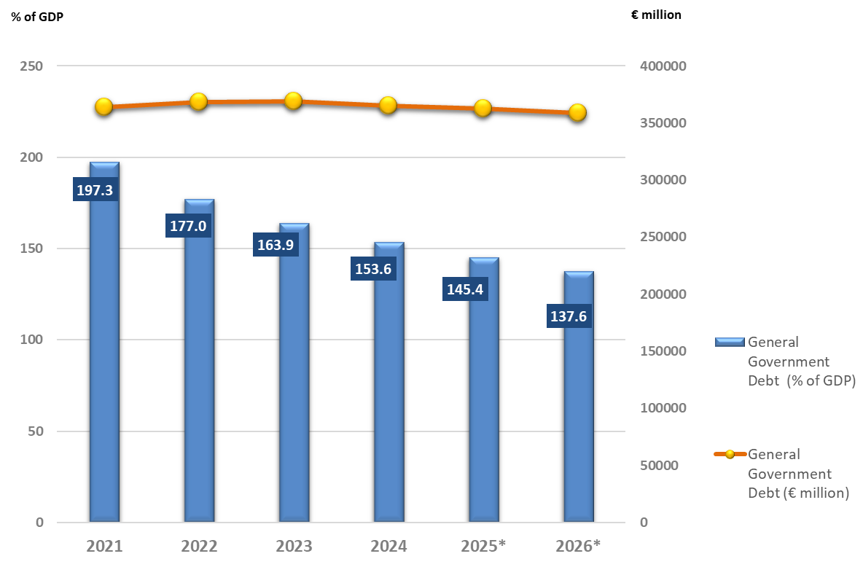
Figure 11 | General Government debt

* Projections

Expenditure and revenue projections

GG Revenue & expenditure
Table 5 below presents the outturn of 2024 and the current fiscal estimations for 2025 and 2026, broken down by main components of revenues and expenditures. The estimations incorporate the effect of all the fiscal interventions presented in the following sections. The general government revenue and expenditure projections at unchanged policies not including the policy measures adopted or announced after the submission of the Annual Progress Report 2025 submitted in April 2025, are presented in Table 18 of Annex II.
Table 5 | Budgetary projections
 | ESA Code | 2024 (Levels) | 2024 | 2025 | 2026
 |  | bn EUR | % GDP
Revenue
1. Taxes on production and imports | D.2 | 40.0 | 16.9 | 17.0 | 16.8
2. Current taxes on income,  wealth, etc. | D.5 | 26.4 | 11.1 | 10.7 | 10.6
3. Social contributions | D.61 | 31.5 | 13.3 | 13.0 | 12.9
4. Other current revenue | (P.11+P.12+P.131) + D.39 + D.4 + D.7 | 13.2 | 5.6 | 5.5 | 4.9
5. Capital taxes | D.91 | 0.3 | 0.1 | 0.1 | 0.1
6. Other capital revenue | D.92+D.99 | 6.0 | 2.5 | 2.9 | 4.3
7. Total revenue (= 1+2+3+4+5+6) | TR | 117.4 | 49.4 | 49.2 | 49.6
8. Of which: Transfers from the EU (accrued revenue, not cash) | D.7EU+D.9EU | 6.2 | 2.6 | 3.8 | 5.0
9. Total revenue other than transfers from the EU (= 7-8) |  | 111.2 | 46.8 | 45.4 | 44.6
10. p.m. Revenue measures (increments, excluding  EU funded measures) |  | 1.9 | 0.8 | 0.1 | -0.3
10b. p.m. Revenue reductions funded by transfers from the EU (levels) |  | 0.0 | 0.0 | 0.0 | 0.0
11. p.m. One-off revenue included in the projections (levels,  excluding EU funded measures) |  | 0.0 | 0.0 | 0.0 | 0.0
Expenditure
12. Compensation of employees | D.1 | 24.5 | 10.3 | 10.2 | 10.1
13. Intermediate consumption | P.2 | 12.3 | 5.2 | 5.6 | 5.4
14. Interest expenditure | D.41 | 8.2 | 3.5 | 3.0 | 2.9
15. Social benefits other  than social transfers in kind | D.62 | 39.6 | 16.7 | 16.9 | 16.8
16. Social transfers in kind  via market producers | D.632 | 6.4 | 2.7 | 2.4 | 2.3
17. Subsidies | D.3 | 3.4 | 1.4 | 1.3 | 1.3
18. Other current expenditure | D.29 + (D.4-D.41) + D.5 + D.7 + D.8 | 3.8 | 1.6 | 1.6 | 2.3
19. Gross fixed capital formation | P.51 | 8.8 | 3.7 | 5.7 | 6.9
20. Of which: Nationally financed public investment |  | 5.3 | 2.2 | 3.3 | 3.4
 | ESA Code | 2024 (Levels) | 2024 | 2025 | 2026
 |  | bn EUR | % GDP
21. Capital transfers | D.9 | 6.8 | 2.8 | 1.8 | 1.9
22. Other capital expenditure | P.52+P.53+NP | 0.4 | 0.2 | 0.0 | 0.0
23. Total expenditure  (=12+13+14+15+16+17+18+19+21+22) | TE | 114.2 | 48.1 | 48.5 | 49.8
24. Of which: Expenditure funded by transfers from the EU (= 8-10b) |  | 6.2 | 2.6 | 3.8 | 5.0
25. Nationally financed expenditure (23-24) |  | 108.0 | 45.5 | 44.8 | 44.8
26. p.m. National co-financing of programmes funded by the Union |  | 0.7 | 0.3 | 0.3 | 0.3
27. p.m. Cyclical component of unemployment benefits |  | 0.1 | 0.1 | 0.0 | 0.0
28. p.m. One-off expenditure included in the projections (levels, excluding EU funded measures) |  | 0.4 | 0.2 | 0.2 | 0.0
29. Net nationally financed primary expenditure (before revenue measures) (= 25-26-27-28-14) |  | 98.5 | 41.5 | 41.3 | 41.5
Net nationally financed primary expenditure |  |  | growth rate
30. Net nationally financed primary expenditure growth (growth rate) |  |  | -0.4 | 4.4 | 5.8
Balances |  | bn EUR | % of GDP
31. Net lending/borrowing (= 7-23) | B.9 | 3.2 | 1.3 | 0.6 | -0.1
Net lending/borrowing by subsector
31a. Central government | B.9 (S.1311) | 2.1 | 0.9 | -0.3 | -1.0
31b. State government | B.9 (S.1312) | - | - | - | -
31c. Local government | B.9 (S.1313) | 0.0 | 0.0 | 0.0 | 0.0
31d. Social security fund | B.9 (S.1314) | 1.1 | 0.5 | 0.8 | 0.8
32. Primary balance (= 31+14) | B.9+D.41p | 11.4 | 4.8 | 3.6 | 2.8
Cyclical adjustment
33. Structural balance |  |  | 0.6 | 0.0 | -0.9
34. Structural primary balance |  |  | 4.0 | 3.0 | 2.0
Debt
35. Gross debt |  | 364.9 | 153.6 | 145.4 | 137.6
36. Change in gross debt |  | -4.2 | -10.3 | -8.2 | -7.8
37. Contributions to changes in gross debt
38. Primary balance (= minus 32) |  |  | -4.8 | -3.6 | -2.8
39. Snowball effect |  |  | -5.2 | -4.4 | -3.4
40. Interest expenditure (= 14) |  |  | 3.5 | 3.0 | 2.9
41. Growth |  |  | -3.6 | -3.2 | -3.3
42. Inflation |  |  | -5.1 | -4.2 | -3.0
43. Stock-flow adjustment (= 36-38-39) |  |  | -0.3 | -0.2 | -1.6
 |  |  | %
44. p.m. Implicit interest rate on debt  (= 14 / DEBT(t-1)) |  |  | 2.2 | 2.1 | 2.1
Defence expenditure |  | bn EUR | % of GDP
45. Total defence expenditure | COFOG 2 | 5.3 | 2.2 | 2.3 | 2.6
46. Of which: Defence investment | COFOG 2, P.51g | 0.9 | 0.4 | 0.6 | 0.8

Discretionary measures
The fiscal interventions for 2026 include a series of reforms primarily aimed at boosting income and reducing the tax burden, particularly for the middle class, the families with children and the young people. The main interventions include:
- The structural reform of the income tax scale for employees, pensioners, farmers and self-employed individuals.
- The gradual elimination of the pensioners’ personal difference offset.
- The reform of the special wage grid of the Armed and Security Forces, as well as wage interventions for other employee categories.
- The gradual abolition of the property tax for small communities up to 1,500 residents.
- The 30% reduction of VAT on remote islands with population up to 20,000.
- The introduction of an intermediate 25% tax rate on income from real estate.
- The reform of the objective living expenses tax system.
The total cost of the new measures for 2026 amounts to €1.76 billion, with an additional cost of €0.7 billion for 2027.
In addition, a further increase of the private sector’s minimum wage is envisaged from April 2026, aiming to reach €950 in April 2027, from the current level of €880. This increase affects the unemployment benefits, the maternity allowances, the seniority allowances, the overtime compensation and the public sector wage grid.
Additional interventions include:
- The extension of the "Marietta Giannakou" program for the renovation and upgrading of school infrastructure, after the €300 million donation from the four systemic banks, raising the total budget to €650 million, aiming to implement projects in more than 2,500 school units.
- The establishment of 100% super tax deductions for investment expenditures in strategic sectors, such as defence and the construction of vehicles, aircraft and their components.
Table 6 below, presents the permanent fiscal interventions and their estimated fiscal impact for the years 2025-2026. The estimated incremental impact of the discretionary revenue measures for the period 2024-2026 is presented in Annex II.

Table 6 | Main permanent discretionary measures 2025-2026
(in million euros)
Description | 2025 | 2026
A. New Interventions
Reform of the income tax scale with emphasis on families with children, young people and the middle class | 0 | -1,218
Reduction of property income tax with the introduction of an intermediate rate of 25% (fiscal impact of 90 €million from 2027 onwards) | 0 | 0
Gradual abolition of property tax (ENFIA) for main residences in communities with a population up to 1,500 inhabitants  (50% reduction in 2026 and full abolition in 2027) | 0 | -38
Reform of the objective living expenses tax system | 0 | -40
Gradual elimination of the pensioners’ personal difference offset | 0 | -75
Reduction of VAT by 30% on remote islands with population up to 20,000 inhabitants | 0 | -25
50% reduction of the objective income for self-employed for communities outside Attica, with population up to 1,500 residents and exemption for self-employed new mothers during the year of childbirth and for the following two years | 0 | -10
Reform of the wage grid of the Armed Forces | -41 | -162
Savings from the restructuring of the Armed Forces | 19 | 77
Increase of the soldiers compensation | 0 | -25
Reform of the wage grid of the security forces  (Police, Fire Brigade, Coast Guard) | -32 | -127
Reform of the compensation of Ministry of Foreign Affairs employees | 0 | -30
Wage increase for graduates of Polytechnic and other University Schools offering a five-year programme of studies | 0 | -7
Introduction of a tax exemption for the academic library allowance of faculty members and researchers | 0 | -6
Exemption from income tax for foundations and legacies  (fiscal impact of 43 €million from 2027 onwards) | 0 | 0
Innovation Fund for Pharmaceuticals | 0 | -50
Abolition of the cable tv fee | 0 | -22
A. Total | -53 | -1,758
B. Interventions included in the Annual Progress Report 2025 | 2025 | 2026
Return of one rent annually with income and property criteria | -230 | -230
Social benefit of €250 to low income pensioners, uninsured elderlies and beneficiaries of disability allowances | -360 | -360
Increase of the national Public Investment Budget | -500 | -500
Extension beyond 2025 of the annual increase of the pharmaceutical expenditure ceiling by €100 million | 0 | -100
Increase of the healthcare expenditure ceiling for diagnostic centers and private clinics | -35 | -35
Distribution of high-cost medicines through private pharmacies | -12 | -12
Hazardous allowance of €100 per month for uniformed personnel | -111 | -222
Extension of the exemption from pharmaceutical expenditure to low-income pensioners | -23 | -23
Non-offsetting of the "personal difference" for public sector employees | -12 | -17
Abolition of age restrictions for the granting of the deafness - severe hearing loss allowance | -4 | -4
Extension of the income tax reduction for building upgrade expenses for the years 2025 and 2026 | -5 | -5
Horizontal increase of the public sector wages so as to maintain the basic salary equal to the minimum wage | -215 | -572
Increase of pensions based on GDP growth and inflation | -474 | -1,028
Reduction of social security contributions by one pp from January 2025 | -448 | -448
Abolition of the overhead tax for self-employed from 2025, following the 50% reduction in 2024 | -125 | -144
20% reduction of property tax (ENFIA) for residences insured against natural disasters | -21 | -41
Permanent return of the special levy on diesel to farmers with a new system | -100 | -100
Decrease in taxation of overtime compensation for hospital doctors | -40 | -40
Reduction of the digital fee for several transactions | -32 | -32
Incentives for innovation, mergers and acquisitions | -41 | -41
Abolition of telecommunication fee (5%) for fiber optic connections  (≥100 mbps) | -24 | -24
Abolishment of the insurance levy (15%) for private healthcare contracts for children up to the age of 18 | -17 | -17
Tax exemption for voluntary benefits from employers to support new parents | -6 | -6
Income tax exemption for vacant or short-term rental properties that will be rented on a long-term lease (extension for the year 2026) | -3 | -13
Extension for 2026 of VAT exemption on new buildings | -18 | -18
Incentive to attract doctors to remote and problematic regions | -16 | -16
Increase of the nightshifts compensation by 20% for uniformed personnel starting from January 2025 | -25 | -25
Increase of the student housing benefit for regional universities | -15 | -15
Increase in the remuneration of military academy students | -14 | -14
Reform of the performance based bonus system in the public sector | -20 | -40
Reform of the hazardous and unhealthy work allowance for local governments employees | -37 | -37
B. Total | -2,983 | -4,179
Grand Total (A+B) | -3,036 | -5,937
Tax reform
Specifically, the reform of the income tax scale includes the following:
- The reduction of tax rates by 2% for income between €10,000 and €40,000;
- the introduction of a new tax bracket with 39% rate (from 44%) for income between €40,000 and €60,000;
- the 20% tax rate for income from €10,000 to €20,000, applicable to tax payers without children, is further reduced depending on the number of children, to 18% for individuals with one child, 16% with two children and 9% with three children;
- for taxpayers with four of more children, the tax on income up to €20,000 is reduced to zero;
- the new rate for income from €20,000 to €30,000 (26%), is further reduced by 2 pp for each child;
- zero taxation for income up to €20,000 for young people up to 25 years old;
- reduced tax rate 9% for income from €10,000 to €20,000 for young people aged from 26 to 30 years old.
The fiscal cost of the personal income tax reform is estimated at €1.2 billion for 2026 and €1.6 billion for 2027 and approximately 4 million taxpayers will benefit from the reform.
Interventions to strengthen pensioners’ disposable income
The interventions implemented during 2025, include:
- Pension increases by 2.4%, based on the existing indexation rule, with a cost of €474 million;
- the extension of the exemption from pharmaceutical expenses for low-income pensioners;
- the new permanent social benefit of €250 to be disbursed every year in November -based on social criteria- to pensioners over 65 years old with low-income, to uninsured elderlies and to beneficiaries of disability allowances, with an annual cost of €360 million.
The new measures for pensioners, in addition to the benefits from the tax reform and the new social benefit of €250, which will be implemented from 2026, include:
- Further pension increases, based on the indexation rule of GDP and inflation;
- the gradual elimination of the pensioners’ personal difference offset. Approximately 671,000 pensioners are estimated to benefit from this measure.
The total cost of the two above interventions is estimated at €629 million for 2026.
Interventions to strengthen public sector employees’ disposable income
During 2025, the following measures were implemented:
- The establishment of an annual horizontal increase in the public sector wages, linked to the adjustment of the minimum wage, with a cost amounting to €215 million for 2025;
- the decrease in taxation for the overtime compensation of hospital doctors, with a cost of €40 million;
- the reduction of social security contributions by one (1) pp for public sector employees, with a cost of €83 million;
- the complete or partial abolition of the “personal difference” offsetting, in the wage evolution of public sector employees, with an annual cost of €12 million, increasing by €5 million per year;
- the increase of the bonus based on performance and quantifiable targets, with an annual cost of €40 million;
- the increase of the compensation of nightshifts for police, fire brigade, coast guard and military personnel, with an annual cost of €25 million;
- the introduction of a hazardous allowance of €100 per month for the Armed and Security Forces personnel, with an estimated total cost of €111 million for 2025 and €222 million for 2026.
For 2026, in addition to the benefits of the public sector employees from the tax reform, the following interventions amounting to €613 million will apply:
- Horizontal wage increases as of April 2026, in line with the adjustment of the minimum wage, with an estimated cost of approximately €358 million;
- reform of the wage grid of the Armed Forces, with wage increases effective from October 2025, with an annual cost of €162 million (net cost of €85 million after the restructuring of the Armed Forces’ organisational structure) and of the Security Corps (Hellenic Police, Fire Brigade, Hellenic Coast Guard), with an annual cost of €127 million;
- increases in the foreign service allowance, the special duties allowance and the reimbursement of tuition fees for the children of Ministry of Foreign Affairs staff, with an annual cost of €30 million;
- wage increase for graduates of Polytechnic and other University Schools offering a five-year programme of studies, with a cost of €7 million;
- introduction of a tax exemption for the academic library allowance of faculty members and researchers, with an annual cost of approximately €6 million.
Interventions to address housing needs
The following measures were implemented during 2025:
- The launch of the new “My Home II” programme, that provides low-interest housing loans, with a total budget of €2 billion, including broader age and income eligibility criteria compared to the initial “My Home” scheme;
- income tax exemption for three years on rents for properties that will be converted to long term rental, from being vacant or on a short-term lease;
- the suspension of new property registrations for short-term rentals in the central districts of Athens (1st, 2nd, and 3rd municipal districts) for 2025;
- the increase of the climate resilience levy for short-term rentals;
- the doubling of the maximum subsidy of the “Renovate-Rent” programme;
- the annual refund, as of November 2025, of one month’s rent to eligible tenants (for main and for student residences), based on income and property criteria, covering approximately 80% of total tenants, with an annual cost of €230 million.
For 2026, the new housing interventions include:
- The extension, for 2026, of the three-year income tax exemption for vacant properties to be made available for long-term leasing, with a cost of €13 million for 2026 and €22 million for 2027;
- the introduction, from 2026, of an intermediate income tax rate of 25% (reduced from 35%) for rental income between €12,000 and €24,000. This measure is expected to benefit approximately 161,000 property owners, to contribute to improved tax compliance, and to help contain rental prices. The estimated fiscal cost is €90 million per year;
- the extension of the suspension of VAT on new buildings until the end of 2026, with an annual cost of €18 million.
- the extension of the income tax reduction for building renovation expenses for 2025 and 2026, with an estimated cost of €5 million;
- the continuation of the restriction on new short-term rentals in the three specific districts of central Athens for 2026;
- the establishment of a new framework for the utilisation of public real estate to construct social housing, with the aim of ensuring affordable social leases for vulnerable groups of citizens.
Other tax interventions
From 2026, the property tax (ENFIA) will be reduced by 50%, while from 2027 onwards, the tax will be fully abolished for primary residences located in regions with population of up to 1,500 inhabitants, excluding regions in Attica . The measure concerns approximately one million properties across 12,720 communities (out of a total of 13,586 nationwide), with an annual cost of approximately €75 million. It should be noted that decentralisation is directly linked to addressing the housing needs, as described above.
From January 2026, VAT will be reduced by 30% in the islands of the North Aegean Region, the Prefecture of Evros (Samothraki) and the Prefecture of Dodecanese with a population of up to 20,000 inhabitants. The annual fiscal cost of this measure is estimated at €25 million, aiming to support residential and business activity in these areas.
In addition, the objective living expenses tax system will be reformed, aiming to reduce the tax burden for approximately 477,000 taxpayers, with an annual cost of 40 million euros.
Interventions to boost and facilitate investments
The main interventions, aiming to strengthen private investments, include:
- Increase of the national Public Investment Budget by €500 million on a permanent basis from 2025, amounting to €3.3 billion in total in 2026;
- super tax deductions for investment expenses aiming to boost private investments in key industrial sectors. In this regard, spending on strategic sectors such as defence and the manufacturing of vehicles, aircraft and their components will be deductible from companies’ gross income, increased by 100%. This measure applies to investments during 2026 - 2028, with a total tax deduction amounting to €150 million;
- a €200 million program under the NSRF 2021-2027, to enhance the competitiveness and extroversion of small and medium-sized enterprises in the manufacturing and services sectors;
- a targeted €50 million program for sectors with deficits in the trade balance;
- a €70 million project to support self-employment of graduates interested in developing new business activities;
- funding for companies investing in development and/or production of digital technologies, biotechnology, and clean, efficient technologies, with a budget of €50 million (European STEP initiative);
- the increase by €300 million of the InvestEU guarantee program, under the Recovery and Resilience Facility (RRF), to support SMEs and mobilize loans amounting to €3.6 billion, which will support at least 25,000 SMEs across the country;
- increase of the Portfolio Fund of TEPIX III via the Hellenic Development Bank (HDB), with an additional €780 million for SME business loans;
- establishment of new funds in 2026, such as the Agricultural Entrepreneurship Fund (up to €170 million), the DeLFI Plus Guarantee Fund (up to €500 million) and the Patent Fund (€41.4 million) to support patent protection.
Other Interventions
The additional interventions implemented in 2025 to strengthen disposable income include:
- Reduction of social security contributions by one pp;
- abolition of the self-employed overhead tax from 2025, following the 50% reduction that took place in 2024;
- return of the special levy on diesel for farmers on a permanent basis, with the establishment of a new system based on actual consumption;
- reduction of the digital transaction fee for a range of transactions;
- abolishment of the 5% telecommunication fee for fiber-optic connections;
- abolishment of the 15% insurance levy on private healthcare contracts for children up to 18 years old;
- tax reliefs for benefits provided voluntarily by employers to new parents;
- incentives to attract doctors in remote and problematic areas;
- increase of student housing allowance in regional universities;
- increase of compensation for students of military academies;
- reform of the hazardous and unhealthy work allowance for local governments employees;
- reduction of banking fees;
- doubling of income eligibility criteria for the out-of-court debt settlement mechanism, and
- reduction of social security contributions for overtimes and night shifts work during public holidays or Sundays for full-time employees.
For 2026, other interventions include:
- Launch, from January 2026, of a fund for pharmaceutical innovation, with an annual cost of €50 million, to facilitate patient access to innovative treatments;
- exemption from income tax for charitable foundations, with an annual fiscal cost of €43 million, starting from the 2026 tax year;
- abolition, from January 2026, of the 10% fee on cable TV subscriptions, with an annual fiscal cost of €22 million;
- extension of the reduction of the objective income for self-employed for communities outside Attica, with population up to 1,500 residents, as well as exemption from the objective income for new mothers practicing a freelance profession during the year of childbirth and for the following two years.

National Recovery & Resilience Plan (NRRP)
Following the revision of Greece’s NRRP in December 2023, the available resources amount to €35.9 billion, of which grants are estimated at €18.2 billion and loans up to €17.7 billion to support investments and reforms.
Greece has so far received €21.3 billion of RRF funds, corresponding to the first five payment requests, out of which €9.9 billion are grants and €11.4 billion loans. A further €2.1 billion of grant is expected to be disbursed by the end of 2025, given the completion of the assessment of the 6th payment request for grants by the Commission, bringing total disbursements to the country to €23.4 billion and the disbursement rate to 65% of the total budget.
As regards the use of funds, until September 2025, €11.22 billion of grants were transferred to entities inside and outside the general government and final recipients for approved RRF projects. Approximately 855 projects, with a total budget of €24.7 billion including VAT, have already been approved and included in the Public Investments Program.
The approved projects include, inter alia: energy renovation of residential buildings, island electrical interconnections, energy storage investments, motorways construction, micro-satellite network development, implementation of the national public health secondary prevention program, implementation of the strategy for excellence in universities and innovation and many others.

Table 7 | RRF grants (% of GDP)
 | 2021 | 2022 | 2023 | 2024 | 2025 | 2026
Revenue from RRF grants
1. RRF grants as included in the revenue projections | 0.2 | 0.4 | 0.7 | 1.0 | 1.9 | 3.2
2. Cash disbursements of RRF grants from EU | 1.3 | 0.8 | 1.5 | 0.5 | 1.4 | 2.4
Expenditure financed by RRF grants
3. Total current expenditure | 0.1 | 0.0 | 0.2 | 0.2 | 0.5 | 0.5
4. Gross fixed capital formation | 0.1 | 0.3 | 0.2 | 0.6 | 0.9 | 1.9
5. Other capital expenditure | 0.0 | 0.1 | 0.3 | 0.3 | 0.5 | 0.8
6. Total capital expenditure (= 4+5) | 0.1 | 0.4 | 0.5 | 0.8 | 1.4 | 2.7
Other costs financed by RRF grants
7. Reduction in tax revenue
8. Other costs with impact on revenue
9. Financial transactions
In the loan facility, which mainly concerns the granting of loans through the commercial banks and International Financial Institutions for the implementation of investment projects in 5 strategic pillars by private businesses, 532 loan agreements have been signed so far (Oct 2025), with a total budget of €17.58 billion (out of which: €7.71 billion RRF loans, €5.80 billion bank loans and €4.07 billion investors’ own resources).
Moreover, Greece has allocated an amount of up to €0.4 billion of RRF loans to the European Investment Fund for the implementation of selected guarantee instruments under the Member State Compartment of InvestEU. Guarantee products are now available for the Greek SMEs providing them access to investment loans and working capital.
Also, following the latest revision of Greece’s NRRP in January 2025, the loan component has been enriched with two new measures of a total RRF budget of €1.3 billion, the «My Home II" measure which provides loan support to individuals or families with low income for the acquisition of their primary residence (€1 billion RRF funds) and the "Upgrade My Home" measure providing loan support to individuals for energy upgrades to their residential properties (€0.3 billion RRF funds). So far (Oct 2025), RRF loans contracted amount to €303.3 million under «My Home II" measure and at €39.2 million under "Upgrade My Home" measure.
Table 8 | RRF loans (% of GDP)
 | 2021 | 2022 | 2023 | 2024 | 2025 | 2026
Revenue from RRF loans
1. Disbursements of RRF loans from EU | 0.9 | 0.9 | 1.7 | 1.0 | 0.7 | 2.4
2. Repayment of RRF loans to EU
Expenditure financed by RRF loans
3. Total current expenditure | 0.0 | 0.0 | 0.0 | 0.0 | 0.0 | 0.1
4. Gross fixed capital formation
5. Other capital expenditure
6. Total capital expenditure (4+5)
Other costs financed by RRF loans
7. Reduction in tax revenue
8. Other costs with impact on revenue
9. Financial transactions | 0.0 | 0.1 | 0.4 | 0.7 | 1.1 | 1.7

Distributional impact of the main revenue and expenditure measures

Methodology
The distributional impact of budgetary interventions is estimated using the EUROMOD tax-benefit microsimulation model for Greece, on which the new measures are simulated. The input data are drawn from the 2022 Greek SILC survey (incomes 2021), adjusted with relative uprating factors for all the following years and all types of income. The sample comprises 22,142 individuals, corresponding to 10,202 households. When applying survey weights, the simulated population corresponds to 10,306,111 individuals and 4,077,884 households.
It should be noted that the simulated policies concern personal income taxes, cash benefits, and social security contributions, and only first-round effects are estimated. Policies that do not directly affect household income, such as changes in corporate taxation, are not included. Similarly, measures affecting consumption or liquidity, such as VAT rates changes, suspension of tax or loan payments, or energy subsidies, are not simulated.
To assess the impact of the permanent measures scheduled for implementation at the end of 2025 —namely, the Housing Allowance Refund and the lump-sum support to vulnerable groups— two alternative scenarios were simulated for 2025. Scenario 1 (2025_base) excludes these measures from the estimations, while Scenario 2 (2025_ref) incorporates them, providing a comprehensive assessment of their effects on the overall projections. To capture the impact of these policies over time, the analysis compares the results of the 2026_ref scenario, which incorporates the full set of policies, with both 2025_base and 2025_ref, allowing for a clear disentanglement of the effects of the individual measures over the two-year period.
The scenarios simulated are presented in Table 9 as follows:
Table 9 | Scenarios simulated for distributional analysis
Scenario | Measures
2025_ref | On top of 2025_base:
2025_ref | 1. Introduce a new policy for the Housing Allowance Refund.
2025_ref | 2. Introduce a lump sum support to vulnerable groups, in particular: (i) disability benefit recipients, (ii) uninsured-elderly benefit recipients, (iii) low-income pensioners.
2026_ref | On top of scenario 2025_ref:
2026_ref | - Apply the new tax schedule for Personal Income Tax (PIT).
2026_ref | - Apply the new tax schedule for Property Income of the PIT.
2026_ref | - Increase pensions on basis of GDP and inflation, as well as increase each band of the Special Solidarity Contribution by the forecasted pension increment (2.4%).
2026_ref | 4. Increase of the minimum wage and the associated unemployment and other benefits (estimation on the hypothesis of 4.5% increase).
2026_ref | 5. Increase monthly salaries for civil servants (in line with the minimum wage increase).

Results
Table 10 presents the mean annual equivalized disposable income (in euros) by decile for the 2025_base scenario, along with the relative and absolute changes observed in the simulated scenarios (2025_ref and 2026_ref) as a result of the fiscal interventions. Disposable income refers to the income available to individuals for consumption or savings, after deduction of direct taxes and social security contributions and the addition of cash transfers, including pensions and benefits. Equivalized income assumes that all household resources are pooled and distributed according to the OECD equivalence scale, which assigns a weight of 1 to the first adult, 0.5 to each additional adult, and 0.3 to children under 14.
Table 10 | Mean annual equivalised disposable income (EUR), relative and absolute changes
Decile | 2025_base | 2025_ref |  | 2026_ref
Decile | Mean  (EUR) | Absolute change (EUR) | Relative change | Absolute change (EUR) | Relative change
1 | 3,959 | 75 | 1.88% | 152 | 3.83%
2 | 6,397 | 96 | 1.50% | 258 | 4.03%
3 | 7,805 | 108 | 1.39% | 363 | 4.65%
4 | 9,150 | 106 | 1.15% | 396 | 4.33%
5 | 10,494 | 94 | 0.89% | 496 | 4.72%
6 | 11,902 | 96 | 0.80% | 493 | 4.14%
7 | 13,599 | 89 | 0.66% | 606 | 4.46%
8 | 15,671 | 72 | 0.46% | 726 | 4.64%
9 | 18,785 | 34 | 0.18% | 794 | 4.23%
10 | 31,055 | 11 | 0.04% | 1520 | 4.90%
All | 11,791 | 78 | 0.61% | 580 | 4.51%
Notes:
Changes are calculated with respect to the 2025_base mean equivalised income per decile.
The equivalised income is calculated using the OECD equivalent scales that give weights 1 to the first adult, 0.5 to other adults in the household and 0.3 to children under 14.
Table 11 presents the Average Tax Burden, calculated as the ratio of total direct taxes and social insurance contributions paid by households to the sum of their original income and cash social benefits. This indicator reflects the proportion of households’ gross resources —comprising market income and transfer income— absorbed by the tax and social contribution system. It provides a consistent measure of the overall level of taxation and social contribution liabilities relative to households pre-tax and pre-contribution income, prior to the calculation of disposable income.

Table 11 | Average tax burden (%), relative changes
Decile | 2025_base | 2025_ref | 2026_ref
Decile | Average Tax Burden | Relative change (pp) | Relative change (pp)
1 | 17.9% | -0.3 | -0.2
2 | 15.3% | -0.2 | -0.2
3 | 15.8% | -0.2 | -0.5
4 | 16.2% | -0.2 | -0.4
5 | 17.0% | -0.1 | -0.7
6 | 17.8% | -0.1 | -0.4
7 | 19.0% | -0.1 | -0.6
8 | 20.3% | -0.1 | -0.8
9 | 21.8% | 0.0 | -0.8
10 | 27.6% | 0.0 | -1.2
All | 21.0% | -0.1 | -0.7
Notes:
Changes are calculated with respect to the 2025_base in percentage points (pp).
An increase indicates a higher share of pre-tax, pre-transfer resources allocated to taxes and contributions, while a decrease reflects a relative reduction in the overall tax and contribution pressure. Decreases may be attributed either to decrease or nominator or increase in the denominator as in the case of scenario (2025_ref).
Table 12 presents the main inequality indices, calculated on the income distribution of the 2025_base scenario, along with the corresponding absolute differences observed under the two reform scenarios.
Table 12 | Inequality indices
 |  | Absolute difference with respect to 2025_base | Absolute difference with respect to 2025_base
 | 2025_base | 2025_ref | 2026_ref
Gini | 0.306 | -0.003 | 0.001
S80/S20 | 4.803 | -0.073 | 0.036
S90/S10 | 7.800 | -0.150 | 0.070
Atkinson 0.25 | 0.041 | -0.001 | 0.000
Atkinson 0.75 | 0.1178 | -0.002 | 0.001
Notes:
- Gini coefficient ranges between 0 (all incomes are equal) and 1 (only one person has all income). It is more sensitive to changes in the middle of the income distribution.
- S80/S20 (S90/S10) ratio is the ratio of the mean equivalised disposable income received by the 20% (10%) of the population with the highest income to that received by the 20% (10%) of the population with the lowest income.
- Atkinson indices range between 0 (all incomes are equal) and 1 (only one person has all income). Atkinson 0.25 is more sensitive to changes at the top of the income distribution, while Atkinson 0.75 is more sensitive to changes at the bottom of the income distribution.
Table 13, Table 14 and Table 15 present the main poverty indices used to depict the aggregate level of poverty in the economy, with respect to both the number of individuals below the poverty line (headcount ratio) and the depth of poverty (poverty gap). Specifically, FGT(0) corresponds to the headcount ratio and measures the share of individuals whose equivalized disposable income falls below 60% of the median equivalized disposable income. When the anchored poverty line is applied (Table 13), the absolute effect of the reforms can be assessed relative to the previous year. In contrast, when a floating poverty line is used (Table 15), the results account for changes in the poverty line itself, meaning that individuals may change their poverty status due to shifts in the threshold in addition to changes in their income. Results are presented for the total population, as well as disaggregated by age group and household type.
FGT(1), shown in Table 14, represents the poverty gap index, defined as the average difference between individual incomes and the 60% poverty line, expressed as a percentage of the poverty line, and calculated only for individuals whose incomes fall below the poverty threshold.
Table 13 | FGT(0) poverty headcount index (anchored poverty line)
 |  | Absolute difference with respect to 2025_base (pp)
 | 2025_base | 2025_ref | 2026_ref
Total Population | 16.9% | -0.6 | -1.8
By age group
0-14 | 18.4% | -0.1 | -2.0
15-24 | 22% | -0.4 | -2.2
25-49 | 15.7% | -0.3 | -1.4
50-64 | 16.3% | -0.1 | -0.8
65-79 | 14.8% | -1.5 | -2.2
80+ | 19% | -2.2 | -4.0
By household type
One adult <65, no children | 19.4% | -0.7 | -1.2
One adult ≥65, no children | 24.8% | -3.5 | -5.5
One adult with children | 32.6% | -0.5 | -1.0
Two adults, <65, no children | 13.7% | 0.0 | -0.6
Two adults, at least one ≥65, no children | 13.5% | -1.4 | -2.1
Two adults with one child | 13.9% | -0.2 | -1.6
Two adults with two children | 15% | -0.4 | -1.5
Two adults with three or more children | 24.8% | 0.0 | -3.3
Three or more adults, no children | 14.8% | -0.1 | -1.1
Three or more adults with children | 22.6% | -0.6 | -2.0
Notes:
Poverty line is anchored to the base scenario: €6,707.33 per year.
Table 14 | FGT(1) poverty gap (anchored poverty line)
 |  | Absolute difference with respect to 2025_base (pp)
 | 2025_base | 2025_ref | 2026_ref
Total Population | 4.70 % | -0.2 | -0.4
Notes:
Poverty line is anchored to the base scenario: €6,707.33 per year
Table 15 | FGT(0) poverty headcount index (floating poverty line)
 |  | Absolute difference with respect to 2025_base (pp)
 | 2025_base | 2025_ref | 2026_ref
Total Population | 16.9 | -0.3 | -0.2
Notes:
- Poverty line in floating: €6,707.33 for 2025, €6,751.48 for scenario 1 of 2025 and €6,980.69 for scenario 2 of 2025.
- FGT (0) is the headcount ratio and shows % of individuals whose income is below 60% of the median equivalised disposable income.
- FGT (1) is the poverty gap index and calculates the average of the differences between individual incomes and the 60% poverty line, expressed as a % of the poverty line, and calculated only for those below the poverty line.

Country Specific Recommendations 2025
CSR 1
Reinforce overall defence and security spending and readiness while ensuring debt sustainability in line with the European Council conclusions of 6 March 2025. Adhere to the maximum growth rates of net expenditure recommended by the Council on 21 January 2025, while making use of the allowance under the national escape clause for higher defence expenditure. Continue efforts to improve tax compliance, including through further centralisation and digitalisation of customs and tax inspections and improve the tax system’s predictability. Further improve the effectiveness and efficiency of its public administration by fully implementing the multi-level governance framework. Pursue the ongoing reduction of the stock of non-performing loans held by banks and credit servicers by accelerating liquidation-related court proceedings.
Regarding defence expenditure, Greece estimates that the increase in total defence expenditure as a ratio to GDP from 2024 to 2025 will reach 0.1 pp, while the increase from 2024 to 2026 will be 0.3 pp. The net expenditure for 2025 and 2026 is estimated to grow by 4.4% and 5.8% on an annual basis, respectively. The cumulative growth in the years 2024-2026 taken together, does not exceed the relevant Council recommendation, while it stands 0.3% of GDP below the maximum growth rate recommended, taking into account the flexibility provided by the activation of the escape clause for higher defence expenditure.
Concerning the improvement of tax compliance, including through further centralisation and digitalisation of customs and tax inspections and improve the tax system’s predictability, for the reference period, the actions of the Ministry of Economy and Finance and the Independent Authority for Public Revenue (IAPR) include the establishment of mandatory electronic invoicing from 01/09/2025 for all B2G transactions, with minor exceptions due to intrinsic transactive characteristics (confidential transactions, etc.), along with the digital submission of delivery notes. The interconnection of POS systems with business cash registers and the digital customer registry in the vehicle sector were also completed. In addition, the submission period for VAT returns (monthly) was amended for newly established businesses with a simplified accounting system, applicable for the first two years of operation.
In order to accelerate the centralization of tax and customs audits, 2025 saw the completion of the establishment of the Customs Audit Center (TEK) of Attica, along with the merger of the three Piraeus Customs Offices and the launch of the Large Taxpayers Audit Center (KEMEF), formed through the merger of the Large Enterprises Audit Center (KEMEEP) and the High-Wealth Individuals Audit Center (KEFOMEP).
In the context of combating smuggling, an integrated Management Information System (MIS) was developed for the utilization of data from the Inflow-Outflow Systems to counter fuel smuggling, leveraging Artificial Intelligence technologies and hence expanding digitalisation. The digital application for the Register of Fuel Station Tanks for public-use fuel stations and Heating Oil Sellers’ Facilities was launched, as well as the “Unified Central Register of the Tobacco Supply Chain and Manufactured Tobacco Products” (EKMEA) —a new digital registry application of IAPR for tobacco products. Moreover, interoperability between the Customs Information System (ICISnet) and the EU Single Window - Certificates Exchange Platform (EU CSW-CERTEX) for pre-customs procedures was implemented.
Moreover, the Directive (EU) 2022/2523 was transposed through law 5100/2024, ensuring a global minimum level of taxation for multinational enterprise groups and large-scale domestic groups in the EU (Pillar II), through which Greece has aligned the income taxation of multinational and large domestic groups with the requirements of Directive (EU) 2022/2523, harmonizing its tax regime with modern international standards, with the aim of preventing multinational enterprises from shifting profits to low-tax jurisdictions.
Furthermore the Council Directive (EU) 2022/542 regarding value-added tax (VAT) rates and the common VAT system for small enterprises was transposed through Law 5222/2025. Also, in the context of negotiations on the “VAT in the Digital Age” (ViDA) package, the Council Directive (EU) 2025/516 was adopted and published on 11 March 2025. This Directive amends the VAT Directive 2006/112/EC concerning:
- Digital Reporting Requirements (DRR),
- Platform Economy (covering short-term accommodation rentals and passenger transport), and
- Single VAT Registration.
At the same time, Regulation (EU) 2025/517 was also adopted and published, amending Regulation (EU) 904/2010 to enhance administrative cooperation and ensure the proper implementation of VAT rules in the digital age.
Actions planned for the upcoming period include the expansion of mandatory electronic invoicing to all businesses, the digital submission of delivery notes to additional market sectors, and the implementation of the Digital Customer Registry in the events sector. In addition, the development of the new digital platform MIDA is underway within IAPR and expected to be completed. The platform will consolidate data on property ownership and usage for each taxpayer across the country. Furthermore, the development of an Advanced Business Intelligence (BI) and Data Analytics System is in progress, designed to analyze and predict non-compliance patterns, along with the establishment of a Compliance Risk Management (CRM) and Enterprise Risk Management (ERM) System for the recording, monitoring, and management of compliance and operational risks. Moreover, applications are being developed within IAPR to support the implementation of Law 5100/2024, “Transposition of Directive (EU) 2022/2523 on ensuring a global minimum level of taxation for multinational enterprise groups and large-scale domestic groups in the EU (Pillar II) and other provisions”.
In addition, the activities of the working group on the taxation, supervision, and regulatory framework for cryptocurrencies and digital assets is currently underway. In 2026, the development of an effective and equitable institutional framework for the taxation of cryptocurrencies will be completed, in line with the European legislative framework for capital markets.
Finally, a law establishing procedures for the issuance of advance tax rulings is expected to be adopted the upcoming months. This reform aims to allow businesses to obtain preliminary clarifications on the tax treatment of specific transactions or business structures, thereby reducing tax uncertainty. It is also expected to strengthen investor confidence and to create a stable and predictable environment, which is crucial for economic growth and the attraction of new investments.
With respect to the Multi-Level Governance (MLG) framework, the Ministry of Interior has focused during the period Q3 2024-Q3 2025 on developing the necessary tools and infrastructures to ensure its operational application across all levels of public administration. In this context, the first phase of the Information System for Multi-Level Governance (IS MLG) (RRF) was completed, enabling more than 2,500 public bodies to digitize and record their competences and the relevant regulatory framework. At the same time, critical preparatory measures were undertaken, including the system’s interoperability with G-Cloud services, the establishment of technical support arrangements, and the development of a Data Protection Impact Assessment (DPIA). A detailed methodological framework for the reallocation of competences across policy areas was elaborated, while the second phase of the IS MLG (RRF) –focusing on the digitization of resources (human, material and infrastructure)– has been launched. In parallel, preparatory work for the MLG Strategy 2030 was initiated, setting the long-term direction for further strengthening governance effectiveness and inter-institutional cooperation. For the forthcoming period, in 2026, the Ministry is advancing the operational specialization and comprehensive implementation of the framework. Key initiatives include the development of an AI-based tool to automatically identify and integrate the competences of public bodies into the IS MLG, the enhancement of interoperability through interconnection with the “MITOS” system documenting administrative processes, as well as the introduction of traceability functions for public sector equipment, using QR code technology. Through these actions, the Ministry of Interior ensures the transition from institutionalization to a holistic and practical application of the MLG system, turning it into a concrete tool for more effective policy-making and reinforced cooperation across all levels of governance.

CSR 2
In view of the applicable deadlines for the timely completion of reforms and investments under Regulation (EU) 2021/241, accelerate implementation of the recovery and resilience plan, including the REPowerEU chapter. Accelerate the implementation of cohesion policy programmes (ERDF, JTF, ESF+, CF), building, where appropriate, on the opportunities offered by the mid-term review. Make optimal use of EU instruments, including the opportunities provided by the InvestEU programme and the Strategic Technologies for Europe Platform, to improve competitiveness.
Policies adopted by the Ministry of Economy and Finance to accelerate the implementation of development and cohesion policy programmes include the enactment of law 5322/2025, which contributes directly to the acceleration of programme implementation by strengthening the administrative capacity and operational efficiency of authorities involved in the management of development programmes. The law streamlines procedures, enhances coordination between managing bodies, and facilitates faster decision-making and fund absorption.
In parallel, the Managing Authority for the Just Transition Development Programme has carried out a needs assessment in the intervention areas, financed by the Programme, in close cooperation with competent bodies and beneficiaries. Regional Territorial Committees have also been established, serving in an advisory and consultative capacity to the governance structures of the Just Transition Programme and its Monitoring Committee, ensuring strong local engagement and coordination for the timely implementation of projects.
Planned policies to further accelerate the implementation of cohesion policy programmes include targeted capacity-building initiatives to strengthen the administrative and managerial capabilities of beneficiaries under the NSRF 2021-2027. A second revision of the NSRF programmes is also underway in 2025 to integrate new strategic priorities, such as strengthening competitiveness and economic decarbonisation, supporting defence and security, promoting affordable and sustainable housing, ensuring safe and sustainable water management, and accelerating the energy transition. The mid-term review of the programmes is expected to be submitted by 31 December 2025.
Under the Just Transition Development Programme, the Managing Authority aims to finalise the specification of the majority of actions by the end of 2025 and continues to provide technical assistance and capacity-building support to beneficiaries. Coordination is being reinforced with regional programmes through the appointed Just Transition officer to ensure timely project maturity and launch. In addition, a second revision of the Programme is planned by end-2025 to take full advantage of the flexibilities provided by the revised EU regulations.
The Strategic Technologies for Europe Platform (STEP), the EU’s key instrument for fostering the development and production of critical technologies that strengthen Europe’s competitiveness and reduce strategic dependencies, has been integrated into the first intermediate revision of the NSRF programmes, completed on 31 March 2025. This integration covers the Competitiveness, Human Resources, Digital Transformation, Just Transition and Western Greece programmes. Within the Just Transition Fund, a new STEP priority of €80 million has already been established (€20 million for skills and €60 million for investments), while an additional €20 million will be allocated in the forthcoming revision.
CSR 3
Simplify regulation, improve regulatory tools and reduce administrative burden for companies by streamlining and digitalising administrative processes, completing the regulatory frameworks for environmental licensing and granting concession agreements on the seashore. Review and remove the high entry barriers to the exercise of professional services and to new entrants to product markets. Improve the governance of the national research, development and innovation system by reducing the fragmentation of research policy management and funding sources, and by facilitating access to finance for start-ups and scale-ups, including developing local private equity and venture capital markets with state-sponsored initiatives to mobilise investment. Streamline judicial proceedings and curtail their length by accelerating civil proceedings, adopting a code on alternative dispute resolution mechanisms, further revising the code of judges, and continuing efforts to accelerate the judicial resolution of disputes related to public procurement.
The Ministry of Economy and Finance is facilitating access to finance for start-ups and scale-ups through projects implemented under the ERDF, CF and ESF+ programmes. These include the development of Technology Transfer Office networks across universities and research centres, promoting the commercial exploitation of research results produced by public research organisations. A call is also under preparation for the creation and reinforcement of Competence Centres, equipped with the necessary infrastructure and expertise to support innovation in key sectors of the Greek economy. The Centres will provide specialised services and promote technology transfer to enterprises, particularly SMEs, thereby enhancing access to finance and mobilising private investment for innovative businesses.
The Hellenic Development Bank (HDB) has implemented a series of initiatives to enhance access to finance and support entrepreneurship. These include the launch of the HDB Academy, a digital knowledge platform for Small and Medium-sized Enterprises (SMEs), providing educational content, practical tools, and diagnostic instruments. The Bank has also proceeded with the separate activation of the Microfinance Fund under the TEPIX III programme, aimed at the co-financing of microloans through Microfinance Institutions for very small entities—often newly established enterprises that had not previously received financing. In parallel, the Microloan Fund for Recovery from Natural Disasters was implemented, targeting very small and small enterprises in the Region of Thessaly to support their recovery from the adverse impacts of recent natural disasters on their operations. Furthermore, HDB has supported the establishment and participation in 11 new Venture Capital and Private Equity Investment Funds, with the Hellenic Development Bank of Investments (HDBI) acting as the anchor investor, alongside other institutional and private investors.
Administered by the Hellenic Development Bank, the Just Transition Portfolio Fund, co-financed by the European Union under the NSRF 2021-2027 and the Just Transition Mechanism 2021-2027, facilitates access to favorable financing for SMEs operating in the Region of Western Macedonia and selected municipalities of the Peloponnese. The Just Transition Loans Fund offers investment loans and working capital on highly favorable terms, while the Investment Loan Guarantee Fund provides interest rate subsidies and guarantee commission subsidies to improve SMEs’ access to finance.
Looking ahead, the activation of the Patent Fund, a new financial initiative of the Hellenic Development Bank (HDB), is planned for 2026. The Fund is designed within the framework of the “Competitiveness 2021-2027” Operational Programme of the National Strategic Reference Framework (NSRF) and aims to provide quasi equity financing to support the acquisition and exploitation of patents primarily submitted by Greek start-ups and newly established enterprises, as well as by companies in their growth phase. In addition, the Hellenic Development Bank of Investments (HDBI) will participate, during the period Q4 2025-Q4 2026, in approximately 12 new investment schemes, with the new funds expected to focus on key sectors such as Technology Transfer, Startups, Scaleups, Innovative SMEs, as well as next-stage growth funds, and the creation of infrastructure and life sciences funds. New investment and strategic partnerships with institutional investors abroad are also being planned.
Furthermore, for the reference period, and with a view to reducing the administrative burden for companies through the streamlining and digitalisation of tax processes, the Independent Authority for Public Revenue (IAPR) developed the new mobile application “myAADEapp” providing citizens and businesses with direct and convenient digital access to tax services from their mobile devices. Through the application, business entities can now use their smartphones or tablets to check their tax accounts and make payments, monitor the progress of their requests, receive instant notifications and updates, and download and store important documents. In addition, a new mobile application for smartphones and tablets has been launched, radically simplifying the registration process for business entities required to participate in the Digital Customer Registry.
By digitalizing business registry procedures, the IAPR has also deployed a new system enabling businesses to declare the termination of their operations electronically, while the tax registry of IAPR is automatically updated with changes concerning Limited Liability Companies (EPE) and Private Capital Companies (IKE) through interoperability with the General Commercial Registry (GEMI). Moreover, a dedicated application has been introduced on the myAADE digital portal for the declaration, modification, or termination of Activity Codes (KAD) and VAT regimes. In addition, the new Integrated Taxpayer Service Center (KEF) of the IAPR has become operational. The KEF significantly reduces waiting times and provides citizens and businesses with fast, direct, and well-documented assistance. It enables taxpayers to resolve their issues either by phone or digitally and manages all inquiries through an intelligent digital ticketing and monitoring system.
As part of the ongoing effort to further facilitate and improve services for citizens and businesses, during the following period, the development of the IAPR’s Legislation Integration and Content Management System is underway. At the same time, improvements and extensions to the Integrated Taxpayer Service Center (KEF) are in progress, including the addition of new functionalities and the development of a modern omnichannel service platform. Within the framework of the project “Development of the new unified Integrated Tax Information System of the IAPR”, the redesign and implementation of the Tax Registry procedures are also in progress, aiming at the optimal service of citizens and businesses. Finally, among other digitalization initiatives, the digitalization of the issuance process for the transit log of private vessels flying foreign flags is also planned.
Furthermore, the National Spatial Strategy for the Marine Space (NMSS) was adopted in April 2025, by the Ministry of the Environment and Energy, establishing clear spatial planning rules for the sustainable development and management of marine and coastal zones, including the seashore. It enhances legal certainty for investors and public authorities in the licensing and ensures coherence between environmental protection and the development of key economic sectors such as offshore renewable energy, aquaculture, shipping, and tourism. In this way, it facilitates environmentally sound and climate-resilient investment, in full alignment with the EU Marine Strategy Framework Directive and the EU Biodiversity Strategy 2030.
The regulatory framework for environmental licensing has been streamlined while standard environmental commitments have been established for energy storage stations and a new classification system for the environmental permitting of onshore wind and photovoltaic power plants has been introduced, streamlining and clarifying approval processes for renewable energy projects.
The digitization of the licensing process for RES projects, scheduled to be completed in 2025, will serve as the unified digital licensing portal for RES projects, , interoperating with the digital systems of licensing authorities and once completed it will contribute to the acceleration of the licensing process, through reduction of bureaucracy as well as of errors and delays, minimization of mistakes through automated document and data verification and finally through transparency and real-time monitoring.
Moreover, the following measures are currently being implemented by the Ministry of Foreign Affairs:
The digital platform “myOEYlive” offers online service to Greek exporters and potential foreign investors to Greece by the Greek Economic and Commercial Affairs Offices located in Greek embassies and consulates around the world and contributes to upgrading services offered to businesses. It began operating on a pilot basis in six Offices in Q1 2025 and by October 2025, it will expand to an additional twenty Offices.
Furthermore, the establishment of Regional Extroversion Offices creates a cooperation mechanism among Greek Regions, the Ministry of Foreign Affairs, “Enterprise Greece” and “Export Credit Greece”. This measure enhances the exporting capacity of Greek businesses, offers local businesses an access point for information and support, and better coordinates actions, and two-way information exchange, while offering a targeted approach to specific markets and sectors.
For the upcoming period, the transformation of “Enterprise Greece” into an integrated hub of extroversion, has been announced in Q3 2025. The reform aims to offer specialised and end-to-end services to businesses and function as a single window for investors and Greek exporters. Additionally, digitalisation of procedures will ensure the operation of Enterprise Greece as a unique access point for exports and investments.
The reform of “Export Credit Greece” includes harmonization with the EU framework for the mandatory transformation of ECG into an Export Credit Agency (ECA), the establishment of two subsidiary companies for short-term credit insurance and factoring, legislative activation of state guarantees and cooperation with European Investment Bank.
The digitalization of licencing procedures for the export of controlled items, includes the creation of a digital platform for issuing certificates/licenses/approvals that fall within the competence of the Ministry of Foreign Affairs. The platform will interoperate with the information system of the Single Window of Independent Authority for Public Revenue (AADE).
The digital platform for trade facilitation includes the creation of a digital platform presenting government actions undertaken to facilitate trade on the basis of the National Strategy and Roadmap for the Facilitation of Foreign Trade for the period 2022-2026.
The development of a new integrated information system for the management of sensitive information within the framework of the national foreign direct investment control mechanism, planned for 2026, refers to the technological support for the implementation of Regulation (EU) 2019/452 on the screening of investments for security/public order reasons and for the national foreign investment screening mechanism, which is currently under establishment, until its full operation.
In addition, the implementation of the Trade Facilitation Roadmap 2022-2026 is in progress. The National Strategy for Trade Facilitation (2020-present), is being coordinated by the Ministry of Foreign Affairs, aiming to streamline administrative procedures for companies operating in Greece. Its implementation focuses on actions of reviewing and simplifying existing pre-customs and customs procedures, identifying unnecessary administrative burdens and/or costs for companies, allowing for the establishment of a Single and Integrated IT system (Single Window). Digital tools are to be developed to facilitate services (all pre-customs procedures), advancing the functioning of the EU Single Market. The rollout of the Single Window is completed and the adoption of a Joint Ministerial Decision for its operation is imminent (October 2025).
On June 28, 2022, the Governmental Trade Facilitation Committee unanimously approved the Trade Facilitation Roadmap 2022-2026. Within the framework of this reform, the Ministry of Foreign Affairs is pursuing the objective of digitalising its services, whereas special effort is given to the digitalization of the Dual-Use Goods & Arms/Ammunition Export Licences. A request for funding for the digitalisation of the export licensing process and for the development of a Government Committee website, was submitted through NSRF 2021-2027.
Furthermore, in cooperation with the Ministry of Infrastructure & Transport, Greece officially adopted (n. 5054/2023 FEK A 159/28.9.2023) the e-CMR Protocol (20/02/2008), supplementing the 1956 Convention on the International Carriage of Goods by Road (CMR). E-CMR enhances transparency and security, providing real-time access to critical data concerning pick-up and delivery processes electronically. With the same aims, the Ministry of Rural Development & Food advanced the electronic platform, through which export health certificates are managed. The first implementation phase has been completed (including approximately 150 health certificates); the goal of the second phase is to include all the certificates required for the export of animal products. The system is operational and has been uploaded on the gov.gr platform.
In addition, the following measures are currently being implemented by the Ministry of Development.
Concerning the New Development Law, it aims to resolve challenges connected to previous similar legal initiatives. Simultaneously, three new state aid schemes have been published targeting strategic sectors of the national economy (Large Investments, Special Aid Areas, Manufacturing and Supply Chain). More state aid rounds will be activated throughout 2026. At the same time, the Development Laws’ Information System is being implemented according to its schedule. It is estimated that its completion will be reached during the first quarter of 2026.
Measures planned for 2026 include:
The adoption of primary legislation for the simplification of licensing procedures for additional economic activities. The project provides for the selection of additional economic activities for the simplification of their licensing procedures and their approval. Subsequently, it is envisaged that inter-ministerial working groups will be established for these additional economic activities in order to proceed with the necessary actions for the enactment of primary legislation. The economic activities that will be proposed for simplification are being processed. Completion of the project is expected by the end of June 2027.
Simplification of the business environment – ​​Reduction of bureaucracy and administrative burdens by 25%. The project includes 12 legislative and non-legislative Interventions, with the aim of simplifying the business environment. The General Secretariat of Industry will act as a coordinator in the implementation of these interventions, which will include the following: Abolition/Replacement of the Industrial Movement Card, Upgrading the electronic Licensing & Inspections system, Simplification of the business closure process, Improvement of the framework for Research and Technology, Removal of overlaps in common data requested when completing and submitting financial statements, Unification of Consumer Protection Legislation into a single Code, Simplification of procedures & supporting documents during the modernization of manufacturing facilities, Improvements in the institutional framework for the establishment of a “Single Large Unit Business Park” (SLBBP), Expansion of industries to adjacent properties that have been designated as incompatible land uses, Solving problems of characterizing high-productivity agricultural land in cases of industrial facilities, Possibility of functional consolidation of plots/agricultural plots in areas of development of Business Parks, Improvement of access conditions of industrial plots to adjacent road networks. The project started in September 2025.
Another pivotal initiative concerns the reform of the Foreign Direct Investments’ legal framework. Τhe new framework will introduce legal improvements with an emphasis on FDI with a size below €20 million. This initiative will be completed by 2026.
In order to review and remove entry barriers the Ministry of Development is currently implementing a review and amendment of Regulations on the Marketing/Trade of Products and the Provision of Services (DIEPPY) for the retail distribution of goods. The reform concerns the modernization of legislative and regulatory provisions with an emphasis on market regulations for the marketing and distribution of products, as well as the provision of services in organized trade (indoor and outdoor)/ e-commerce.
In addition, a ministerial decision has been issued to define a training program for the exercise of the activity of operating forklifts for construction projects classified in specialty 2.
Measures planned by the Ministry of Development for 2026 include a new legislative initiative regarding retail commerce entry barriers elimination. This reform will introduce legal improvements considering the OECD Product Market Regulation (PMR) indicators. They also include a study regarding regulatory barriers in goods and services markets (mainly in food, health, transport and fuel markets). This initiative is one of the government's policy priorities and relates in particular to the need to establish a theoretical and practical basis for the need to take action at EU level to regulate the issue of territorial supply constraints.
In addition, Presidential Decree 113/12 will be amended by the end of 2026 to simplify the procedures for accessing the activity of construction machinery operators.
Regarding the acceleration of the judicial resolution of disputes related to public procurement”, the Ministry of Development adopted new legislation regarding public procurement dispute resolution (Law 5218/2025) in July 2025, which includes specific measures to discourage dilatory litigation from economic operators, in order to accelerate dispute resolution in public procurement.
Concerning the improvement of the governance of the national research, development and innovation system, through the reduction of fragmentation in the management of research policy and funding sources, a project is currently underway, concerning the Validation of the National Strategy for Research, Technological Development and Innovation (NRDI Strategy). In particular, the General Secretariat for Research and Innovation is working on a draft strategic document, which is expected to incorporate comments from the newly established (end of May 2025) National Council for Research, Technological Development and Innovation (ESTEAK), in order to be submitted to the Council of Ministers.
Furthermore, the Registry of Cultural Organizations of the Ministry of Culture, accessible via the website of the Cultural Organizations Portal (portal.culture.gov.gr), is an information system through which non-profit cultural organizations across Greece submit grant proposals in response to annual calls for applications. Through the Registry, the Ministry’s grant application process has been almost entirely digitized. This includes registration in the Registry by submitting supporting documents via e-mail, electronic submission of grant proposals and accompanying documentation, and the automated issuance of grant-related documents such as the special report, expenditure statement, and others. The Registry of Cultural Organizations is continually being improved and upgraded through the ongoing enhancement of electronic registration and application forms. The goal is to fully digitize the Ministry of Culture’s grant process, standardize and automate the issuance of relevant documents, and improve the quality of the services provided.
The Hellenic Museum Accreditation Programme aims to transform the country's museum landscape in response to the challenges of modern era, namely, sustainable development, digital transformation, inclusion and social relevance. The Accreditation Programme provides tools that enable participating museums to conform to the standards set in the Law. Since 2021, the Accreditation Programme is co-funded by NSRF 2014-2020-and 2021-2027 (Public Sector Reform 2014-2020 and Digital Transformation 2021-2027). The Programme includes the development of a dedicated Integrated Information System (IIS) and a Knowledge Base, while providing tools for civil society and community engagement. The policy is successful as its wholehearted adoption by the cultural institutions can testify: more than 40 non-government Museums have initiated their Accreditation process, precisely because they recognize its positive effect.
The Information System and Online Platform for licensing procedures simplification for the use and reuse of the cultural heritage assets of the Ministry of Culture and Sports and fees management using open standards and emerging technologies concerns the development of an Integrated Information System and Web Platform for the Organization for the Management and Development of Cultural Resources (ODAP) and the Ministry of Culture, with the objective of achieving the complete digitization, standardization, and simplification of the procedures for licensing, use, and reuse of cultural assets, as well as the management of related fees. The platform will operate on the Government Cloud (G-Cloud) and will integrate technologies such as Artificial Intelligence (AI), Machine Learning (ML), Robotic Process Automation (RPA), Natural Language Processing (NLP), and Geographical Information Systems (GIS). Through a user-friendly and interactive interface, citizens and businesses will be able to submit requests electronically, track their progress, and complete payments online, supported by a digital assistant that provides real-time guidance and information.
The system will serve as a modern administrative tool, enhancing efficiency and decision-making speed, while reducing administrative costs and bureaucratic workload. For citizens and businesses, it will ensure faster, secure, and predictable service delivery, without the need for physical presence. The digitization and standardization of procedures are expected to enhance the utilization of the country’s cultural assets, facilitate investment, and promote cooperation between the public and private sectors, contributing to sustainable cultural development. The standardization of procedures and the reduction of administrative burden will create a more attractive environment for investments and partnerships between the public and private sectors, particularly in the field of audiovisual productions. The project is co-funded by NSRF “Digital Transformation 2021-2027”. It was announced on 03/10/2025, with an implementation period of 20 months. Contract award for the project is expected in December 2025, while implementation is scheduled for January 2026.
During the period Q3 2024-Q3 2025, the Ministry of Tourism promoted significant reform measures related to CSR 3, aimed at simplifying the regulatory framework and reducing the administrative burden for businesses through the rationalization and digitalization of administrative procedures. In this context, the modernization of the legal framework governing the relations (rights and obligations) between tourism accommodation providers and their customers has been completed, as well as the necessary legal framework for the development of a new hotel and other tourism accommodation classification system based on the principles of sustainable development. At the same time, projects are underway and expected to be completed within the current year, concerning:
- The digitalization and standardization of procedures with the aim of including additional enterprises supervised by the Ministry of Tourism under the notification regime (“notify business” legal framework and platform).
- The definition of a reporting and complaints system of procedures for tourism enterprises.
- The amendment of the regulatory framework regarding the technical and operational specifications of hotels, considering also the environmental criteria for the classification of hotels and other accommodation.
- The definition of the methodology for inspections in tourism enterprises.
In addition, an institutional and regulatory framework is being promoted for new forms of tourism activity, such as medical tourism, wineries open to public and luxury camping.
Similarly, in the context of removing barriers to entry into tourism professions, during the period Q3 2024-Q3 2025, projects are underway such as:
- The regulation of the profession of tour leaders, and
- The creation of an Electronic Registry of Tourist Guides from EU member states who have already undergone (or are in the process of undergoing) compensatory measures.
- For the period Q4 2025-Q4 2026, further interventions are planned, which are fully aligned with the priorities of CSR 3 and include:
- The modernization of the institutional framework for the licensing of tourist ports, as well as the definition of the inspection and sanction framework applicable to their management bodies,
- the regulation of the activity of operating conference centers,
- the issuance of a Ministerial Decision defining standardized “inspection sheets” for tourism enterprises, and
- the modernization and simplification of the administrative framework for the exercise of the tourist guide profession, including the provision of services through the Civil Service Centers (KEP).
The Ministry of Justice has advanced a comprehensive set of legislative reforms aiming to reduce backlogs, improve efficiency, and reinforce legal certainty and economic activity, while broadening citizens’ access to justice. Key measures include Law 5134/2024 (Government Gazette A' 146/11.09.2024), which introduced significant amendments to the Code of Civil Procedure, the Code of Criminal Procedure, and the Code of Organization of Courts and Status of Judicial Officers. This law introduced significant reforms to procedural codes to accelerate judicial processes and improve coherence in jurisdictional matters. Law 5197/2025 (Government Gazette A' 76/16.05.2025) further strengthened institutional capacity through reforms to the National School of Judicial Officers, the organization of courts, and the framework for notaries, enhancing the training and professionalism of judicial officers.
Law 5221/2025 (Government Gazette A' 133/28.07.2025) focused on civil procedure, further accelerating civil procedures and improving legal certainty in enforcement matters (see also CSR1 “by accelerating liquidation-related court proceedings”, addressed by an RRP reform). Furthermore, the adoption of the Code on Alternative Dispute Resolution was accompanied by the establishment of the Special Secretariat for ADR and a dedicated working group to ensure its full implementation. This represents a decisive step in institutionalizing efficient dispute resolution mechanisms outside the traditional court system, thereby alleviating the caseload of courts and facilitating faster access to justice. Looking forward, the Ministry of Justice will continue to build on these reforms by focusing on their full operational implementation and by further enhancing the effectiveness, transparency, and timeliness of judicial proceedings.
Since September 2024 the obligation of enterprises to implement the Digital Work Card mechanism of the Ministry of Labour and Social Security has been extended to the following sectors: Accommodation Services in the Tourism Industry, as well as Food and Catering Services (11/09/2024). Since June 2025 and with full implementation from November 2025, the obligation of enterprises to implement the Digital Work Card mechanism is extended to the following sectors: 1) Electricity, gas, steam and air conditioning supply, 2) wholesale and retail trade and repair of motor vehicles and motorcycles, 3) financial and insurance activities, 4) administrative and support activities.
The Ministry has submitted the Draft Law «Fair Work for All: Simplification of Legislation– Support for the Worker – Protection in Practice – Pension Provisions». It abolishes the obligation to submit part-time and rotation work contracts on the ERGANI Information System. Furthermore, the law simplifies the procedure that employers must follow to declare the annual leave that has been taken by their employees. It also abolishes the companies’ obligation to keep hard-copy documents of information that are also available in electronic form. Also, the bill abolishes the obligation to submit individual employment contracts, and their amendments, to the ERGANI II Information System. In addition, it introduces the mobile application «Ergani», allowing businesses’ easy access to the ERGANI II system and the ability to upload and modify declarations directly, facilitating particularly small businesses’ declaration procedures. Furthermore, the law simplifies the hiring notification process by eliminating the requirement to submit key and essential terms of employment relationship and the individual employment contract when hiring the employee. Additionally, the employer’s obligation to notify the essential terms of employment is fulfilled by the electronic submission of the hiring notification. Furthermore the bill creates a dedicated application for quick hires/recruitments to cover urgent company’s needs of up to two days per week, enabling companies to submit essential employment relationship terms and declare the documents proving legal access of the employee to the labour market following employee acceptance via MyErgani. This facilitates company’s operations, protects employees’ rights, and helps in combatting undeclared work.

CSR 4
Developing non-fossil flexibility solutions, including demand-response and storage, which will contribute in making electricity prices more affordable; recalibrating energy taxes to incentivise electrification; taking concrete steps to phase out fossil-fuel subsidies in particular in the industrial sector; and increasing the capacity of electricity networks by streamlining the licensing process for new transmission networks and by improving the quality of the distribution network to reduce technical and non-technical losses. Accelerate the decarbonisation of the transport sector under a comprehensive strategy with reforms and investment in the shift to electric mobility, upgrading urban and inter-regional public transport, and improving railway infrastructure and operations, including by undertaking the short-term organisational reform work required and the accelerated deployment of the European Rail Traffic Management System on the railway network to improve interoperability, efficiency and safety. Draw up a plan for climate-proofing key infrastructure, including the water supply; reform the institutional framework to improve the capacity and accountability of local water service providers; and take steps to increase private insurance coverage against natural disaster-related damages.
Concerning the phasing out of fossil-fuel subsidies in particular in the industrial sector, Greece has already gradually abolished all energy measures and subsidies that came into force during the COVID-era or were related to the subsequent energy crisis due to the war in Ukraine. Remaining measures are all within permitted framework by EU law. Furthermore, certain steps have been taken to promote the use of electricity:
a) the excise tax exemption in the use of electricity in Agriculture: The measure should be considered as a green subsidy as it aims to substitute usage of fossil fuels with electricity. This measure is within the allowed exemptions from Directive 2003/96/EC.
b) Heating allowance for households for space heating purposes: This constitutes a social subsidy, rather than a fossil fuel subsidy, as its main purpose is to lower the cost of heating for households, based on income criteria. As from 2024 the heating allowance energy includes additional heating sources other than oil, i.e. natural gas and electricity. The subsidy amount differs by energy source, promoting electricity compared to oil. Therefore, it should be considered as an attempt to turn consumption to "clean" energy sources used for heating.
Regarding the recalibration of energy taxes to incentivise electrification, the current Greek tax framework already substantially supports electric mobility through various incentives covering both individuals and businesses. In particular, it provides exemptions and reductions in vehicle ownership and usage taxes, increased deductions for business expenses, and accelerated depreciation for investments related to electromobility. Specifically, measures for individuals and electric vehicle users include:
- Exemption from registration tax for electric vehicles.
- Lower taxation based on CO₂ emissions.
- Higher VAT refund for electric vehicles.
- Exemption from income-in-kind calculation (Article 13 of the Income Tax Code) for zero- or low-emission vehicles (up to 50 g CO₂/km) with a Retail Price Before Taxes (RPT) of up to €40,000, for any period within the tax year.
- Exemption from luxury tax for electric cars.
The measures for businesses and investments include:
- Article 22B of the Income Tax Code – Businesses are granted extra tax deductions for investing in electric mobility, including leasing electric vehicles, installing charging points, and purchasing electric commercial or small vehicles, with deductions reaching up to 90% in certain cases (e.g. on islands or when using renewable energy).
- Article 24 of the Income Tax Code – Businesses can apply accelerated depreciation for corporate electric vehicles, gaining up to +50% (or +25% for higher values), and even +75% (or +35%) for companies based on islands, encouraging faster tax write-offs for electric vehicle investments.
- Article 33(h) of the Income Tax Code – Electric vehicles with a pre-tax retail price up to €50,000 are fully exempt from annual objective expenses and acquisition presumptions, while more expensive models are subject to a fixed annual expense of €4,000.
- Article 71Z of the Income Tax Code – A 5-percentage-point reduction in the tax rate is granted to businesses and individuals producing electric vehicles or related goods. This measure applies to Western Macedonia and the Regional Unit of Arcadia and remains in force for up to five profitable tax years from the start of production.
The measures to be taken for the following period will depend on the results of the processing of the revised Energy Taxation Directive (ETD), proposed by the European Commission in July 2021. The directive aims, among other things, to align taxation with the EU’s climate change goals by increasing the minimum rates for energy products and electricity and incorporating new forms of energy.
In any case, an adjustment and rationalization of the system of living standards criteria is planned for the vehicle category (including electric vehicles and distinguishing between newer and older models). According to a tax bill open for public consultation until October 22, the changes in the calculation of these criteria for cars concern owners of private vehicles registered from November 1/2010, onwards. The new calculation method will follow the system used for annual road taxes:
- For all vehicles up to 15 years old (registered after November 1/2010), the deemed living expenses will be determined based on CO₂ emissions (similar to road tax). This will significantly reduce the assessed expenses, bringing them closer to the levels currently applied to cars over ten years old. Reductions could exceed 50% for new-technology vehicles up to five years old, while smaller reductions will apply to cars around ten years old.
- For vehicles over 15 years old (registered before 2010), the deemed living expenses will remain unchanged.
Finally, through a TSI (Technical Support Instrument) program on “green taxation”, the Ministry of Economy and Finance has developed two key tools to assess and implement a sustainable framework for green tax reforms: a) the CGE (Computable General Equilibrium) model, a specialized tool tailored to the Greek economy, which enables the Ministry to evaluate the impact of related policy reforms; and b) policy proposals based on a thorough analysis of the Greek legislative framework, identifying preliminary areas for intervention. Based on the TSI model, a draft legislative proposal with tax-related measures is already under consultation within the Ministry hierarchy. Further legislative initiatives may follow, depending on the available fiscal space.
Concerning the incentives to increase private insurance coverage against natural disaster-related damages, we highlight the following measures already taken by the Ministry of Economy and Finance:
- Art. 10 of Law 5162/2024 introduced a reduction of ENFIA property tax for residential private properties insured against natural disaster damages: (a) 20% reduction for properties with taxable value for ENFIA purposes not exceeding €500,000 and (b) 10% reduction for properties with taxable value for ENFIA purposes exceeding €500,000.
- Art. 25 of Law 5162/2024 (amending art. 5 of Law 5116/2024) mandatory insurance of enterprises with annual gross revenues over €500,000 against natural disaster damages (threshold lowered compared to earlier provision).
- Art. 26 of Law 5162/2024 (amending art. 5A of Law 5116/2024) insurance against wildfires and floods are added to the risks against which vehicle insurance is mandatory, starting from June 2025, with the exception of state vehicles.
Furthermore, several measures by the Ministry of the Environment and Energy, (all within the framework of RRP) are being implemented with the objective of increasing energy storage capacity, thereby contributing to more affordable electricity through the balancing of supply and demand and improving the quality of the distribution network.
Among other crucial funding sources, the Decarbonization Fund for the Greek Islands shall allow Greece to claim up to 25 million allowances under the EU ETS for the financing of projects aimed at the decarbonization of electricity consumption in Greek Islands. Since non-interconnected islands rely heavily (in cases, even exclusively) on fossil fuels for their electricity needs, those funds will significantly reinforce the reduction of the reliance on fossil fuels. The agreement to establish Greece's Islands Decarbonization Fund was signed in November 2024 between Greece, EC and EIB, which will consist of three main pillars: Installations to increase the penetration of Renewable Energy Sources (RES), new Renewable Energy Sources (RES) installations and island interconnections.
The updated National Energy and Climate Plan (NECP), adopted in December 2024 and submitted to the European Commission, explicitly integrates the development of demand-response mechanisms. These are designed to allow consumers to actively participate in the electricity market, facilitating load shifting and system balancing, and thereby contributing to price stability.
In line with the recommendation for the development of a plan to climate-proof key infrastructure including the water supply, as well as the reform of the institutional framework to enhance the capacity and accountability of local water service providers, the following measures have been implemented:
In June 2025, the first revision of the Flood Risk Management Plans (FRMPs) regarding the country’s river basin districts was completed, which constitutes an important step towards strengthening the resilience of flood-affected areas, protecting human life, property, and the natural environment, and is part of the broader planning for addressing the impacts of climate change. It updates and refines previous flood risk assessments to reflect new data, evolving environmental conditions, and the effectiveness of previous measures, aiming to enhance protection for human health, cultural heritage, and economic activity from flood risks.
Furthermore, Greece has adopted important measures to climate-proof key infrastructure and to strengthen the institutional framework for the provision of water services. Since late 2024, the dimension of climate resilience has been formally integrated into the environmental permitting process for all projects and activities in Greece, including water infrastructure projects, under Ministerial Decision. Τhe Decision mandates that the Environmental Impact Assessment (EIA) of all projects and activities must now include a Climate Resilience Assessment, which involves climate risk and vulnerability analysis of the project, adaptation measures, including monitoring and review mechanisms to assess the effectiveness of these adaptation measures over time. This ensures that all newly licensed infrastructure is designed to withstand the evolving impacts of climate change.
Institutional reforms have also strengthened the capacity and accountability of water service providers. From September 2024 onwards, Regulatory Authority for Water (RAAEY) the single regulatory supervision body for water services, is fully operational and supervises the fulfilment of the binding obligations of the water service providers to ensure the continuous provision of affordable, sufficient, and high-quality water services. The main obligations are: a) the issuing of General Water Services Plan (Masterplan) that constitutes the long-term, integrated, and sustainable planning of water services, b) the costing and pricing policy of each provider to be aligned with the regulatory framework governing the costing and pricing of water services that was introduced in 2024, and c) the Certificate of Managerial Capacity for providers, issued by RAAEY. In this framework, RAAEY has certified several water service providers.
As part of the comprehensive policy on climate-proofing key infrastructure, an initiative has been launched by the Ministry of Climate Crisis and Civil Protection, to prevent forest fires, based on which a Joint Ministerial Decision is planned to be issued by 30/4/2026 in accordance with Article 53B of Law 4662/2020, for the creation of firebreaks, around forests and power lines, involving clearing flammable vegetation down to bare soil to create a barrier that stops or slows wildfire spread.
In the same context, the establishment of a Private Insurance Observatory against Natural Disasters was defined, with the aim of initiating a National Strategy for private insurance against natural disasters. The Observatory's operating schedule has been set until March 31, 2026, and formal meetings of the relevant Committee will follow.
The Ministry of Infrastructure and Transport has advanced a comprehensive set of reforms and investments aimed at enhancing sustainability, efficiency, and connectivity across the transport sector.
On decarbonisation and the promotion of electric mobility, payments to beneficiaries were completed under the “Kinoumai Ilektrika-Cycle B” subsidy scheme and the final implementation report was issued. Cycle C of the programme commenced in May 2024 with a budget of €33 million and currently applications are still open with the total budget increased to €57 million.
Regarding urban and inter-regional public transport, the Ministry is preparing a large-scale project for the procurement of electric buses, to serve Athens, Thessaloniki, and 20 regional cities, with resources from European funds beyond the RRF. The objective is to phase out polluting public transport vehicles. Superstructure works for the extension of the Athens Tram depot in Elliniko were completed, and the Automatic Fare Collection System for both Metro Line 3 and the Tram extensions to Piraeus advanced, with the completion of equipment maintenance. On Metro Line 1, modernisation of the rolling stock progressed with the delivery of a prototype YE1 trainset. For Athens Metro Line 4, Section A (“Alsos Veikou-Goudi”), 20% of the project’s financial scope has already been implemented. In parallel, interoperability arrangements for TAP-N-PAY contactless payments were finalised, and prototype testing of Tram telecommunications equipment was completed.
In the context of the National Transport Plan for Greece (NTPG), data collection was concluded to strengthen the analytical and technical foundation necessary for developing a comprehensive national strategy for the decarbonisation of the transport sector. This work supports evidence-based planning for reforms and investments in transport infrastructure, as well as the design of measures promoting inter-regional public transport. The next phase involves the elaboration and formal adoption of the updated NTPG, integrating decarbonisation targets and concrete actions to promote sustainable mobility. The implementation of related investment projects, co-financed by the RRF and CEF instruments, will further enhance sustainability, interconnectivity, and multimodality nationwide.
Finally, in railway infrastructure and operations, within the framework of TSI 2024 and with the support of the National Railway Authority, the Ministry is finalising the national ERTMS Master Plan, which will guide subsequent implementation steps to improve the safety and reliability of rail transport. On the Alexandroupolis-Ormenio line upgrade (doubling, electrification, and ETCS signalling), progress continued with the submission of a funding proposal for the Alexandroupolis-Pythio section. These developments complement the organisational reform of the railway sector and accelerate the deployment of interoperability, efficiency, and safety measures.

CSR 5
Increase the rate of women and vulnerable groups in work or looking for work, and help more young people find work by promoting more flexible work arrangements, expanding formal early childhood care and education and long-term care, reinforcing active labour market policies, and tackling skill mismatches. Improve educational outcomes by enhancing continuous professional development for teachers focused on competence-based approaches and aligning student assessment to these approaches, improving school autonomy, and expanding teacher evaluation. Address poverty and social exclusion by further increasing the effectiveness and efficiency of the social protection system.
Concerning the effectiveness and efficiency of the social protection system, and in order to provide a clearer overview of the social benefits granted by the State to individuals, the Ministry of Economy and Finance enacted Law 5217/2025 (art. 63-69), which provides for the creation of the National Registry of Benefits and Aids. The central purposes of the registry are: (a) the concentration in a single registry of benefits and aids granted by public sector bodies to natural persons and the productive utilization of public data, (b) the more effective monitoring of the fiscal impact of benefits and aids granted by public sector bodies and (c) the support of the planning and implementation of public policies. A pilot programme will run until June 2026, to include all the social benefits of OPEKA and DYPA, as well as the heating allowance granted by IAPR and the benefits in kind (vouchers) concerning kindergartens granted via EETAA.
Further initiatives –already adopted– that aim to boost income and address the risks of poverty and social exclusion, while at the same time addressing the demographic and housing crisis are:
- Establishment of social support of €250 every November for pensioners over 65 years with low-income criteria (€14,000 for unmarried and €26,000 for married) as well as uninsured elderly people and persons with disabilities, with an annual fiscal cost of €360 million.
- From November 2025, annual return of one month’s rent to eligible renters (main house and student’s house), based on income and property criteria, covering around 80% of renters, with an annual cost of €230 million.
- Abolishment of age restrictions for the granting of deafness - hearing loss allowance, with an annual cost of €4 million.
- Horizontal increase in the public sector wage bill, so that the initial wage does not fall below the minimum wage level. The fiscal cost of the measure was €215 million for 2025, €572 million for 2026 and €882 million for 2027.
Main initiatives –in the pipeline to be voted on– connected also with the above scope are:
- The reform of the tax scale, with a fiscal cost of €1.2 billion for 2026 and €1.6 billion for 2027, is expected to benefit approximately 4 million taxpayers and includes the following measures:
- reduction of tax rates by 2 pp for income ranging from €10,000 to €40,000
- introduction of a new scale with a tax rate of 39% for income ranging from €40,000 to €60,000
- further reduction of the tax rate for income from €10,000 to €20,000 according to the number of children and even more for families with more than 3 children
- elimination of tax for income up to €20,000 for young taxpayers under 25 years
- tax rate of 9% for income from €10,000 to €20,000 for taxpayers in the age cohort of 26-30 years.
- Gradual abolition of ENFIA property tax for main residences in settlements with a population of up to 1,500 residents (50% reduction in 2026 and complete abolition in 2027). The annual cost of the measure is €38 million for 2026 and €75 million for 2027.
- Non-offsetting of 50% of the pension’s increase with the personal difference of pensioners in 2026 and abolition of the offsetting from 2027. The annual cost of the measure is €75 million for 2025 and €210 million for 2027.
With a view to address poverty and social exclusion by further increasing the effectiveness and efficiency of the social protection system, the Ministry of Migration and Asylum took the initiative to strengthen intercultural mediation services in Community Centers and Immigrant Integration Centers by employing intercultural mediators with a migrant background, while simultaneously implementing relevant training. Furthermore, in respect to the protection of unaccompanied minors and former unaccompanied minors, the implementation of the integration mechanism "Helios Junior" was launched, providing housing support and integration services to former unaccompanied minors. In addition, 155 places are available in emergency accommodation facilities for unaccompanied minors who are homeless or living in precarious conditions, while a new memorandum of understanding has been signed for the accommodation of 850 homeless unaccompanied minors. In the same context, the National Emergency Response Mechanism for minors at risk of homelessness, received 1,000 requests by email or telephone, while by the end of 2025, the Mechanism is envisaged to refer 1,500 unaccompanied minors to appropriate housing and protection services. Moreover, through the National Guardianship System, guardianship services were provided to 2,070 unaccompanied and separated children that will reach 3,000 by the end of the year. At the same time, through the operation of day centers in Athens, Thessaloniki, Lesvos, Ioannina, and Larissa, psychosocial and legal support as well as educational/counseling support is provided to 400 children while mobile child protection units and information centers operate in Athens and Thessaloniki as part of the National Emergency Response Mechanism, supporting 830 unaccompanied minors. The abovementioned initiatives are added to the core initiatives, concerning the 1,507 places which are available in accommodation facilities for unaccompanied minors and the 238 places in supervised apartments through Supported Independent Living for Unaccompanied Children. Moreover, with regard to asylum seeker accommodation facilities, an initiative is being introduced to upgrade the provision of primary health care services, while the operation of 8 Mobile Units/Polyclinics and the provision of medical and psychosocial support services to 62,000 residents will be initiated by the end of the year. Finally, the housing scheme for vulnerable third-country nationals (especially women) "STIRIXIS", is continuing through the issuance of a relevant call for participation and a Joint Ministerial Decision, which are scheduled for November 2025.
In reference to promoting the integration of beneficiaries of international and temporary protection into the labor market, the successful HELIOS program is continuing through ESF as HELIOS + with emphasis on the labor sector. The program is being implemented in five regions, where 1,000 beneficiaries have already registered and will be provided with housing services by the end of the year, constituting the initial phase of the project. At the same time, through the "Bridging the Skills Gap" project, the provision of employability services to 500 refugees and migrants is set for the end of the year, while through the program "Cultivating futures for migrants", which involves psychosocial and vocational counseling for refugees and migrants in Athens and Lesvos, psychological support and trauma-centered care services will be initially provided to 100 beneficiaries, similarly by the end of the year. Finally, the EU-funded projects “EMBRACE” and “HOST” constitute targeted interventions to combat labor trafficking, by actively engaging the business community and promoting ethical business practices within supply chains.
As social exclusion also directly affects inmates in correctional facilities, many initiatives have been undertaken by the Ministry of Citizen Protection, such as treatment guidelines for vulnerable LGBTQI+ inmates, the establishment and operation of 16 new educational structures in correctional facilities across the country, the expansion of the EPANODOS, a non-profit organization which aims to reintegrate ex-offenders into society and the labour market, with three new branches and six more planned for 2026, the continuation of the provision of a Temporary Prisoner Health Care Number (PAYPEK), with the aim of providing access to public health structures and medical care for Greek and foreign prisoners who do not have and do not meet the conditions for issuing an AMKA (Social Security Number) with 7,850 beneficiaries to date, along with other key initiatives related to enhancing accessibility for persons with disabilities which are currently underway in 23 correctional facilities, while the works in the remaining 12 correctional facilities will be held in 2026.
At the same time, the Hellenic Police has taken significant measures to combat social exclusion of vulnerable groups such as the development of an operational plan for the protection of victims of human trafficking, the specialized training for police personnel with a focus on understanding and respecting diversity in terms of race, ethnic origin, religious beliefs, sexual orientation, gender identity, through the "DISMANTLE" action, as well as the organized training for 300 police officers on dealing with racist violence by the end of 2025, the initiation of a multisectoral network for the benefit of the members of LGBTQI+ communities so as to protect victims of hate and racist crimes (“EXIS” project) and the operational protocols for the management of incidents of gender-based violence, which are expected to be issued by the end of 2025. Finally, the establishment of a new Directorate of Social Policing in May 2025, constitutes a major step in this direction.
Moreover, the Ministry of Education, Religious Affairs and Sports is actively implementing policies aimed at strengthening youth participation in the labour market, particularly among young people, by addressing skill mismatches and improving the relevance of vocational education and training (VET) to employment needs. In September 2025, the National Organisation for the Certification of Qualifications and Vocational Guidance (EOPPEP) launched a public tender for the development of the “Graduate Transition Observatory for VET Graduates (levels 3 and 5 of the NQF)”. This information system will systematically monitor graduates’ career paths, identify skill gaps, and inform the design of new specialties and programmes, thus improving labour market forecasting and alignment of VET provision with employment needs. In parallel, the Institute of Educational Policy (IEP) is developing the “Tracking of School and Employment Pathways through the Transition Observatory”, which will track students’ pathways from school to higher education or employment. The system will provide students, parents, and educators with access to data and tools that support informed educational and career choices. The Ministry of Education also proceeded with the modernisation and simplification of the regulatory framework governing vocational education. Law 5224/2025 introduced simplifications to facilitate the establishment of Vocational Education and Training Centres (KEEK), a reform designed to improve coordination among VET structures (levels 3, 4, and 5), prevent overlaps, and strengthen regional governance mechanisms. Moreover, on 8 October 2025, the Parliament passed the draft law establishing Vocational Training Academies and their integration into the National System of Vocational Education and Training (level 5 of the NQF). These Academies will operate in selected regions, focusing on specific thematic areas and specialties, ensuring direct access to apprenticeship and work-based learning placements through partnerships with local and regional stakeholders. Between Q4 2025 and Q4 2026, further upgrades to the VET system are scheduled to better align VET provision with employment needs, including i) the establishment of the first Vocational Academy, ii) a revised Ministerial Decision on Production and Labour Market Liaison Councils (SSPAE), which will establish clear evaluation criteria for new specialties and strengthen their capacity to effectively identify local labour market needs. Finally, to further strengthen the quality and relevance of VET, Greece is expanding work-based learning (WBL) opportunities, including the Post-secondary Apprenticeship Year for EPAL graduates, which combines school-based learning with paid on-the-job training.
The Ministry of Education continues the implementation of a coherent reform programme aimed at creating a new, open, and inclusive school, oriented towards 21st-century skills. The reform agenda aims to improve educational outcomes by enhancing continuous professional development for teachers, aligning student assessment to competence-based approaches, improving school autonomy, and expanding teacher evaluation. Concerned by Greek students’ low performance in PISA, the Ministry of Education commissioned an OECD Policy Review aiming to reach the OECD average by 2027 and address the system's structural shortcomings. Improving educational outcomes is pursued through four main axes: Teacher Professional Development and Evaluation, Strengthening Student Learning Outcomes, School Governance and Autonomy. In more detail, a National Framework for Teacher Professional Development, implemented by IEP from November 2025, promotes continuous upskilling aligned with competence-based teaching. Teacher evaluation, introduced under Law 4823/2021, is planned to be refined based on ADIPPDE and IEP proposals to enhance evaluator roles, criteria, and procedures, with the goal of improving learning outcomes. Moreover, the National System of Diagnostic Examinations (in its fourth year in 2025) monitors learning progress. Curricula have been enriched with interdisciplinary and competence-based approaches, emphasizing critical thinking, citizenship, well-being, STEM, and AI. In both primary and secondary education, further measures have been introduced, including new subjects (e.g., swimming, active citizenship), and the ongoing enrichment of the Bank of Graded Difficulty Examination Topics. The Ministry remains committed to implementing reforms that support early intervention in kindergartens and promote inclusive education. The governance of schools is being strengthened through the expansion of the network of Model and Experimental Schools, the adoption of a legislative framework for the establishment of 22 Onassis Schools, and the pilot introduction of the International Baccalaureate (IB) in the national education system. In the context of forthcoming reforms, a new model of school governance is expected to be introduced. Such an approach will enhance school autonomy, enabling more effective adaptation to local needs and foster innovation within the national framework. The reform of school education, also, includes the introduction of free choice of textbooks among multiple approved titles and a national informatics certification system. Educational opportunities are expected to increase with the establishment of new Sports Schools. Last, 13 Innovation Centres are to be opened, and initiatives have been undertaken to improve school libraries and equip laboratories.
In order to increase the rate of women in employment, the Ministry of Labour and Social Security runs an entrepreneurship support program for 10,055 unemployed individuals aged 30-59 with an emphasis on women (about 7,000 women) (NSRF). For the period Q4 2025-Q4 2026, a subsidy program is planned for businesses to hire 10,000 unemployed women in the private sector, with an emphasis on mothers of minors (national funding). Related to older persons, the following projects are in the implementation phase: program for subsidizing businesses, entities and organizations of the public sector, and local government enterprises to hire unemployed individuals aged 55 years and over, and program subsidizing businesses for hiring 5,000 unemployed individuals, aged over 50, in private sector businesses (national funding). To support other vulnerable groups, such as persons with disabilities, a special employment program is being implemented for hiring 2,000 unemployed persons with disabilities in First Degree Local Authorities (national funding). Moreover, an Integration and re-integration program will be launched by DYPA to create 3,041 new full-time jobs in the private sector for unemployed individuals aged 30 and over who belong to vulnerable social groups (NSRF). Also, DYPA is launching an integrated program to support the employment of 370 unemployed young people (aged 18-29) from vulnerable social groups (NSRF). To boost young people’s integration into the job market, a co-funded professional experience acquisition - pre-employment training program for 25,000 unemployed young people aged 18-29 (NSRF) is currently being implemented. Pre-employment training programs are also being implemented for 500 and 200 unemployed young people aged 18-30 in the Regions of Thessaly and Evros respectively (national funding). Furthermore, DYPA is launching an integrated counseling and employment subsidy program aiming to create 5.971 new full-time jobs for unemployed youth aged 18-29, with businesses receiving a 12-month subsidy for new recruits (NSRF). Last, a co-funded program is planned to enhance new entrepreneurship targeting 2,114 unemployed individuals aged 18-29. This program will be focused on young women and the digital and green economy (NSRF).
With regard to formal early childhood care and education, DYPA Nurseries are expanding their services. Following the operation of 26 facilities in 2024, two opened in Ilion and Haidari in 2025, increasing the total enrollment capacity from 1,492 to 1,596 children for the 2025-2026 school year. The construction of four new DYPA Nurseries is scheduled for 2026 in Salamina, Vonitsa, Pyrgos and Agrinio.
In the framework of reinforcing active labour market policies, a co-financed integrated intervention program for former employees of companies in the manufacture of electrical equipment sector in the region of Attica to provide emergency and immediate support to dismissed individuals (206 people) through vocational counselling, training in digital skills, vocational training and contribution to the establishment of a business, has already been completed. Also, a special subsidy program by DYPA to encourage businesses to hire 1,700 unemployed individuals who were formerly employed by companies affected by the "de-lignitization" efforts in Western Macedonia and Megalopolis (NSRF) is ongoing. For the period Q4 2025-Q4 2026, an integrated intervention is planned to create a structured pathway for the entry or reintegration into the labour market of 47,000 unemployed persons over 30 years of age, through the development and enhancement of their professional skills. Also, DYPA is launching an employment subsidy program targeting unemployed individuals aged 30 and over, with a major focus on women and those aged 50+. The initiative incentivizes private-sector employers across Greece to hire registered unemployed individuals aged 30+. Lastly, DYPA continues the special subsidy program to encourage businesses to hire another 1,000 unemployed individuals who were formerly employed by companies affected by the de-lignitization in Western Macedonia and Megalopolis (NSRF).
As regards the efforts to increase women in work, the “Nannies of the Neighborhood” Programme is a key initiative being implemented by the Ministry of Social Cohesion and Family Affairs, in order to provide accredited childcare and financial vouchers to support mothers and caregivers in reintegrating into the labour market. During Q3 2024-Q3 2025, the programme was piloted in 62 municipalities. The Programme is planned to expand nationwide during the period Q4 2025-Q4 2026. Moreover, the FAIR PAY Project is taking into account the framework set by the EU Directive 2023/970 on pay transparency. Its actions include the development of guidance, analytical tools and checklists for the assessment and comparison of equal pay for equal work or work of equal value within the same employer, including the implementation of gender-neutral job evaluation and classification systems. A bilingual website (in Greek and in English) has been created: https://fairpay.isotita.gr. For the period Q4 2025-Q4 2026, two workshops on consultation with social partners and competent stakeholders are scheduled to take place in Athens. The project includes a series of activities, such as the exchange of good practices, consultation with stakeholders, the production of educational material for employers and employees, capacity building seminars, as well as publicity, awareness-raising and networking actions among stakeholders. The education material, the seminars and the publicity activities will be implemented in 2026. The Employment Support for Women Victims of GBV is a programme providing subsidized employment and entrepreneurship opportunities covering up to 90% of wages, targeting GBV survivors, trafficking victims, and transgender persons to facilitate labour market integration (in collaboration with the Public Employment Service - DYPA). Since September 2022, the Employment Program of DYPA has been amended to include unemployed women victims of domestic and gender-based violence among the eligible beneficiaries. For the period Q3 2024-Q3 2025, 37 applications were submitted to the Counseling Centers and 6 applications to the Shelters, with the corresponding certificates issued. The program will continue for the period Q4 2025-Q4 2026. Lastly, for the period Q4 2025-Q4 2026, the Equality Label will be implemented, encouraging companies to adopt gender equality measures in pay, training, parental protection, work-life balance, and harassment prevention.
To promote and expand long-term care, a National Strategic Framework for Long-Term Care was formulated in July 2024 and was presented in December 2024. The design of a National Action Plan for Long-Term Care is currently in progress. Also, a Technical Support Instrument (TSI) project “Reform of long-term care in Greece” is being implemented by the OECD in cooperation with the Reform and Investment Task Force (SG Reform) of the European Commission. For the period Q4 2025-Q4 2026 a peer review proposed by Greece will be organized in Athens (January 2026), focusing on regional disparities in access to long-term care in Greece and participatory strategies for equitable service delivery. The forthcoming deliverables of the project include Stakeholder consultation on the new long-term care model, and a Roadmap for the national roll-out for the new person-centred long-term care model.
With respect to housing policies, during Q3 2024-Q3 2025, the Housing and Work for the Homeless program was implemented, aiming at individuals and families living in conditions of homelessness or precarious housing. It provides a rent subsidy and coverage of basic needs, a job subsidy and training. The program is implemented every two years. During the reference period, the determination of the terms and conditions for the implementation of the program took place, as well as the issuance of Call for applications for funding. For the period Q4 2025- Q4 2026, an amendment to the joint ministerial decision is planned, increasing the budget from €20 to €25 million. Also, the programme “COVER” provides private housing with subsidized rent to young people aged 25-39, beneficiaries of the Guaranteed Minimum Income (GMI) who do not own a primary residence. The beneficiaries of the program amount to 429 people.
To strengthen early childhood care and family support, the Ministry implements a comprehensive framework of welfare and childcare programs under the General Secretariat for Demographic and Housing Policy. These include a voucher-based scheme for the next two years (Joint Ministerial Decision 134947/ Government Gazette B’ 4127/29.07.2025) providing access to early childhood education and care services for infants and toddlers, and to creative and inclusion services for children, adolescents, and persons with disabilities, based on economic and social criteria. Single-parent families receive additional points in recognition of their specific needs. Complementary benefits, such as the universal child allowance, the birth grant, and annual income support for families in mountainous and disadvantaged areas, further reinforce social protection and demographic resilience. All measures are financed through a mix of national and EU resources and aim to reduce child poverty, promote equal opportunities, and enhance work-life balance for parents.

Annex I: DBP tables
Table 16 | Macroeconomic scenario
 | ESA Code | 2024 (Levels) | 2024 | 2025 | 2026
 |  | bn EUR | growth rate
GDP
1. Real GDP | B.1*g |  | 2.3 | 2.2 | 2.4
2. GDP deflator |  |  | 3.2 | 2.8 | 2.1
3. Nominal GDP | B.1*g | 237.573 | 5.5 | 5.1 | 4.6
Components of real GDP
4. Private consumption expenditure | P.3 |  | 2.1 | 1.9 | 1.7
5. Government consumption expenditure | P.3 |  | -4.1 | 1.4 | 0.7
6. Gross fixed capital formation | P.51 |  | 4.5 | 5.7 | 10.2
7. Changes in inventories and net acquisition  of valuables (% of GDP) | P.52  + P.53 |  | 3.9 | 3.1 | 2.8
8. Exports of goods and services | P.6 |  | 1.0 | 2.2 | 4.5
9. Imports of goods and services | P.7 |  | 5.5 | 0.9 | 4.6
Contribution to real GDP growth
10. Final domestic demand |  |  | 1.3 | 2.5 | 3.1
11. Changes in inventories  and net acquisition of value | P.52  + P.53 |  | 3.0 | -0.7 | -0.2
12. External balance of goods and services | B.11 |  | -2.0 | 0.4 | -0.5
Deflators and HICP
13. Private consumption deflator |  |  | 3.6 | 3.2 | 2.2
14. p.m. HICP |  |  | 3.0 | 3.0 | 2.2
15. Government consumption deflator |  |  | 4.3 | 3.0 | 2.3
16. Investment deflator |  |  | 1.7 | 1.8 | 2.1
17. Export price deflator (goods and services) |  |  | 0.3 | -1.4 | 1.6
18. Import price deflator (goods and services) |  |  | -2.3 | -0.2 | 2.0
Labour market |  | level | growth rate
19. Domestic employment  (1,000 persons, national accounts) |  | 3,752.5 | 1.4 | 2.5 | 0.6
20. Average annual hours worked  per person employed |  | 1,911.4 | 0.2 | 0.4 | 0.1
21. Real GDP per person employed |  |  | 0.9 | -0.3 | 1.8
22. Real GDP per hour worked |  |  | 0.7 | -0.7 | 1.7
23. Compensation of employees (bn NAC) | D.1 | 83.2 | 7.4 | 6.3 | 4.4
24. Compensation per employee (= 23 / 19) |  | 22.2 | 6.0 | 3.7 | 3.7
 |  |  | %
25. Unemployment rate (%) |  |  | 10.1 | 9.1 | 8.6
Potential GDP and components |  |  | growth rate
26. Potential GDP |  |  | 1.2 | 2.5 | 2.4
Contribution to potential growth
27. Labour |  |  | 0.1 | 0.3 | 0.3
28. Capital |  |  | 0.1 | 0.3 | 0.4
29. Total factor productivity |  |  | 1.0 | 1.9 | 1.7
 |  |  | % pot. GDP
30. Output gap |  |  | 1.8 | 1.5 | 1.5
Table 17 | External assumptions
Description |  | 2024 | 2025 | 2026
1. Short-term interest rate | (%, annual average) | 3.6 | 2.2 | 1.9
2. Long-term interest rate | (%, annual average) | 2.9 | 3.1 | 3.4
3. USD/EUR exchange rate | (annual average) | 1.1 | 1.1 | 1.1
4. World real GDP (excluding EU) | (growth rate) | 3.6 | 3.1 | 3.2
5. EU real GDP | (growth rate) | 1.0 | 1.1 | 1.5
6. World import volumes, excluding EU | (growth rate) | 3.2 | 2.0 | 2.2
7. Oil prices | (Brent, USD/barrel) | 80.5 | 67.7 | 64.0

Table 18 | Budgetary projections under unchanged policies
 | ESA Code | 2024 (Levels) | 2024 | 2025 | 2026
 |  | bn EUR | % GDP
Revenue
1. Taxes on production and imports | D.2 | 40.0 | 16.9 | 17.0 | 16.9
2. Current taxes on income, wealth, etc | D.5 | 26.4 | 11.1 | 10.7 | 11.1
3. Social contributions | D.61 | 31.5 | 13.3 | 13.0 | 12.9
4. Other current revenue | (P.11+P.12+P.131) + D.39 + D.4 + D.7 | 13.2 | 5.6 | 5.5 | 4.9
5. Capital taxes | D.91 | 0.3 | 0.1 | 0.1 | 0.1
6. Other capital revenue | D.92+D.99 | 6.0 | 2.5 | 2.9 | 4.3
7. Total revenue (= 1+2+3+4+5+6) | TR | 117.4 | 49.4 | 49.2 | 50.2
Expenditure
8. Compensation of employees | D.1 | 24.5 | 10.3 | 10.2 | 10.0
9. Intermediate consumption | P.2 | 12.3 | 5.2 | 5.6 | 5.4
10. Interest expenditure | D.41 | 8.2 | 3.5 | 3.0 | 2.9
11. Social benefits other than social transfers in kind | D.62 | 39.6 | 16.7 | 16.9 | 16.8
12. Social transfers in kind via market producers | D.632 | 6.4 | 2.7 | 2.4 | 2.3
13. Subsidies | D.3 | 3.4 | 1.4 | 1.3 | 1.3
14. Other current expenditure | D.29 + (D.4-D.41) + D.5 + D.7 + D.8 | 3.8 | 1.6 | 1.6 | 2.3
15. Gross fixed capital formation | P.51 | 8.8 | 3.7 | 5.7 | 6.9
16. Of which: Nationally financed public investment |  | 5.3 | 2.2 | 3.3 | 3.4
17. Capital transfers | D.9 | 6.8 | 2.8 | 1.8 | 1.9
18. Other capital expenditure | P.52+P.53+NP | 0.4 | 0.2 | 0.0 | 0.0
19. Total expenditure  (= 8+9+10+11+12+13+14+15+17+18) | TE | 114.2 | 48.1 | 48.5 | 49.6
Balances
20. Net lending/borrowing (= 7-19) | B.9 | 3.2 | 1.3 | 0.6 | 0.5
21. Primary balance (= 20+10) | B.9+D.41p | 11.4 | 4.8 | 3.7 | 3.5

Annex II: Measure tables
Table 19 | Discretionary revenue measures (additional budgetary impact, % of GDP)
Description | First budgetary impact | Labels | ESA | Account principle | Already adopted | 2024 | 2025 | 2026
Solidarity contribution on refineries | 2023 | #ENERGY-21 | D.5 | Accrual | Yes | -0.27 | 0.00 | 0.00
Reform of the taxation of self-employed | 2024 |  | D.5 | Cash | Yes | 0.21 | 0.00 | -0.04
Solidarity contribution on refineries for 2023 applied in 2024 | 2024 |  | D.5 | Cash | Yes | 0.20 | -0.26 | 0.09
Interconnect POS & MyDATA (effect on VAT) | 2024 |  | D.2 | Cash | Yes | 0.24 | 0.05 | 0.00
Interconnect POS & MyDATA (effect on CIT) | 2025 |  | D.5 | Cash | Yes | 0.00 | 0.11 | 0.00
Reform of the  Personal Income Tax | 2026 |  | D.5 | Cash | No | 0.00 | 0.00 | -0.47
Decrease of social security contributions by 1% in 2025 | 2025 |  | D.61 | Cash | Yes | 0.00 | -0.24 | 0.00
Working pensioners reform | 2024 |  | D.61 | Cash | Yes | 0.13 | 0.00 | 0.00
Increased energy revenues - price cap mechanism on renewables | 2022 | #ENERGY-21 | D.2 | Cash | Yes | -0.23 | 0.00 | 0.00
Various other COVID-related D.5 discretionary revenue measures | 2024 | #COVID-19 | D.5 | Cash | Yes | 0.02 | 0.00 | 0.00
Description | First budgetary impact | Labels | ESA | Account principle | Already adopted | 2024 | 2025 | 2026
Various other D.2 discretionary revenue measures | 2024 |  | D.2 | Cash | Yes | 0.05 | 0.04 | -0.04
Various other D.5 discretionary revenue measures | 2024 |  | D.5 | Cash | Yes | 0.18 | 0.36 | 0.17
Various other D.61 discretionary revenue measures (including the effect of the Digital labour card) | 2024 |  | D.61 | Cash | Yes | 0.18 | 0.07 | 0.00
Various other discretionary revenue measures | 2025 |  | P.11+P.12  +P.131+D.39+D.7+D.9 (other than D.91) | Cash | Yes | 0.00 | 0.02 | 0.00
Various other energy-related D.2 discretionary revenue measures | 2024 | #ENERGY-21 | D.2 | Cash | Yes | 0.09 | -0.09 | 0.00

Table 20 | One-off expenditures (additional budgetary impact, % of GDP)
Description | First  budgetary  impact | ESA | One-off | One-off  type | Funded  by EU | Account principle | Already adopted | 2024 | 2025 | 2026
State aid and compensation to farmers for Daniel storm natural disasters | 2024 | D.9 | Yes | Short-term emergency costs | No | Cash | Yes | 0.17 | -0.13 | -0.03
Decisions regarding disallowances and penalties | 2025 | D.9 | Yes | Other | No | Accrual | Yes |  | 0.12 | -0.11

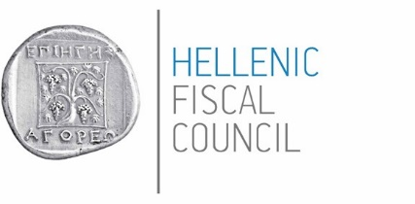
Annex III: Hellenic Fiscal Council opinion
Athens, 14th of October, 2025

Opinion on the Draft Budgetary Plan 2026
The Hellenic Fiscal Council (HIFSC) constituted as an independent fiscal authority under the law 4270/2014, as amended by the law 5217/2025 and currently in force. HFISC submits its opinion on macroeconomic and budgetary forecasts and assumptions underpinning the Draft Budgetary Plan 2026 (DBP 2026), monitoring compliance with country-specific numerical fiscal rules as stipulated in Regulation 473/2013 (Art. 6 par. 3f) of the European Parliament and the Council of the European Union (EU).
This assessment takes into account the following:
(a) The macroeconomic scenario and budgetary forecasts as communicated to the HFISC by the Ministry of Economy and Finance (MinFin) on September 17 and October 2, 2025 respectively, and the technical dialogue between experts from MinFin and HFISC.
(b) The most recent macroeconomic and budgetary data for the Greek economy, published by the Hellenic Statistical Authority (ELSTAT), that cover developments up to the first half of the year.
(c) The Annual Progress Report 2025 (APR 2025) projections as well as those of the State Budget 2025 (SB 2025), and of the Medium Term Fiscal-Structural Plan 2025-2028 (MTP 2025-2028).,,
(d) The European Commission’s Spring Forecasts 2025, and the forecasts of other international and national organizations regarding the performance of the main macroeconomic indicators of the Greek economy.
(e) The GDP forecasts based on the econometric models of the HFISC.
Macroeconomic forecasts
The macroeconomic forecasts of the MinFin, for the real GDP growth rate in 2025 (2.2%) on which the DBP 2026 is based are aligned with those of the HFISC (see, Figure 1). HFISC projects GDP growth of 2.2% this year, driven by strong investment from EU-funded programs and solid momentum in private consumption supported by favorable employment and disposable income growth. It is worth noting that HFISC’s forecast for 2025 was revised downward from 2.35% in the July 2025 bi-annual report, along with MinFin, reflecting greater caution over external uncertainties and inflation pressures (see, Figure 2). The adjustment mainly stemmed from tariff concerns, a Eurozone growth slowdown that could weigh on Greek exports and the wider economy, and weaker-than-projected Q2 2025 data (1.7% year-over-year, y-o-y GDP growth). Despite the above, Greece is expected to maintain a growth rate well above the euro area average: according to the EC’s Spring Forecast 2025, euro area growth is projected at 0.9%, with the first half of 2025 slightly weaker at 0.7% y-o-y.
For 2026, HFISC projects a 2.3% growth rate, within a wider range of uncertainty due to geopolitical tensions, and other vulnerabilities stemming from external shocks, with the DBP forecast at 2.4% sitting at the upper end of HFISC’s range (see, Figure 1). The DBP has revised the expected GDP growth for 2026 upward, to 2.4% from 2.0% (APR, April 2025) following the growth-friendly tax reform designed to stimulate economic activity, continued resilience in investment levels, and steady financial support from the Recovery Funds (see, Figure 2). All the above are expected to boost various sectors of the economy and enhance the overall economic outlook for Greece, though HFISC weighs uncertainties more heavily which is reflected in their more conservative growth projections.
Figure 1: 2025 & 2026, HFISC real GDP growth rate forecasts | Figure 2: 2024-2026, real GDP growth rate projections, MinFin
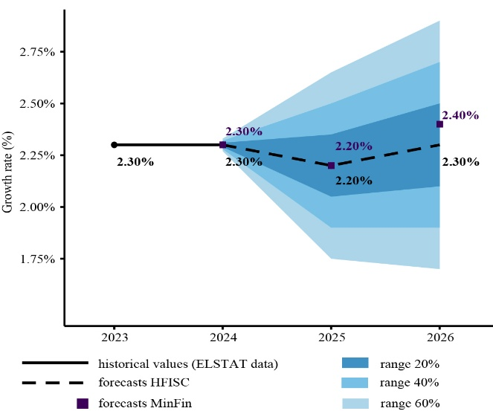 | 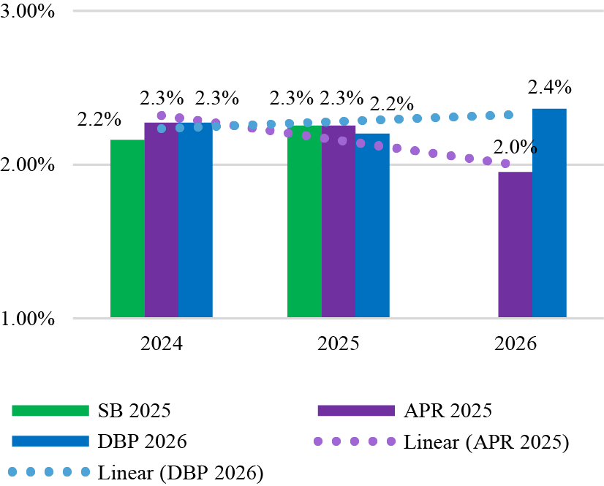
Source: Econometric forecasting models of HFISC. | Sources: Ministry of Economy and Finance (MinFin): 1. State Budget 2025 (SB, November 2024) 2. Annual Progress Report 2025 (APR, April 2025) 3. Draft Budgetary Plan 2026 (DBP, October 2025), HFISC data processing.
DBP 2026 growth projections are supported by forecasts from international and national institutions (see, Figure 3). For 2025, most institutions expect GDP growth for Greece at around 2.2% pointing to a favorable outlook, but with balanced risks that justifies though more modest growth estimates compared to previous higher projections. Specially, ELSTAT reported a y-o-y GDP growth 2.0% in the first half of 2025, while the Bank of Greece (BoG, June 2025) and the EC (Spring Forecasts, May 2025) are slightly more optimistic for the whole year at 2.3%, confirming solid momentum consistent with these forecasts. In constant, the International Monetary Fund (IMF, April 2025) and the Organization of Economic Co-operation and Development (OECD, May 2025) forecast a growth of 2.0%, emphasizing broader fiscal challenges across Europe and heightened uncertainty surrounding geopolitical and economic stability. Collectively, these assessments affirm the solid momentum behind the MinFin’s projections, which align with international forecasts.
For 2026, the expected growth rates reflect not only how each organization weighs uncertainties, such as the fiscal challenges across Europe and geopolitical risks, but also the fact that more recent data, not yet incorporated into these forecasts, could potentially lead to a revised growth outlook. More specifically, the EC (May 2025) projects growth at 2.2% and the OECD (June 2025) at 2.1%, while the BoG (June 2025) anticipates 2.0%. The IMF (April 2025) remains the most conservative, forecasting only 1.8% growth.
Overall, the convergence of forecasts suggests that Greece's economic growth remains robust, though slightly tempered for 2025 compared to earlier, more optimistic estimates. A solid growth outlook is expected for 2026, but it occurs against a backdrop of geopolitical tensions, fluctuations in global markets, and broader fiscal challenges within Europe.
Figure 3: 2025 & 2026, a comparison of GDP growth rate projections (y-o-y)
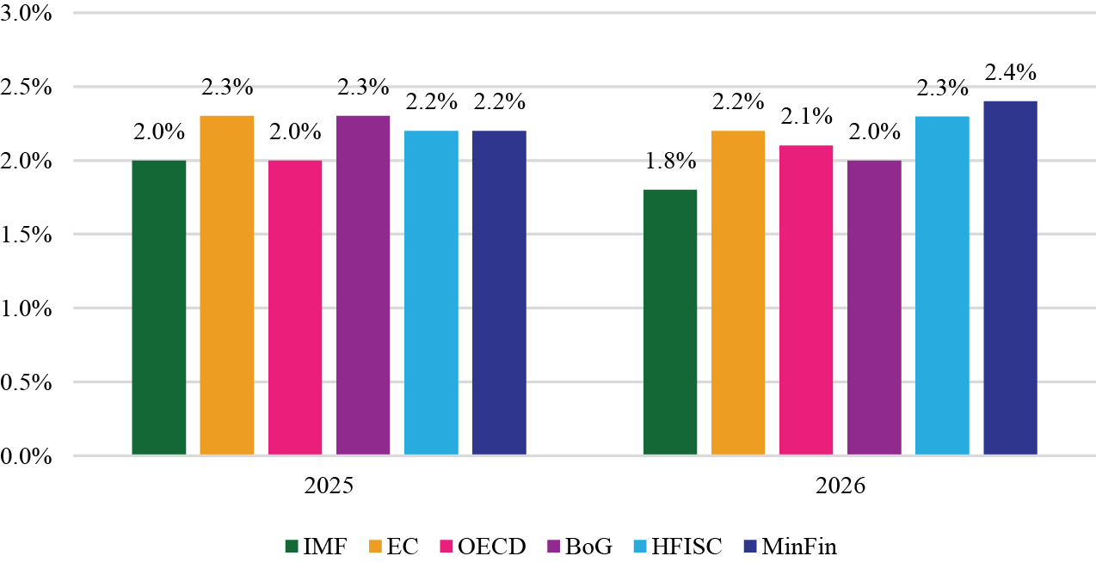
Sources: 1. IMF, World Economic Outlook (April 2025), 2. EC, European Economic Forecast (May 2025), 3. OECD Economic Outlook, Vol. 2025, No 117 (May 2025), 4. BoG, Monetary Policy Report 2024-2025 (June 2025), 5. HFISC (October 2025), 6. MinFin (October 2025).
According to the macroeconomic scenario underpinning the DBP 2026, growth in 2025 and 2026 will be driven mainly by higher investment and strong private consumption, supported by recent tax relief measures, substantial funding from the Recovery and Resilience Facility (RRF), and favorable labor market conditions.
In more detail, private consumption is expected to remain robust, with projected growth rates of 1.9% in 2025 and 1.7% in 2026, despite a y-o-y increase of 1.5% in the first half of 2025, reflecting the stabilization of disposable income (see, Table 1). As private consumption constitutes the largest component of GDP, this helps explain the recent upward revisions in growth forecasts. Public consumption in the first half of 2025 was broadly in line with 2024 levels, indicating a contained fiscal stance. For the whole year 2025, it is projected to increase by 1.4%, followed by a 0.7% rise in 2026, mainly reflecting already announced fiscal initiatives.
At the same time, gross fixed capital formation rose by 2.1% in the first semester of 2025, with further increases to be projected at 5.7% for the whole year and 10.2% for 2026. The significant increase in gross fixed capital formation from 2025 to 2026 primarily reflects investment projects financed through the RRF, many of which are expected to reach their implementation peak in 2026. In particular, investment in fixed capital (e.g. machinery, infrastructure) is particularly important, as it strengthens the country's long-term productive capacity. As of June 2025, the amount of grants and loans disbursed so far under RRF to the Greek economy is €21.34 billion out of the €35.95 billion (15.96% as a share of GDP). It is important to maintain the pace of RRF fund absorption, while carefully assessing the quality of funded investments to ensure their efficiency and multiplier effect on the economy. Overall, investment remains a key factor in achieving the new economic scenario, with particular emphasis on RRF.
The current account deficit is projected to narrow in 2025 but to widen again in 2026, reflecting expected pressures from higher imports mainly driven by increased investment activity. Despite the slight improvement observed in the first half of 2025, the current account remains a structural concern for the Greek economy.
Table 1: 2025 & 2026, Key macroeconomic indicators forecasts (% change y-o-y, constant 2020 prices)
 | Draft Budgetary Plan 2026 |  | 1st Semester 2025
Years | 2025 | 2026 | 2025
GDP | 2.2% | 2.4% | 2.0%
Private Consumption | 1.9% | 1.7% | 1.5%
Public Consumption | 1.4% | 0.7% | 0.2%
Gross Fixed Capital Formation | 5.7% | 10.2% | 2.1%
Exports of Goods & Services | 2.2% | 4.5% | 2.2%
Imports of Goods & Services | 0.9% | 4.6% | -0.6%
Sources: MinFin, ELSTAT and HFISC calculations.
The fundamental assumption underpinning the DBP 2026 projections entails a continued decline in inflation, aiming to align with the European Central Bank’s (ECB's) target of 2.0%. For 2025, inflation (Harmonized Index of Consumer Prices, HICP) is projected to decline to 3.0% (see, Figure 4). More specifically, according to the most recent ELSTAT data, the average inflation sustained at 3.2% in the first eight-month period of 2025 vis-à-vis a 3.0% in the first eight-month period of 2024. Over the past two years, inflation in Greece has remained at an average level of approximately 3%, without displaying a clear downward trend toward the ECB’s target of 2%. For 2026, inflation is expected to fall to 2.2% lower than what was forecasted in APR 2025 (2.4%).
The above DBP 2025 forecasts for the inflation are consistent with those of international organizations that fall in a range of 2.4%–2.8% for 2025 and 2.0%–2.3% for 2026 (see, Figure 5). However, compared to the Eurozone average, the Greek economy is still going through a period of inflationary pressure (2.8% for 2025 and 2.3% for 2026 vis-à-vis the Eurozone average 2.1% and 1.7%, respectively, according EC Spring Forecasts, May 2025). The risk of inflation in Greece remaining persistently higher than in other European partners remains a challenge.

Figure 4: 2024-2026, Inflation (HICP) projections, MinFin | Figure 5: 2025 & 2026, Inflation (HICP) projections, MinFin and International –National Institutions
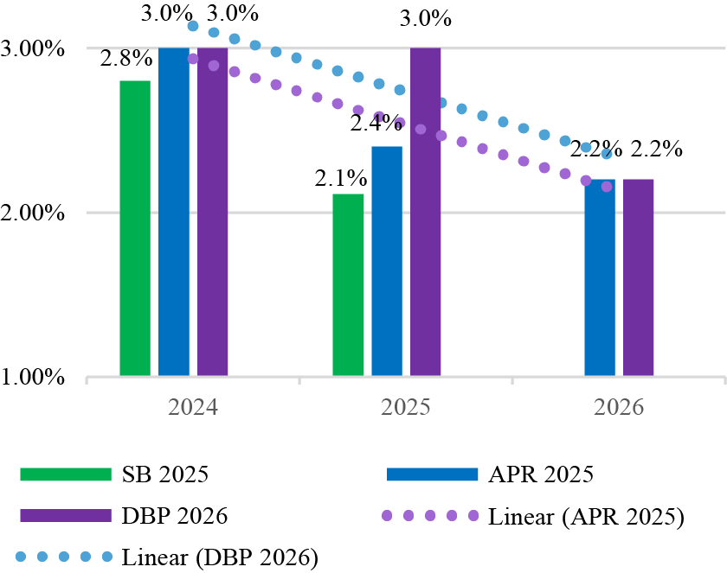 | 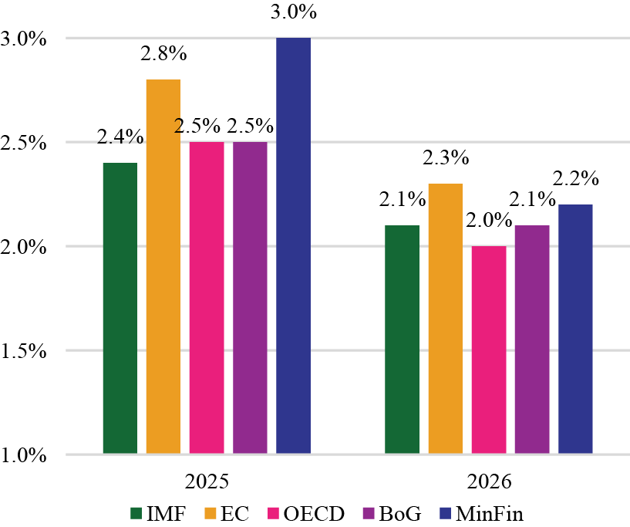
Sources: Ministry of Economy and Finance (MinFin): 1. State Budget 2025 (SB, November 2024), 2. Annual Progress Report 2025 (APR, April 2025), 3. Draft Budgetary Plan 2026 (DBP, October 2025), HFISC data processing. | Sources: 1. IMF, World Economic Outlook (April 2025), 2. EC, European Economic Forecast (May 2025), 3. OECD Economic Outlook, Vol. 2025, No 117 (May 2025), 4. BoG, Monetary Policy Report 2024-2025 (June 2025), 5. MinFin (October 2025), HFISC data processing.

Budgetary forecasts
According to the 2026 DBP, Greece is expected to maintain primary surpluses, projected at 3.6% of GDP in 2025 and 2.8% in 2026 (see, Figure 6). At the same time, the general government balance is forecast to record a surplus in 2025 (0.6% of GDP) and a marginal deficit in 2026 (-0.1% of GDP) under the baseline scenario. These projections are based on the expected steady growth momentum of the Greek economy, with growth rates above 2%, supported by rising public revenues and prudent expenditure management.
Figure 6: General Government Primary Balance 2023-2026 (% GDP)
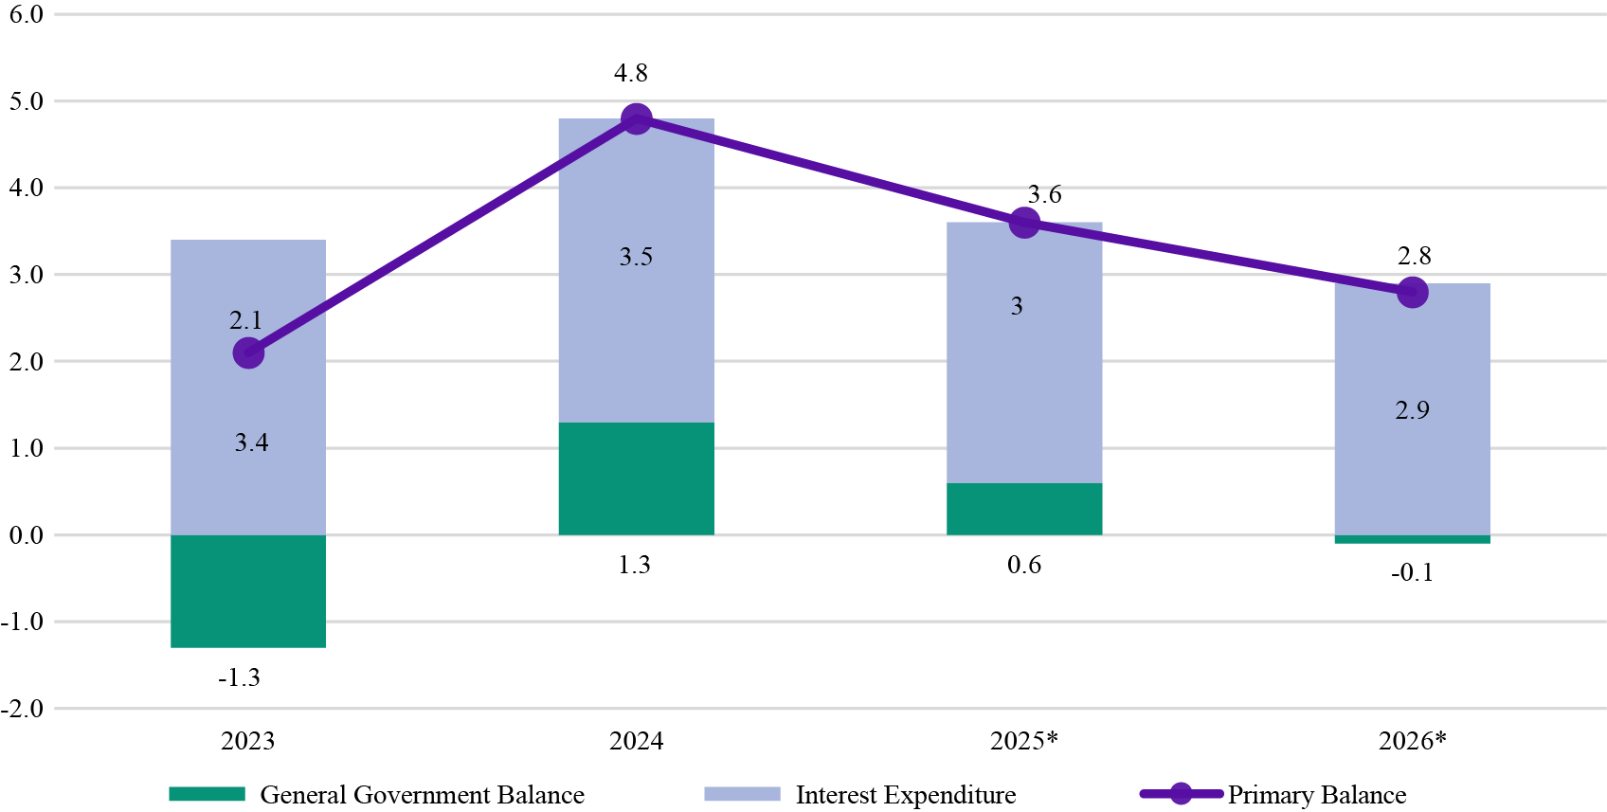
Source: Draft Budgetary Plan 2026, MinFin, October 2025.
* The figures for 2025 are estimates, and those for 2026 are forecasts.

For 2025, the DBP 2026 moves to revise the primary surplus target to 3.6% of GDP, up from the 2.4% of GDP forecast in the SB 2025. Based on the data currently available, the achievement of the revised target is considered feasible. Specifically, the General Government bulletins for the first seven months of 2025 show a cash-based primary surplus of €9.1 billion, equal to 3.70% of GDP (see, Table 2). This improvement is largely due to an increase in revenues of €5.9 billion (9.9%), deriving from both tax revenues and social contributions, while expenditures rose by €3.1 billion (5.8%) compared with the corresponding period of the previous year. Provided that no extraordinary fiscal pressures arise (such as fines, court-ordered compensation, or geopolitical instability) and that fiscal discipline is maintained, achieving the revised target of 3.6% of GDP remains feasible, though it will require heightened commitment to the implementation of the budget.
Table 2: General Government Budget Execution (million euros*), Jan – Jul 2025
 | Jan - Jul 2024 | Jan - Jul 2025 | Difference 2024-2025 | % Difference 2024-2025
 | (a) | (b) | (c) = (b) - (a) | (d) = (c)/(a)
Α. Revenues | 59,745 | 65,671 | 5,926 | 9.9%
Β. Expenditures | 53,774 | 56,872 | 3,098 | 5.8%
C. Net acquisitions of non-financial assets | 5,543 | 4,438 | -1,105 | -19.9%
Surplus/ Deficit (Α-Β-C) | 428 | 4,361 | 3,933
% GDP | 0.2% | 1.8%
Primary Balance of General Government | 5,261 | 9,147 | 3,886
% GDP | 2.2% | 3.7%
GDP | 237,573 | 247,514
Source: Monthly Bulletin of General Government Data, July 2025, MinFin. HFISC data processing. *Data on a cash basis
The fiscal projections of the MinFin for 2025 are broadly aligned with those of the EC and other international institutions (see, Table 2). The EC’s spring forecasts are slightly more optimistic, projecting a primary surplus of 3.8% of GDP and a general government surplus of 0.7% in 2025, rising to 4.4% and 1.4% of GDP, respectively, in 2026. The IMF (April 2025) takes a more conservative view, projecting a primary surplus of 2.5% and a general government deficit of 0.5% in 2025, and 2.4% and 0.6%, respectively, in 2026. Finally, the OECD (June 2025) provides more restrained forecasts, estimating primary surpluses of 2.1% in 2025 and 2.2% in 2026, with a balanced or slightly negative general government balance. It also highlights fiscal risks from declining EU investment support, productivity challenges, and potential natural disasters or other unforeseen events that could further strain public finances.
Table 3: Forecasts by International Institutions, General Government Balance and Primary Balance (% GDP)
 |  | General Government Balance |  | Primary Balance
 |  | 2025 | 2026 | 2025 | 2026
IMF | April 2025 | -0.5% | -0.6% | 2.5% | 2.4%
European Commission | May 2025 | 0.7% | 1.4% | 3.8% | 4.4%
OECD | June 2025 | 0.0% | -0.2% | 2.1% | 2.2%
MinFin | October 2025 | 0.6% | -0.1% | 3.6% | 2.8%
Sources: 1. IMF, World Economic Outlook Database (April 2025), 2. European Commission, European Economic Forecast, Spring 2025 (May 2025), 3. OECD Economic Outlook, No 117 (May 2025), and 4. Draft Budgetary Plan 2026, MinFin (October 2025).
According to the DBP 2026, the general government debt-to-GDP ratio is expected to reach 145.3% in 2025, marking a decline of 8.2 percentage points compared with 2024 (see, Figure 7). This downward trend is projected to continue in 2026, with debt falling by a further 7.8 percentage points to 137.6% of GDP. If these projections materialize, the country’s public debt is expected, for the first time in 15 years, to drop below the 140% of GDP threshold, a milestone with particular symbolic significance for Greece’s long-standing fiscal stabilization effort.
The main factors driving this strong decline in debt are the persistence of high nominal economic growth and the improvement in the primary surplus. In the coming years, the effect of the gap between the implicit interest rate and the nominal growth rate is expected to lessen, while the contribution of the primary surplus will become more decisive in reducing the debt-to-GDP ratio. Despite the substantial decrease, the still-elevated level of public debt requires continued monitoring and fiscal vigilance, as it remains well above the 60% of GDP benchmark set by the EU’s Stability and Growth Pact (SGP).
Figure 7: Debt of General Government
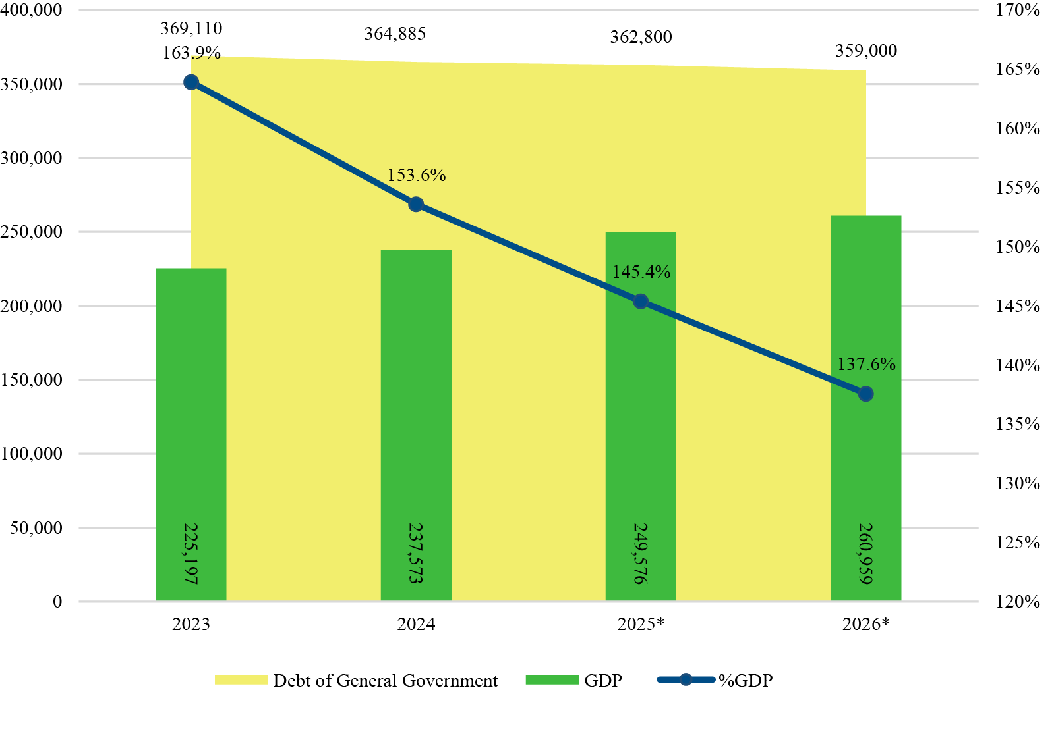
Source: MinFin (October 2025), ELSTAT, HFISC data processing.
Compliance with Fiscal Rules
The general principles governing fiscal planning, set out in Article 34 of Law 4270/2014, as amended, and aligned with the new European Union economic governance framework effective from 30 April 2024, focus on controlling public finances. Specifically, they aim to maintain the growth of net nationally financed primary expenditure of the general government at levels that ensure both the sustainability of public debt and the containment of the fiscal deficit below the 3% of GDP reference value over the medium term. They also aim at shaping the fiscal position of the general government’s primary balance into a surplus.
According to the DBP 2026, the annual increase in the general government’s net primary expenditure is estimated at 4.4% for 2025 and 5.8% for 2026, both rates exceeding the upper limits set in the MTFS 2025–2028 (3.7% and 3.6%, respectively). Despite this deviation, the projections remain consistent with the new fiscal framework, as the actual change recorded in 2024 was -0.4% of GDP, lower than the established ceiling, thus creating fiscal space for higher expenditure during 2025–2026. This deviation is mainly attributed to the stronger-than-expected impact of discretionary revenue measures. Under the new fiscal framework, an annual deviation of up to 0.3 percentage points of GDP (around €0.7 billion) is allowed, providing additional flexibility.
In addition, the national escape clause, foreseen in Regulation (EU) 2024/1263, provides for a justified deviation from the endorsed net expenditure path in the presence of exceptional circumstances with a major fiscal impact beyond the control of Member States. Specifically, defense expenditures are estimated to increase by approximately 0.1% of GDP in 2025 and 0.3% of GDP in 2026, compared to the baseline year 2024. It is also noted that, the projected cumulative increase in net primary expenditures aligns with the MTP 2025–2028 limits of 6.5% of GDP in 2025 and 10.3% in 2026, remaining within the prescribed thresholds.
Furthermore, compliance with the 3% of GDP reference value for the general government deficit is ensured for both years. The deficit is projected to register a surplus of 0.6% of GDP in 2025 and a marginal deficit of -0.1% of GDP in 2026. The general government primary balance remains in surplus for both years, in full alignment with the national numerical fiscal rule. Finally, the dynamics of public debt are reflected in the steady and significant decline in the debt-to-GDP ratio, with a reduction of 8.2 percentage points in 2025 and 7.8 percentage points in 2026. This trajectory exceeds the forecasts of the MTP 2025–2028, demonstrating the strengthened resilience and positive outlook of the Greek economy.
Upside-downside risks
In 2026, the Greek economy may face several uncertainties that could hold back the strong economic momentum experienced in recent years.
A key downside external risk stems from the geopolitical and world trade uncertainties as well as problems in European countries facing fiscal challenges and political tensions, all of which combined could disrupt markets and weigh on growth. Within this international environment, weaker external demand, particularly if tourism underperforms, would hit Greece’s exports, overall economic activity, tax revenues and the current account. A higher disposable income, due to favorable tax reforms like the recently announced one, may further boost consumption and increase aggregate demand, but its net macroeconomic effect will also depend on inflation as well as the broader macroeconomic environment. For instance, persistent or renewed inflationary pressures compared with other European countries might erode household purchasing power, highlighting the need to closely monitor divergence from the Eurozone average. Delays in carrying out structural reforms to boost market competition could slow productivity gains and reduce the economy’s ability to absorb shocks. A slower-than-expected absorption of EU Recovery and Resilience Facility funds might weaken the investment momentum observed in recent years and delay key infrastructure and green transition projects.
On the positive side, defense expenditures with increased investment in procurement, infrastructure and technology, are expected to stimulate domestic industries, create spillovers in manufacturing and innovation, and attract strategic international partnerships. A continued decline in inflation at EA level could limit future interest rate hikes, generating further benefits for both the private economy and public finances. Combined with robust EU fund absorption, an improved consumer and investor sentiment, supported by Greece’s upgraded credit profile and fiscal prudency, could reinforce the country’s growth trajectory and strengthen its economic resilience.
Based on the above, the Hellenic Fiscal Council endorses the macroeconomic projections underlying the Draft Budgetary Plan 2026. The Council has assessed the fiscal projections and confirmed compliance with the numerical fiscal rules.
For the Hellenic Fiscal Council,

The Chairperson
Anastasia Miaouli



HELLENIC REPUBLIC

Ministry of Economy
and Finance


General Accounting Office
37 Panepistimiou St.
10564 Athens

minfin.gov.gr/

Eurostat Euro indicators, September 2025.
European Commission, Business and consumer survey results for August 2025 - Statistical Annex.
In line with the macroeconomic scenario, employee compensation is projected to increase by 3.7% in 2025 and by the same rate in 2026, and these adjustments have been incorporated into the estimations.
The transposition of Council Directive (EU) 2024/1265 of 29 April 2024, amending Directive 2011/85/EU on requirements for budgetary frameworks of the Member States (OJ L, 2024/1265, 30.4.2024), was adopted in July 2025 through the amendment of the law 4270/2014 by the law 5217/2025.
A comprehensive analysis of the macroeconomic and budgetary developments of the Greek economy will be presented in the forthcoming HFISC bi-annual report.
ELSTAT, press releases, Quarterly National Accounts, 2nd Quarter 2025, 5/9/2025 and Quarterly Non-Financial Accounts of General Government, 1st Quarter 2025, 21/07/2025.
Annual Progress Report 2025, Greece
State Budget 2025 (in Greek) – Ministry of Finance and Economy
Medium Term Fiscal-Structural Plan 2025-2028, Greece
European Commission, Spring forecasts 2025
EC, Recovery and Resilience Scoreboard.
Regulation (EU) 2024/1263 of the European Parliament and of the Council of 29 April 2024 on the effective coordination of economic policies and multilateral fiscal surveillance and repealing Council Regulation (EC) No 1466/97 (OJ L, 2024/1263, 30.4.2024), Council Regulation (EU) 2024/1264 of 29 April 2024 amending Regulation (EC) No. 1467/97 on speeding up and clarifying the implementation of the excessive deficit procedure (OJ L, 2024/1264, 30.4.2024) and Council Directive (EU) 2024/1265 of 29 April 2024 amending Directive 2011/85/EU on requirements for budgetary frameworks of the Member States (OJ L, 2024/1265, 30.4.2024).
Within the framework of the Net Expenditure Rule, as provided in Article 36 of Law 4270/2014, the percentage change in net expenditures is not allowed to exceed the upper limits set in the applicable Council Recommendation, pursuant to Article 17 of Regulation (EU) 2024/1263, concerning the approval of the National Medium-Term Fiscal-Structural Plan.
Article 2 par. 2 of Regulation (EC) 1467/1997: “The Commission shall prepare a report in accordance with Article 126(3) TFEU where… the deviations recorded in the control account of the Member State exceed: (a) either 0.3 percentage points of GDP annually, (b) or 0.6 percentage points of GDP cumulatively.”
Article 26 of Regulation (EU) 2024/1263: “exceptional circumstances outside the control of the Member State with a major impact on its public finances, provided that it does not endanger fiscal sustainability over the medium term”. HFISC has acknowledged that the significant fiscal burden arising from existing and/or planned defense expenditures meets the criteria of such an exceptional circumstance, following the assessment of the relevant request submitted by the MinFin.

